CSS ISLAMIC STUDIES · T1KB
بِسْمِ ٱللَّهِ ٱلرَّحْمَٰنِ ٱلرَّحِيمِ
Topic I — Introduction to Islam and the Islamic Beliefs
The Knowledge Base · Islam and Din, Wahi, Tawhid, Risalat, the Finality of Prophethood, the Hereafter — and their impact on the individual and society
Eleven chapters built from the syllabus and from the ten questions set on this topic between 2015 and 2026, with a chapter of contemporary challenges, the examiner's record, five likely questions, a one-liner bank and a revision sheet. Every point carries its evidence — the Quran first, then the Hadith, then the scholars — inside the point itself.
Edition of September 2026 · covers the papers of 2015–2026 · written for CSS 2027 and after
Contents
HOW TO BUILD THE CONTENTS
The Contents below is left empty on purpose. In Microsoft Word, right-click anywhere on the grey line below and choose Update Field → Update entire table → OK. The full table of contents with page numbers will appear.
On a Mac: right-click (or Control-click) the line → Update Field. If you edit the notes later, repeat this step to refresh the page numbers. You can also press Ctrl + A then F9 (Windows) to update every field in the document at once.

How to Use This Document 10
What this topic covers 10
How this document is built 11
Part Zero — The ABC Before the Chapters 12
0.1 The three questions every human being asks 12
0.2 Why belief matters in an exam about 'life' 12
0.3 The words of this topic 13
Chapter 1 · The Concept of Islam 15
1.1 Islam: the meaning of the word 15
(1) Literal meaning 15
(2) Technical meaning 15
1.2 Islam in the Quran: the Din of all the Prophets 16
(1) The only Din accepted by Allah 16
(2) Islam was the religion of every Prophet 16
(3) The whole universe is 'Muslim' 17
1.3 The structure of Islam: Iman, Islam, Ihsan 18
(1) Iman — the level of belief 18
(2) Islam — the level of practice 18
(3) Ihsan — the level of excellence 18
1.4 Islam as a complete code of life 18
(1) The completion of the Din 18
(2) Enter Islam completely 19
(3) What 'complete code of life' means in practice 19
Chapter 2 · Din: Meaning and Importance in Human Life 21
2.1 The meaning of 'Din' 21
(1) Literal meanings 21
(2) The four meanings of Din in the Quran 21
(3) The technical meaning 22
2.2 The importance of Din in human life 23
(1) Din answers the needs of human nature 23
(2) Din builds the individual 24
(3) Din builds society 25
(4) Din serves humanity 26
Chapter 3 · Din and Religion: The Difference 28
3.1 What 'religion' means 28
(1) The word 28
(2) How the idea was formed 28
3.2 Din vs religion — the differences 28
3.3 Arguing the difference — the evidence 29
(1) Islam claims all of life 29
(2) Islam claims to prevail as a system 29
(3) The Din of Allah has a law, a state and a society 30
(4) The practice of the Prophet ﷺ 30
3.4 Where Din and religion meet 30
Chapter 4 · The Distinctive Aspects of Islam 31
4.1 Pure monotheism (Tawhid) 31
4.2 Universality 31
4.3 Completeness and comprehensiveness 31
4.4 Preservation of the sources 32
4.5 Balance and moderation (Wasatiyyah) 32
4.6 Ease and practicality 33
4.7 Harmony of reason and revelation 33
4.8 Harmony of this world and the Hereafter 34
4.9 Human dignity and equality 34
4.10 Freedom of belief and tolerance 35
4.11 Direct relationship between man and God 35
4.12 Finality and permanence 35
Chapter 5 · Wahi: Revelation and Its Supremacy over Other Sources of Knowledge 37
5.1 The meaning of Wahi 37
(1) Literal meaning 37
(2) Technical meaning 37
5.2 The kinds and modes of Wahi 37
(1) The two kinds 37
(2) The three modes 38
(3) How revelation came to the Prophet ﷺ 38
(4) The first revelation 39
5.3 The sources of human knowledge — and their limits 39
(1) The senses 39
(2) Reason 40
(3) Intuition and experience 40
(4) Wahi 40
5.4 The supremacy of Wahi as the solution of human problems (CSS 2015) 40
(1) Certainty against conjecture 41
(2) Freedom from contradiction 41
(3) Freedom from desire and interest 41
(4) Permanence of values 41
(5) Answers to the ultimate questions 41
(6) A complete and balanced system 42
(7) The proof of history 42
(8) The inimitable challenge 42
5.5 Wahi and reason are partners, not enemies 42
(1) Islam honours reason 42
(2) The division of labour 43
(3) The rule of priority 43
5.6 Wahi and science 43
(1) Different questions 43
(2) The Quran's invitation to science 44
(3) Muslim science was born of revelation 44
Chapter 6 · Tawhid: Concept, Kinds, Rational Arguments and Impact 45
6.1 The meaning of Tawhid 45
(1) Literal meaning 45
(2) Technical meaning 45
(3) The Kalimah: the formula of Tawhid 45
6.2 Tawhid in the Quran and Sunnah 45
6.3 The kinds of Tawhid 46
(1) Tawhid al-Rububiyyah — the Oneness of Lordship 46
(2) Tawhid al-Uluhiyyah — the Oneness of Worship 47
(3) Tawhid al-Asma wal-Sifat — the Oneness of Names and Attributes 47
6.4 The rational arguments for the existence of Allah (CSS 2026) 48
(1) The argument from creation (cosmological argument) 48
(2) The argument from design and order (teleological argument) 49
(3) The argument from the unity of order 50
(4) The argument from the fitrah (innate nature) 51
(5) The moral argument 52
(6) The argument from life, consciousness and the self 52
6.5 Shirk: the opposite of Tawhid 53
(1) Meaning 53
(2) The kinds of shirk 53
(3) Modern forms of shirk 54
6.6 The impact of Tawhid on the individual (CSS 2019, 2026) 55
(1) Dignity and self-respect 55
(2) Courage and fearlessness 55
(3) Peace of heart and contentment 56
(4) Humility without servility 56
(5) Accountability and moral discipline 57
(6) A broad and universal outlook 57
(7) Hope and freedom from despair 57
(8) Trust in Allah with hard work (tawakkul) 57
6.7 The impact of Tawhid on society 58
(1) Equality and brotherhood 58
(2) Justice and the rule of law 58
(3) Freedom from tyranny and exploitation 59
(4) Unity of the Ummah 59
(5) Cooperation and welfare 60
(6) Moral order and social peace 60
Chapter 7 · Risalat: The Doctrine of Prophethood and Its Importance 61
7.1 The meaning of Nubuwwah and Risalah 61
(1) Nabi — the Prophet 61
(2) Rasul — the Messenger 61
(3) The difference between Nabi and Rasul 61
(4) How many Prophets? 61
7.2 The doctrine of Prophethood — what a Muslim believes 62
(1) Prophethood is a gift of Allah, not an achievement 62
(2) The Prophets are human beings 62
(3) The Prophets are protected from sin (ismah) 63
(4) The Prophets convey the message completely 63
(5) Belief in all the Prophets is required 63
(6) The Prophets are supported by miracles 63
7.3 Why man needs Prophets 64
(1) Reason alone cannot find the full truth 64
(2) Man needs a practical model, not only a theory 64
(3) Justice needs a revealed standard 65
(4) The argument of man is removed 65
7.4 The functions of the Prophets 65
7.5 The qualities of the Prophets 66
(1) The four essential qualities 66
(2) Other qualities 66
7.6 The importance of Prophethood in human life 66
(1) In belief: the only door to the knowledge of Allah 66
(2) In worship: the method of obedience 67
(3) In morality: the perfect example 67
(4) In law and society: the final authority 67
(5) In civilization: the founders of just societies 67
(6) In the unity of mankind 68
(7) In salvation 68
Chapter 8 · Khatm-e-Nubuwwat: The Finality of Prophethood 69
8.1 The meaning of Khatm-e-Nubuwwat 69
(1) Literal meaning 69
(2) Technical meaning 69
8.2 The evidence from the Quran 69
(1) The explicit text 69
(2) The completion of the Din 69
(3) A universal Prophet for all people and all time 70
(4) The Quran speaks of revelation 'before you', never 'after you' 70
(5) The preservation of the message 70
8.3 The evidence from the Sunnah 71
(1) The parable of the house and the last brick 71
(2) 'There is no Prophet after me' 71
(3) The warning against false claimants 71
(4) Prophethood and messengership have ended 71
(5) Sent to all creation, and the Prophets sealed with him 72
(6) Even the greatest would not have been a Prophet 72
8.4 The consensus (Ijma) of the Ummah 72
(1) The Companions' consensus in action 72
(2) The consensus of all schools 72
8.5 The wisdom of Finality — the rational argument 72
(1) The Din is complete 72
(2) The message is preserved 72
(3) The message is universal 72
(4) Humanity reached maturity 73
(5) Guidance continues — through the scholars and renewal 73
(6) Finality protects the unity of the Ummah 73
8.6 Why faith in Prophethood is unacceptable without faith in its Finality 73
Chapter 9 · Akhirah: The Quranic Argument and Its Impact 75
9.1 The meaning of Akhirah 75
(1) Literal meaning 75
(2) Technical meaning 75
(3) The names of the Day in the Quran 75
9.2 The place of Akhirah in the faith 75
9.3 The stages of the Hereafter 76
(1) Death 76
(2) Barzakh — the interval 77
(3) The Trumpet and the Resurrection 77
(4) The Reckoning and the Record 77
(5) The witnesses 78
(6) The Scales 78
(7) Paradise and Hell 78
9.4 The Quranic arguments for the Hereafter (CSS 2023) 78
(1) The argument from the first creation 79
(2) The argument from the revival of the earth 80
(3) The argument from justice 81
(4) The argument from purpose 81
(5) The argument from the conscience 82
(6) The rational and moral support 82
9.5 The impact of belief in the Hereafter on the individual 83
(1) A sense of accountability — the inner judge 83
(2) Moral conduct and self-control 83
(3) Purpose, seriousness and good use of time 83
(4) Patience and hope in suffering 84
(5) Freedom from greed and materialism 84
(6) Courage and sacrifice 84
(7) Remembrance of death 84
9.6 The impact of belief in the Hereafter on collective life 85
(1) Justice and the rule of law 85
(2) Honest trade and economy 85
(3) The rights of people (Huquq al-Ibad) 86
(4) Care for the weak 86
(5) Less crime and corruption 86
(6) Peace instead of revenge 86
Chapter 10 · Angels, Books and Qadr 87
10.1 Belief in the Angels (Mala'ikah) 87
(1) Who the angels are 87
(2) The great angels and their duties 87
(3) The impact of belief in angels 88
10.2 Belief in the revealed Books 88
(1) The Books named in the Quran 88
(2) What a Muslim believes about them 88
(3) The impact 88
10.3 Belief in Qadr — divine decree 89
(1) Meaning 89
(2) The four levels of Qadr (as taught in the books of creed) 89
(3) Qadr and human free will 89
(4) The impact of belief in Qadr 90
Chapter 11 · The Islamic Beliefs Together: Impact on the Individual and Society 92
11.1 Belief and deeds are inseparable 92
11.2 The impact matrix 92
11.3 The impact on the individual — in one list 93
(1) A clear identity and purpose 93
(2) Moral discipline from within 93
(3) Peace of mind and emotional balance 93
(4) Courage, dignity and freedom from fear of creatures 93
(5) Responsibility for time, wealth, knowledge and body 93
(6) Good character — the proof of faith 93
11.4 The impact on society — in one list 93
(1) Brotherhood and equality 93
(2) Justice and the rule of law 93
(3) Honesty in trade, office and public life 93
(4) Care for the poor, the orphan and the weak 93
(5) Stability, trust and social peace 93
(6) The historical proof: the society of Madinah 93
Part Two — Contemporary Challenges, Narratives and Hot Debates 95
12.1 Atheism and scepticism among the educated youth 95
(1) The challenge 95
(2) The causes 95
(3) The Islamic response 95
12.2 'Science has replaced religion' 96
(1) The narrative 96
(2) The answer 96
12.3 Secularism and 'religion is a private matter' 96
12.4 The meaning crisis: anxiety, depression and loneliness 96
(1) The challenge 96
(2) The answer of the Islamic beliefs 97
12.5 Relativism: 'all truths are equal' 97
(1) The narrative 97
(2) The answer 97
12.6 Materialism and consumerism — the modern idols 97
12.7 Finality of Prophethood today 97
Part Three — The Examiner's Record and Five Likely Questions 99
13.1 Every question on this topic, 2015–2026 99
13.2 What the record teaches 99
13.3 Five likely questions 99
Part Four — The One-Liner Bank 100
One-liners · Islam and Din 100
One-liners · Wahi 100
One-liners · Tawhid 100
One-liners · Risalat and Finality 101
One-liners · Akhirah, Angels, Books, Qadr 101
Part Five — Revision Sheet · Topic 1 102
R1.1 The topic in ten lines 102
R1.2 The definitions to write word for word 102
R1.3 The evidence to carry into the hall 102
R1.4 The two impact lists (learn them as a pair) 103
R1.5 The figures to practise 103

How to Use This Document

What this topic covers
Topic 1 is the foundation of the whole paper. It carries the first head of the syllabus — Introduction to Islam — except the worships, which have their own topic (T2). It answers three questions every other topic depends on: What is Islam? Why does man need it? What does a Muslim believe, and what difference does that belief make?
Syllabus line | Where it is taught
Concept of Islam | Chapter 1
Importance of Din in human life | Chapter 2
Difference between Din and religion | Chapter 3
Distinctive aspects of Islam | Chapter 4
Islamic beliefs and their impact on individual and society | Chapters 5–11 (Wahi, Tawhid, Risalat, Khatm-e-Nubuwwat, Akhirah, Angels, Books, Qadr, and their combined impact)
The fundamentals of Islam | Chapters 1, 4 and 11

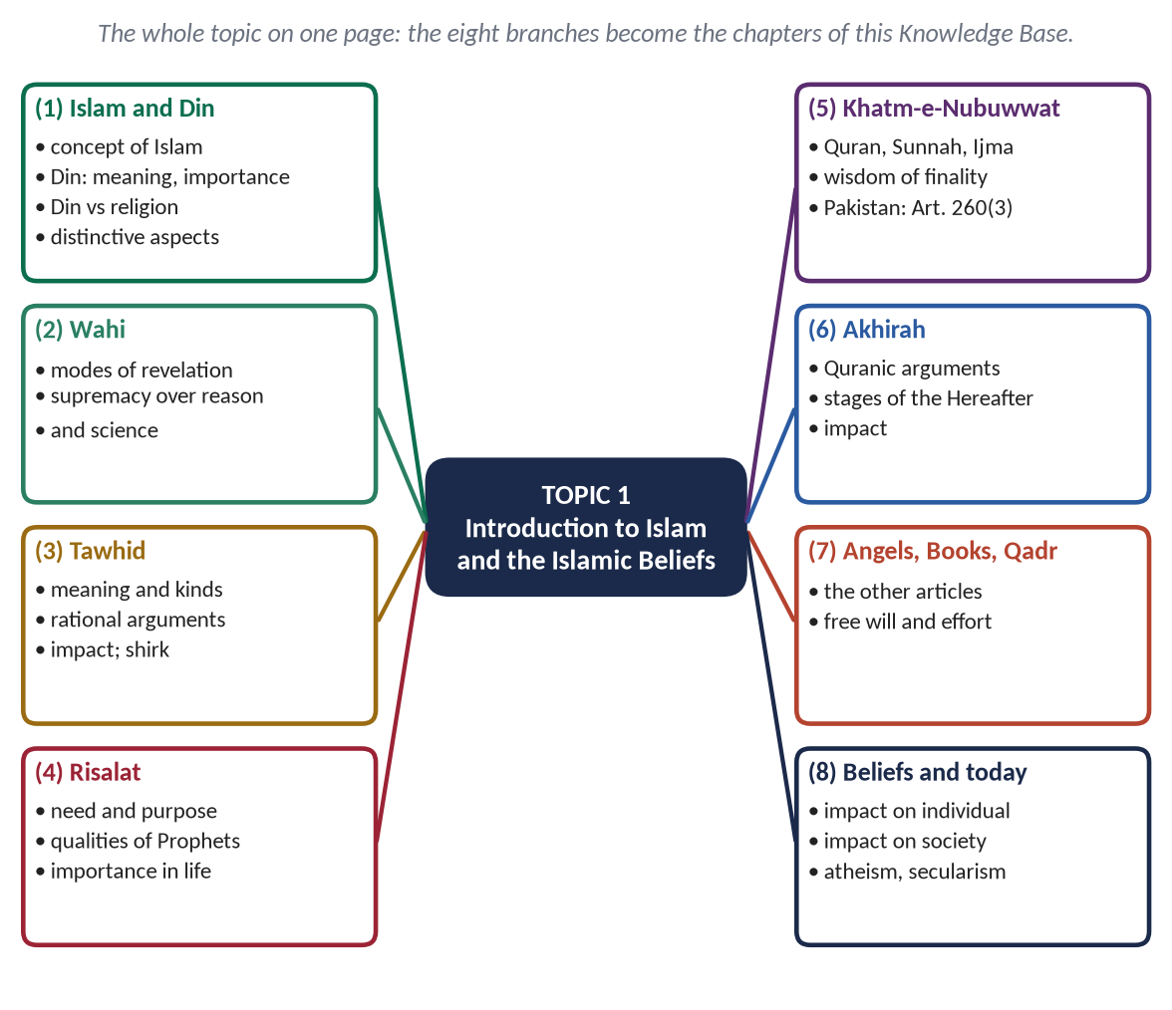
Figure 1 · Topic 1 on one page. The eight branches are the chapters of this Knowledge Base.

How this document is built
1. Part Zero gives you the ABC: why man needs belief, and the words of this topic.
2. Part One has eleven chapters, one for each syllabus line and each family of past questions. Every chapter is divided into headings down to four levels — (1), (i), (a) — so that you can lift them straight into an answer.
3. Every point carries its evidence inside it: a green card is the Quran, a gold card a hadith, a blue card a scholar.
4. Part Two covers the contemporary challenges and hot debates: atheism, secularism, science and religion, the meaning crisis.
5. Part Three is the examiner's record of this topic and five likely questions.
6. Part Four is the one-liner bank; Part Five the revision sheet.
EXAMINER'S EYE · THIS TOPIC IN THE PAPER
Topic 1 has been asked ten times in twelve years — in 2022, 2023, 2024 and 2026 in a row. Its favourite questions are Prophethood and its finality (2015, 2022, 2024), Din vs religion (2016, 2022), Tawhid (2019, 2026) and the Hereafter (2021, 2023). Almost every one ends with the same words: 'its impact on individual and society'. This Knowledge Base therefore gives every belief two ready lists of impacts.

Part Zero — The ABC Before the Chapters

0.1 The three questions every human being asks
Every thinking person, in every age, asks three questions. Philosophy has argued about them for thousands of years without agreement. Islam answers all three with certainty, and its three basic beliefs are exactly these three answers.
The question | The belief that answers it | What the answer gives
Where have I come from? | Tawhid — Allah, the One Creator | Origin, identity, dignity
Why am I here, and how should I live? | Risalat — guidance through the Prophets | Purpose, law, morality, a model
Where am I going? | Akhirah — the Hereafter | Accountability, hope, justice

✦ QURAN
﴿أَفَحَسِبۡتُمۡ أَنَّمَا خَلَقۡنَٰكُمۡ عَبَثٗا وَأَنَّكُمۡ إِلَيۡنَا لَا تُرۡجَعُونَ﴾
“Then did you think that We created you uselessly and that to Us you would not be returned.” (Al-Mu'minun, Quran)
➜ The Quran itself poses the question of purpose: man was not created without aim and will return to Allah — the three questions in one verse.

REMEMBER · THE FORMULA OF THE FAITH
Tawhid answers the origin, Risalat answers the way, Akhirah answers the end. The other articles — Angels, Books and Qadr — support these three. Write this triangle in the introduction of any belief question.

0.2 Why belief matters in an exam about 'life'
A belief is not only an idea in the mind. In Islam, belief (Iman) has three parts, and the third is what the examiner calls 'impact':
1. Tasdiq bil-qalb — affirmation in the heart;
2. Iqrar bil-lisan — declaration by the tongue;
3. Amal bil-arkan — confirmation by the limbs, that is, by deeds.
✦ HADITH
الْإِيمَانُ بِضْعٌ وَسَبْعُونَ شُعْبَةً، فَأَفْضَلُهَا قَوْلُ لَا إِلَهَ إِلَّا اللَّهُ، وَأَدْنَاهَا إِمَاطَةُ الْأَذَى عَنِ الطَّرِيقِ، وَالْحَيَاءُ شُعْبَةٌ مِنَ الْإِيمَانِ
“Faith has seventy-odd branches: the highest is saying 'There is no god but Allah', and the lowest is removing something harmful from the road; and modesty is a branch of faith.” (Muslim)
➜ Faith runs from the highest belief to the smallest social act — clearing a road. This hadith is the bridge from 'belief' to 'impact on society'.

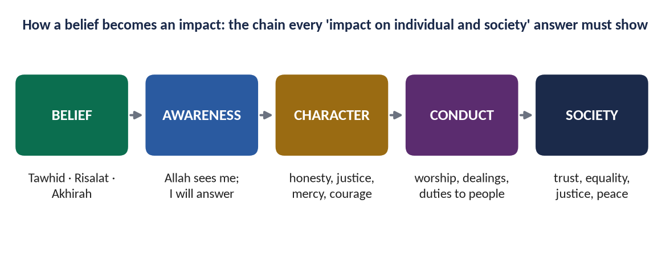
Figure 2 · How a belief becomes an impact. Every 'impact on individual and society' answer in this topic follows this chain.

0.3 The words of this topic
Term | Arabic | Meaning in this topic
Islam | إِسْلَام | Submission to Allah; also peace and safety (root s-l-m).
Muslim | مُسْلِم | One who submits to Allah.
Din | دِين | A complete way of life: sovereignty, obedience, law and recompense.
Madhhab | مَذْهَب | 'Religion' in the narrow sense; also a school of law.
Iman | إِيمَان | Faith: in the heart, on the tongue, in deeds.
Aqidah | عَقِيدَة | Creed; a belief firmly 'knotted' in the heart.
Ghayb | غَيْب | The unseen: what the senses cannot reach.
Wahi | وَحْي | Revelation: Allah's message to a Prophet.
Fitrah | فِطْرَة | The innate nature on which every human is created.
Tawhid | تَوْحِيد | The Oneness of Allah.
Rububiyyah | رُبُوبِيَّة | Allah's Lordship: creating, owning, sustaining.
Uluhiyyah | أُلُوهِيَّة | Allah's right to be worshipped alone.
Shirk | شِرْك | Associating partners with Allah.
Taghut | طَاغُوت | Any false object of worship or obedience against Allah.
Nabi / Rasul | نَبِيّ / رَسُول | Prophet (bringer of news) / Messenger (bringer of a law or book).
Ismah | عِصْمَة | The Prophets' protection from sin.
Mu'jizah | مُعْجِزَة | A miracle given to a Prophet as proof.
Khatam an-Nabiyyin | خَاتَمُ النَّبِيِّين | The Seal of the Prophets.
Akhirah | آخِرَة | The Hereafter.
Barzakh | بَرْزَخ | The barrier-life between death and resurrection.
Hisab / Mizan | حِسَاب / مِيزَان | The reckoning / the scales of deeds.
Malak (pl. Mala'ikah) | مَلَك / مَلَائِكَة | Angel(s).
Qadr | قَدَر | Divine decree and measure.
Tawakkul | تَوَكُّل | Trust in Allah after making every effort.

Chapter 1 · The Concept of Islam

1.1 Islam: the meaning of the word

(1) Literal meaning
The word Islam comes from the Arabic root s-l-m (س ل م). From this one root come three connected meanings:
- Submission and surrender — aslama: he surrendered himself.
- Peace — salam: the greeting of the Muslims and one of the names of Allah (As-Salam).
- Safety and soundness — salamah: to be safe and whole.
So Islam means peace that comes through submission to Allah: when a person surrenders his will to the will of his Creator, he finds peace within himself and gives peace to others.

(2) Technical meaning
In the terminology of the Shariah, Islam is to submit to Allah alone in belief, worship and the whole conduct of life, according to the guidance revealed to the Prophet Muhammad ﷺ. A person who does this is a Muslim — 'one who submits'.
✦ QURAN
﴿بَلَىٰۚ مَنۡ أَسۡلَمَ وَجۡهَهُۥ لِلَّهِ وَهُوَ مُحۡسِنٞ فَلَهُۥٓ أَجۡرُهُۥ عِندَ رَبِّهِۦ وَلَا خَوۡفٌ عَلَيۡهِمۡ وَلَا هُمۡ يَحۡزَنُونَ﴾
“Yes [on the contrary], whoever submits his face in Islam to Allah while being a doer of good will have his reward with his Lord. And no fear will there be concerning them, nor will they grieve.” (Al-Baqarah, Quran)
➜ Islam is submitting one's whole self ('face') to Allah while doing good — submission joined with right action.

✦ HADITH
الْمُسْلِمُ مَنْ سَلِمَ الْمُسْلِمُونَ مِنْ لِسَانِهِ وَيَدِهِ
“The Muslim is the one from whose tongue and hand the Muslims are safe.” (Al-Bukhari and Muslim)
➜ The Prophet ﷺ defined the Muslim by the word's own root: a Muslim is one from whom others are salim — safe.

1.2 Islam in the Quran: the Din of all the Prophets

(1) The only Din accepted by Allah
✦ QURAN
﴿إِنَّ ٱلدِّينَ عِندَ ٱللَّهِ ٱلۡإِسۡلَٰمُۗ وَمَا ٱخۡتَلَفَ ٱلَّذِينَ أُوتُواْ ٱلۡكِتَٰبَ إِلَّا مِنۢ بَعۡدِ مَا جَآءَهُمُ ٱلۡعِلۡمُ بَغۡيَۢا بَيۡنَهُمۡۗ وَمَن يَكۡفُرۡ بِـَٔايَٰتِ ٱللَّهِ فَإِنَّ ٱللَّهَ سَرِيعُ ٱلۡحِسَابِ﴾
“Indeed, the religion in the sight of Allah is Islam. And those who were given the Scripture did not differ except after knowledge had come to them - out of jealous animosity between themselves. And whoever disbelieves in the verses of Allah, then indeed, Allah is swift in [taking] account.” (Aal-e-Imran, Quran)
➜ Islam is the Din with Allah — not one religion among many, but the one way of life He has always approved.

✦ QURAN
﴿وَمَن يَبۡتَغِ غَيۡرَ ٱلۡإِسۡلَٰمِ دِينٗا فَلَن يُقۡبَلَ مِنۡهُ وَهُوَ فِي ٱلۡأٓخِرَةِ مِنَ ٱلۡخَٰسِرِينَ﴾
“And whoever desires other than Islam as religion - never will it be accepted from him, and he, in the Hereafter, will be among the losers.” (Aal-e-Imran, Quran)
➜ Whoever seeks a way of life other than Islam, it will not be accepted from him.

(2) Islam was the religion of every Prophet
Islam did not begin in the seventh century. It is the same message that every Prophet brought — from Adam to Muhammad ﷺ. The Quran calls Nuh, Ibrahim, Yaqub, Yusuf, Musa and the disciples of Isa (peace be upon them) Muslims.
✦ QURAN
﴿إِذۡ قَالَ لَهُۥ رَبُّهُۥٓ أَسۡلِمۡۖ قَالَ أَسۡلَمۡتُ لِرَبِّ ٱلۡعَٰلَمِينَ ۝ وَوَصَّىٰ بِهَآ إِبۡرَٰهِـۧمُ بَنِيهِ وَيَعۡقُوبُ يَٰبَنِيَّ إِنَّ ٱللَّهَ ٱصۡطَفَىٰ لَكُمُ ٱلدِّينَ فَلَا تَمُوتُنَّ إِلَّا وَأَنتُم مُّسۡلِمُونَ﴾
“When his Lord said to him, "Submit", he said "I have submitted [in Islam] to the Lord of the worlds. And Abraham instructed his sons [to do the same] and [so did] Jacob, [saying], "O my sons, indeed Allah has chosen for you this religion, so do not die except while you are Muslims.” (Al-Baqarah, Quran)
➜ Ibrahim (AS) submitted (aslamtu) to the Lord of the worlds and left the same instruction to his sons: 'die not except as Muslims'.

✦ QURAN
﴿… هُوَ سَمَّىٰكُمُ ٱلۡمُسۡلِمِينَ مِن قَبۡلُ وَفِي هَٰذَا …﴾
“It is He who named you 'Muslims' before and in this [Quran].” (Al-Hajj, Quran)
➜ It was Allah who named you 'Muslims' — before, and in this Quran.

✦ HADITH
الْأَنْبِيَاءُ إِخْوَةٌ لِعَلَّاتٍ، أُمَّهَاتُهُمْ شَتَّى وَدِينُهُمْ وَاحِدٌ
“The Prophets are brothers from one father; their mothers are different, but their Din is one.” (Al-Bukhari)
➜ One Din, many Shari'ahs: belief is the same in every age; the detailed laws differ with time and people.

✦ SCHOLARLY VIEW
Shah Waliullah Dehlawi · Hujjat Allah al-Baligha
Shah Waliullah explains that the Din of all the Prophets is one — Tawhid, worship, the Hereafter and good morals — while their Shari'ahs (detailed laws) differ according to the conditions of each people, just as a physician's medicine differs while the aim of health stays the same.
➜ The difference between Din (fixed) and Shariah (adapted) — useful in 'Din vs religion' and 'Islam is the Din of all Prophets'.

(3) The whole universe is 'Muslim'
In the widest sense, everything in the universe is 'muslim' — it submits to the laws of its Creator. The sun rises by His law, water flows by His law, the heart beats by His law. Man alone has been given a choice: to submit willingly in the moral sphere as the rest of creation submits by nature.
✦ QURAN
﴿أَفَغَيۡرَ دِينِ ٱللَّهِ يَبۡغُونَ وَلَهُۥٓ أَسۡلَمَ مَن فِي ٱلسَّمَٰوَٰتِ وَٱلۡأَرۡضِ طَوۡعٗا وَكَرۡهٗا وَإِلَيۡهِ يُرۡجَعُونَ﴾
“So is it other than the religion of Allah they desire, while to Him have submitted [all] those within the heavens and earth, willingly or by compulsion, and to Him they will be returned.” (Aal-e-Imran, Quran)
➜ Whatever is in the heavens and the earth has submitted to Allah, willingly or by compulsion — Islam is the law of the whole universe.

✦ SCHOLARLY VIEW
Abul A'la Mawdudi · Towards Understanding Islam (on the FPSC reading list)
Mawdudi explains that because every object in the universe obeys the law of its Creator, the universe itself is 'muslim'; man is 'muslim' in his body by nature, and becomes a Muslim in the full sense when he also submits his will and choices to Allah.
➜ A clear, simple way to explain the concept of Islam in an introduction.

1.3 The structure of Islam: Iman, Islam, Ihsan
The Prophet ﷺ taught the structure of the religion through the Hadith of Jibril. It has three levels, and together they are 'your Din':

(1) Iman — the level of belief
Belief in Allah, His Angels, His Books, His Messengers, the Last Day and Qadr. This is the root.

(2) Islam — the level of practice
The five pillars: Shahadah, Salah, Zakat, Sawm and Hajj. This is the trunk.
✦ HADITH
بُنِيَ الْإِسْلَامُ عَلَى خَمْسٍ: شَهَادَةِ أَنْ لَا إِلَهَ إِلَّا اللَّهُ وَأَنَّ مُحَمَّدًا رَسُولُ اللَّهِ، وَإِقَامِ الصَّلَاةِ، وَإِيتَاءِ الزَّكَاةِ، وَالْحَجِّ، وَصَوْمِ رَمَضَانَ
“Islam is built on five: testifying that there is no god but Allah and that Muhammad is the Messenger of Allah, establishing prayer, paying Zakat, Hajj, and fasting in Ramadan.” (Al-Bukhari and Muslim)
➜ The five pillars hold up the building; the building itself — Islam — is far larger than its pillars.

(3) Ihsan — the level of excellence
Worshipping Allah as though you see Him. This is the fruit: sincerity, purity of heart and noble character.
✦ HADITH
فَإِنَّهُ جِبْرِيلُ أَتَاكُمْ يُعَلِّمُكُمْ دِينَكُمْ
“That was Jibril; he came to teach you your Din.” (Muslim)
➜ After explaining Iman, Islam and Ihsan, the Prophet ﷺ called all three together 'your Din' — Islam is a complete structure, not a set of rituals.

1.4 Islam as a complete code of life

(1) The completion of the Din
✦ QURAN
﴿… ٱلۡيَوۡمَ أَكۡمَلۡتُ لَكُمۡ دِينَكُمۡ وَأَتۡمَمۡتُ عَلَيۡكُمۡ نِعۡمَتِي وَرَضِيتُ لَكُمُ ٱلۡإِسۡلَٰمَ دِينٗاۚ …﴾
“This day I have perfected for you your religion, completed My favour upon you, and approved for you Islam as your way of life.” (Al-Ma'idah, Quran)
➜ Revealed at the Farewell Hajj: the Din is complete — nothing essential is missing, and nothing may be added as religion.

(2) Enter Islam completely
✦ QURAN
﴿يَـٰٓأَيُّهَا ٱلَّذِينَ ءَامَنُواْ ٱدۡخُلُواْ فِي ٱلسِّلۡمِ كَآفَّةٗ وَلَا تَتَّبِعُواْ خُطُوَٰتِ ٱلشَّيۡطَٰنِۚ إِنَّهُۥ لَكُمۡ عَدُوّٞ مُّبِينٞ﴾
“O you who have believed, enter into Islam completely [and perfectly] and do not follow the footsteps of Satan. Indeed, he is to you a clear enemy.” (Al-Baqarah, Quran)
➜ 'Enter into Islam completely' — Islam cannot be accepted in the mosque and rejected in the market, the court or the parliament.

✦ QURAN
﴿قُلۡ إِنَّ صَلَاتِي وَنُسُكِي وَمَحۡيَايَ وَمَمَاتِي لِلَّهِ رَبِّ ٱلۡعَٰلَمِينَ ۝ لَا شَرِيكَ لَهُۥۖ وَبِذَٰلِكَ أُمِرۡتُ وَأَنَا۠ أَوَّلُ ٱلۡمُسۡلِمِينَ﴾
“Say, "Indeed, my prayer, my rites of sacrifice, my living and my dying are for Allah, Lord of the worlds. No partner has He. And this I have been commanded, and I am the first [among you] of the Muslims.” (Al-An'am, Quran)
➜ 'My prayer, my sacrifice, my living and my dying are for Allah' — the whole of life, not a part of it, is devoted to Him.

(3) What 'complete code of life' means in practice
Islam gives guidance for every department of life:
Sphere | What Islam gives
Belief | Tawhid, Risalat, Akhirah — the worldview
Worship | Salah, Zakat, Sawm, Hajj — the spiritual discipline
Morality | truth, justice, mercy, modesty, trust — the character
Family | marriage, rights of spouses, parents and children, inheritance
Economy | lawful earning, Zakat, prohibition of riba and hoarding
Politics | sovereignty of Allah, Shura, justice, accountability
Law | the Shariah and its sources: Quran, Sunnah, Ijma, Qiyas
International relations | treaties, peace, rules of war, rights of non-Muslims

✦ SCHOLARLY VIEW
Quaid-e-Azam Muhammad Ali Jinnah · Eid message, 1945
The Quaid told the Muslims of India that everyone except the ignorant knows the Quran is the general code of the Muslims — a religious, social, civil, commercial, military, judicial, criminal and penal code — regulating everything from the ceremonies of religion to the daily life, from the salvation of the soul to the health of the body.
➜ The founder of Pakistan himself described Islam as a complete code of life — a strong Pakistani authority in any T1 or T9 answer.

TRAP · 'ISLAM IS A COMPLETE CODE OF LIFE' IS NOT AN ARGUMENT
This sentence appears in almost every script. On its own it earns nothing. Prove it: give the two verses (Al-Ma'idah, Al-Baqarah), then show the table of spheres, then give one example from each sphere.

Chapter 2 · Din: Meaning and Importance in Human Life

2.1 The meaning of 'Din'

(1) Literal meanings
The Arabic word Din (دِين) has several connected meanings in the Arabic language: authority and power, obedience and submission, law, custom and way, and recompense and judgement.

(2) The four meanings of Din in the Quran
The Quran uses the word Din in all four meanings. Put together, they describe a complete system: an authority (Allah), the obedience of those under it (man), the law that governs them (the Shariah), and the recompense that follows (the Hereafter).
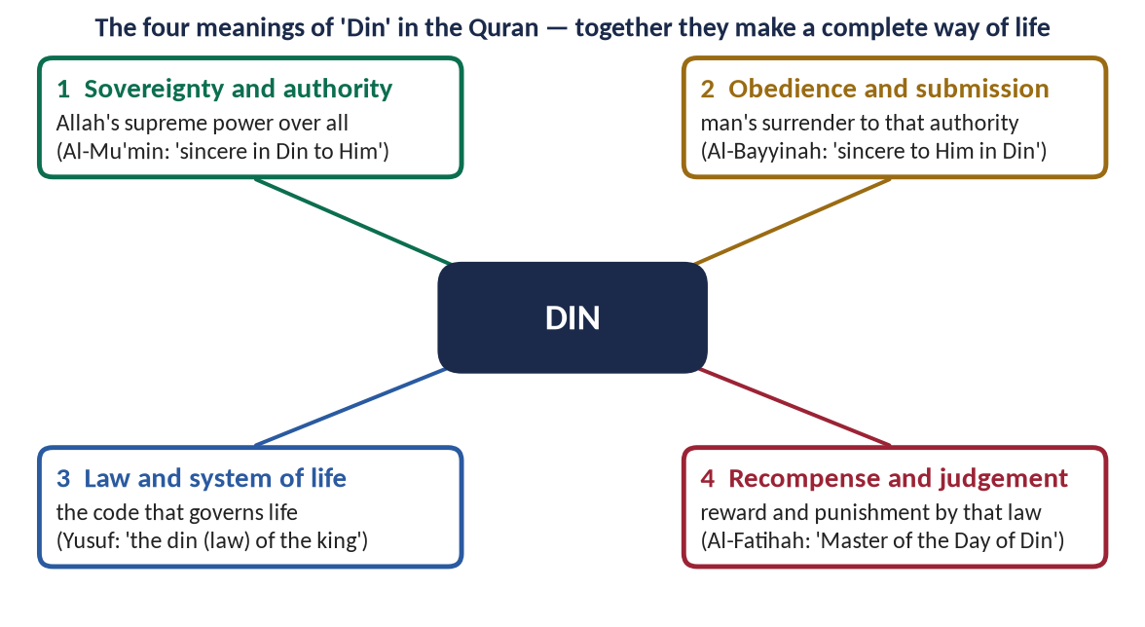
Figure 3 · The four meanings of 'Din' in the Quran.

(i) Din as sovereignty and authority
✦ QURAN
﴿هُوَ ٱلۡحَيُّ لَآ إِلَٰهَ إِلَّا هُوَ فَٱدۡعُوهُ مُخۡلِصِينَ لَهُ ٱلدِّينَۗ ٱلۡحَمۡدُ لِلَّهِ رَبِّ ٱلۡعَٰلَمِينَ﴾
“He is the Ever-Living; there is no deity except Him, so call upon Him, [being] sincere to Him in religion. [All] praise is [due] to Allah, Lord of the worlds.” (Ghafir, Quran)
➜ 'Call upon Him, sincere to Him in Din' — the Din belongs to Allah alone: supreme authority is His.

(ii) Din as obedience and submission
✦ QURAN
﴿وَمَآ أُمِرُوٓاْ إِلَّا لِيَعۡبُدُواْ ٱللَّهَ مُخۡلِصِينَ لَهُ ٱلدِّينَ حُنَفَآءَ وَيُقِيمُواْ ٱلصَّلَوٰةَ وَيُؤۡتُواْ ٱلزَّكَوٰةَۚ وَذَٰلِكَ دِينُ ٱلۡقَيِّمَةِ﴾
“And they were not commanded except to worship Allah, [being] sincere to Him in religion, inclining to truth, and to establish prayer and to give zakah. And that is the correct religion.” (Al-Bayyinah, Quran)
➜ They were commanded only to worship Allah, sincere to Him in Din — Din is the obedience given to that authority.

(iii) Din as law and system
✦ QURAN
﴿… فِي دِينِ ٱلۡمَلِكِ …﴾
“[He could not have taken his brother] within the law (din) of the king.” (Yusuf, Quran)
➜ In the story of Yusuf (AS), 'the din of the king' means the king's law — so the Din of Allah is Allah's law and system of life.

(iv) Din as recompense and judgement
✦ QURAN
﴿مَٰلِكِ يَوۡمِ ٱلدِّينِ﴾
“Sovereign of the Day of Recompense.” (Al-Fatihah, Quran)
➜ Allah is Master of the Day of Din — the Day of Recompense, when every deed is judged by His law.

(3) The technical meaning
Technically, Din is the complete system of life that Allah has revealed through His Prophets: belief in Him as the only sovereign, obedience to Him in every sphere, life according to His law, and accountability before Him on the Day of Judgement.
✦ SCHOLARLY VIEW
Khurshid Ahmad · Islam: Its Meaning and Message (on the FPSC reading list)
Khurshid Ahmad explains that Islam is not a 'religion' in the limited Western sense of a private relationship between man and God, but a Din — a complete way of life that covers the individual and the society, the spiritual and the material, this world and the next.
➜ The best-known Pakistani statement of the Din concept.

2.2 The importance of Din in human life
This is the second limb of the 2016 and 2022 questions. Organise it in three groups — the individual, the society, humanity — and give each point its evidence.

(1) Din answers the needs of human nature

(i) Din is the demand of the fitrah
Man is created with a natural sense of his Creator. Din does not impose something foreign on him; it completes what is already in him.
✦ QURAN
﴿فَأَقِمۡ وَجۡهَكَ لِلدِّينِ حَنِيفٗاۚ فِطۡرَتَ ٱللَّهِ ٱلَّتِي فَطَرَ ٱلنَّاسَ عَلَيۡهَاۚ لَا تَبۡدِيلَ لِخَلۡقِ ٱللَّهِۚ ذَٰلِكَ ٱلدِّينُ ٱلۡقَيِّمُ وَلَٰكِنَّ أَكۡثَرَ ٱلنَّاسِ لَا يَعۡلَمُونَ﴾
“So direct your face toward the religion, inclining to truth. [Adhere to] the fitrah of Allah upon which He has created [all] people. No change should there be in the creation of Allah. That is the correct religion, but most of the people do not know.” (Ar-Rum, Quran)
➜ Set your face to the Din, the fitrah of Allah upon which He created mankind — Din is the natural state of the human soul.

✦ HADITH
مَا مِنْ مَوْلُودٍ إِلَّا يُولَدُ عَلَى الْفِطْرَةِ، فَأَبَوَاهُ يُهَوِّدَانِهِ أَوْ يُنَصِّرَانِهِ أَوْ يُمَجِّسَانِهِ
“Every child is born upon the fitrah; then his parents make him a Jew, a Christian or a Magian.” (Al-Bukhari and Muslim)
➜ Belief in the Creator is natural; unbelief is learned.

(ii) Din gives purpose and meaning
Without Din, life has no final purpose; man becomes, in the words of many modern writers, 'a stranger in the universe'. Din tells him why he exists.
✦ QURAN
﴿وَمَا خَلَقۡتُ ٱلۡجِنَّ وَٱلۡإِنسَ إِلَّا لِيَعۡبُدُونِ﴾
“And I did not create the jinn and mankind except to worship Me.” (Adh-Dhariyat, Quran)
➜ The purpose of life is ibadah — to know and obey Allah in the whole of life.

✦ QURAN
﴿ٱلَّذِي خَلَقَ ٱلۡمَوۡتَ وَٱلۡحَيَوٰةَ لِيَبۡلُوَكُمۡ أَيُّكُمۡ أَحۡسَنُ عَمَلٗاۚ وَهُوَ ٱلۡعَزِيزُ ٱلۡغَفُورُ﴾
“[He] who created death and life to test you [as to] which of you is best in deed - and He is the Exalted in Might, the Forgiving.” (Al-Mulk, Quran)
➜ Life and death were created to test which of you is best in deeds — life is a test with meaning, not an accident.

(iii) Din gives peace of heart
✦ QURAN
﴿ٱلَّذِينَ ءَامَنُواْ وَتَطۡمَئِنُّ قُلُوبُهُم بِذِكۡرِ ٱللَّهِۗ أَلَا بِذِكۡرِ ٱللَّهِ تَطۡمَئِنُّ ٱلۡقُلُوبُ﴾
“Those who have believed and whose hearts are assured by the remembrance of Allah. Unquestionably, by the remembrance of Allah hearts are assured.” (Ar-Ra'd, Quran)
➜ In the remembrance of Allah do hearts find rest — the answer to the anxiety of modern man.

✦ QURAN
﴿وَمَنۡ أَعۡرَضَ عَن ذِكۡرِي فَإِنَّ لَهُۥ مَعِيشَةٗ ضَنكٗا وَنَحۡشُرُهُۥ يَوۡمَ ٱلۡقِيَٰمَةِ أَعۡمَىٰ﴾
“And whoever turns away from My remembrance - indeed, he will have a depressed life, and We will gather him on the Day of Resurrection blind.” (Taha, Quran)
➜ Whoever turns away from Allah's reminder will have a life of hardship (ma'ishatan dhanka) — the empty life of material plenty and inner poverty.

(2) Din builds the individual

(i) Moral guidance and character
Reason can say what is useful; only Din can say, with authority, what is right. Din gives fixed moral values that do not change with fashion or majority vote.
✦ HADITH
إِنَّمَا بُعِثْتُ لِأُتَمِّمَ مَكَارِمَ الْأَخْلَاقِ
“I was sent only to perfect noble character.” (Al-Bayhaqi)
➜ The mission of the Prophet ﷺ is summed up as character — Din exists to make good human beings.

(ii) Self-control and accountability
Belief that Allah sees and that every deed will be judged gives an inner policeman that no law can provide.

(iii) A good life in this world
✦ QURAN
﴿مَنۡ عَمِلَ صَٰلِحٗا مِّن ذَكَرٍ أَوۡ أُنثَىٰ وَهُوَ مُؤۡمِنٞ فَلَنُحۡيِيَنَّهُۥ حَيَوٰةٗ طَيِّبَةٗۖ وَلَنَجۡزِيَنَّهُمۡ أَجۡرَهُم بِأَحۡسَنِ مَا كَانُواْ يَعۡمَلُونَ﴾
“Whoever does righteousness, whether male or female, while he is a believer - We will surely cause him to live a good life, and We will surely give them their reward [in the Hereafter] according to the best of what they used to do.” (An-Nahl, Quran)
➜ Whoever does good, man or woman, while a believer — We will give them a good life (hayatan tayyibah) and their reward.

(3) Din builds society

(i) A just social order
✦ QURAN
﴿لَقَدۡ أَرۡسَلۡنَا رُسُلَنَا بِٱلۡبَيِّنَٰتِ وَأَنزَلۡنَا مَعَهُمُ ٱلۡكِتَٰبَ وَٱلۡمِيزَانَ لِيَقُومَ ٱلنَّاسُ بِٱلۡقِسۡطِۖ وَأَنزَلۡنَا ٱلۡحَدِيدَ فِيهِ بَأۡسٞ شَدِيدٞ وَمَنَٰفِعُ لِلنَّاسِ وَلِيَعۡلَمَ ٱللَّهُ مَن يَنصُرُهُۥ وَرُسُلَهُۥ بِٱلۡغَيۡبِۚ إِنَّ ٱللَّهَ قَوِيٌّ عَزِيزٞ﴾
“We have already sent Our messengers with clear evidences and sent down with them the Scripture and the balance that the people may maintain [their affairs] in justice. And We sent down iron, wherein is great military might and benefits for the people, and so that Allah may make evident those who support Him and His messengers unseen. Indeed, Allah is Powerful and Exalted in Might.” (Al-Hadid, Quran)
➜ Allah sent His Messengers with the Book and the Balance so that people may uphold justice — Din is the foundation of a just society.

(ii) Unity and brotherhood
Din joins people of every race and language into one brotherhood, above tribe and nation.
✦ QURAN
﴿وَٱعۡتَصِمُواْ بِحَبۡلِ ٱللَّهِ جَمِيعٗا وَلَا تَفَرَّقُواْۚ وَٱذۡكُرُواْ نِعۡمَتَ ٱللَّهِ عَلَيۡكُمۡ إِذۡ كُنتُمۡ أَعۡدَآءٗ فَأَلَّفَ بَيۡنَ قُلُوبِكُمۡ فَأَصۡبَحۡتُم بِنِعۡمَتِهِۦٓ إِخۡوَٰنٗا …﴾
“And hold firmly to the rope of Allah all together and do not become divided. Remember Allah's favour upon you: you were enemies, and He brought your hearts together, and by His favour you became brothers.” (Aal-e-Imran, Quran)
➜ 'Hold fast, all together, to the rope of Allah' — Din turned the warring tribes of Arabia into brothers.

(iii) Rights and duties
Din fixes the rights of Allah and the rights of people — parents, spouses, children, neighbours, workers, the poor, even animals — and makes their fulfilment an act of worship.

(iv) Law and order
Law obeyed out of faith is obeyed even when no policeman is present. This is why the society of Madinah needed so few punishments.

(4) Din serves humanity

(i) Answers to the problems of modern man
Materialism, the breakdown of the family, loneliness, depression, inequality and moral confusion are the fruits of a life without Din.

(ii) The balance of the spiritual and the material
Din refuses both extremes: the monk who abandons the world and the materialist who abandons the soul.
✦ QURAN
﴿وَٱبۡتَغِ فِيمَآ ءَاتَىٰكَ ٱللَّهُ ٱلدَّارَ ٱلۡأٓخِرَةَۖ وَلَا تَنسَ نَصِيبَكَ مِنَ ٱلدُّنۡيَاۖ وَأَحۡسِن كَمَآ أَحۡسَنَ ٱللَّهُ إِلَيۡكَۖ وَلَا تَبۡغِ ٱلۡفَسَادَ فِي ٱلۡأَرۡضِۖ إِنَّ ٱللَّهَ لَا يُحِبُّ ٱلۡمُفۡسِدِينَ﴾
“But seek, through that which Allah has given you, the home of the Hereafter; and [yet], do not forget your share of the world. And do good as Allah has done good to you. And desire not corruption in the land. Indeed, Allah does not like corrupters.” (Al-Qasas, Quran)
➜ Seek the Hereafter with what Allah has given you, but do not forget your share of this world — the balance of Din.

✦ SCHOLARLY VIEW
Allama Muhammad Iqbal · The Reconstruction of Religious Thought in Islam
Iqbal argues that humanity today needs three things: a spiritual interpretation of the universe, the spiritual emancipation of the individual, and basic principles of universal import to direct the evolution of human society on a spiritual basis — and that only religion can supply them.
➜ The strongest modern statement of the importance of Din for humanity — ideal for a conclusion.

METHOD · 'IMPORTANCE OF DIN' IN THREE LEVELS
Always organise 'importance' in levels: (1) the individual → (2) the society → (3) humanity/the modern world. Under each, give 3–5 headed points, each with one verse or hadith. Finish with the Pakistani angle: Article 2 (Islam the State religion) and the Objectives Resolution.

Chapter 3 · Din and Religion: The Difference

3.1 What 'religion' means

(1) The word
The English word religion probably comes from the Latin religare, 'to bind', or relegere, 'to go over again'. In modern Western usage — especially after the European Enlightenment — religion has come to mean a set of beliefs and rituals concerning God or the sacred, practised privately by the individual, separate from politics, economics and law.

(2) How the idea was formed
The Western idea of religion was shaped by European history: the long conflict between the Church and the state, the wars of religion, and the rise of secularism, which placed religion in the private sphere. The Arabic word that comes closest to this narrow sense is madhhab — a belief or school — not Din.

3.2 Din vs religion — the differences
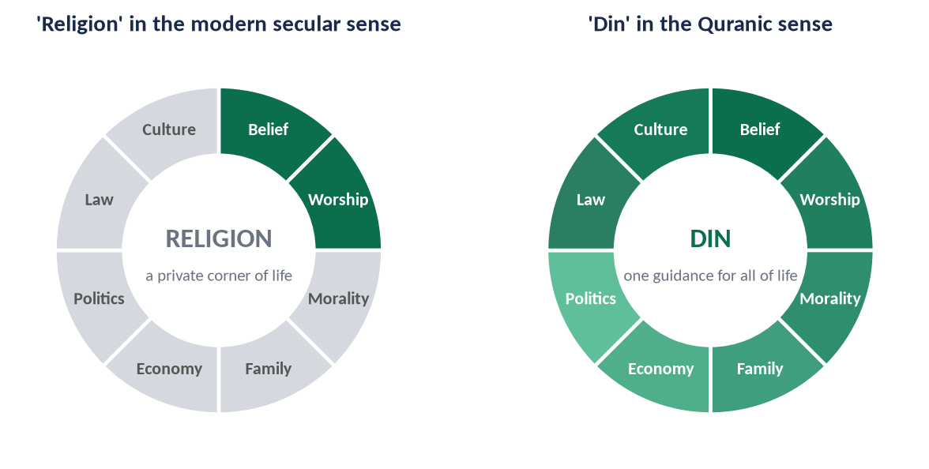
Figure 4 · 'Religion' as one corner of life, and 'Din' as guidance for the whole of life.
Point | Din (the Quranic concept) | Religion (the modern secular concept)
Scope | The whole of life: belief, worship, morals, family, economy, politics, law | Belief and worship only; a private matter
Source | Revelation from Allah | Often human tradition, custom or philosophy
Sovereignty | Allah is sovereign; man is His vicegerent (khalifah) | The people or the state are sovereign; God is kept out of public life
Relation with the state | Guides the state and law | Separate from the state (secularism)
Nature | A system (nizam) and a way of life | A set of rituals and personal devotions
Law | Includes a law (Shariah) | Has no public law of its own
Individual and society | Both | The individual only
This world and the Hereafter | Both, balanced | Mainly the other world, or only moral comfort in this one
Change | Fixed principles; flexible application (Ijtihad) | Either rigid or wholly changeable

3.3 Arguing the difference — the evidence

(1) Islam claims all of life
✦ QURAN
﴿يَـٰٓأَيُّهَا ٱلَّذِينَ ءَامَنُواْ ٱدۡخُلُواْ فِي ٱلسِّلۡمِ كَآفَّةٗ وَلَا تَتَّبِعُواْ خُطُوَٰتِ ٱلشَّيۡطَٰنِۚ إِنَّهُۥ لَكُمۡ عَدُوّٞ مُّبِينٞ﴾
“O you who have believed, enter into Islam completely [and perfectly] and do not follow the footsteps of Satan. Indeed, he is to you a clear enemy.” (Al-Baqarah, Quran)
➜ 'Enter Islam completely' — a religion can be partial; a Din cannot.

(2) Islam claims to prevail as a system
✦ QURAN
﴿هُوَ ٱلَّذِيٓ أَرۡسَلَ رَسُولَهُۥ بِٱلۡهُدَىٰ وَدِينِ ٱلۡحَقِّ لِيُظۡهِرَهُۥ عَلَى ٱلدِّينِ كُلِّهِۦ وَلَوۡ كَرِهَ ٱلۡمُشۡرِكُونَ﴾
“It is He who has sent His Messenger with guidance and the religion of truth to manifest it over all religion, although they who associate others with Allah dislike it.” (At-Tawbah, Quran)
➜ Allah sent His Messenger with guidance and the Din of truth to make it prevail over all 'din' — Din here means a whole system of life, which can prevail over other systems.

(3) The Din of Allah has a law, a state and a society
✦ QURAN
﴿شَرَعَ لَكُم مِّنَ ٱلدِّينِ مَا وَصَّىٰ بِهِۦ نُوحٗا وَٱلَّذِيٓ أَوۡحَيۡنَآ إِلَيۡكَ وَمَا وَصَّيۡنَا بِهِۦٓ إِبۡرَٰهِيمَ وَمُوسَىٰ وَعِيسَىٰٓۖ أَنۡ أَقِيمُواْ ٱلدِّينَ وَلَا تَتَفَرَّقُواْ فِيهِۚ …﴾
“He has ordained for you of the Din what He enjoined upon Nuh, what We have revealed to you, and what We enjoined upon Ibrahim, Musa and Isa: 'Establish the Din and do not be divided in it.'” (Ash-Shura, Quran)
➜ Allah has ordained for you of the Din what He enjoined on Nuh, Ibrahim, Musa and Isa: 'establish the Din and do not be divided in it'. The command is to establish (iqamah) the Din — something done in society, not only in the heart.

(4) The practice of the Prophet ﷺ
The Prophet ﷺ was a Prophet and a head of state, a judge, a commander and a legislator. He did not separate 'religion' from 'politics'; he built a mosque and a state in the same city in the same year.
✦ SCHOLARLY VIEW
Dr Muhammad Hamidullah · Introduction to Islam (on the FPSC reading list)
Dr Hamidullah points out that Islam does not divide life into the spiritual and the temporal: the Prophet ﷺ gave equal attention to prayer and to government, and the Quran regulates both the relation of man with God and the relations of men with one another.
➜ The Prophet's life is the living proof of 'Din, not religion'.

3.4 Where Din and religion meet
Be fair to the other view: Din includes everything that 'religion' means — faith, prayer, spirituality and love of God. The difference is not that Din rejects religion, but that Din does not stop where religion stops.
HOT DEBATE · 'RELIGION IS A PRIVATE MATTER'
The secular narrative says religion should stay in the home and the mosque. The Islamic answer: (1) Allah's authority cannot be limited to one part of His creation; (2) morality without law is weak, and law without morality is tyranny — Din joins both; (3) Islam guarantees freedom of belief to non-Muslims (Al-Baqarah: 'no compulsion in religion'), so a Din-based state is not a theocracy of force; (4) Pakistan's Constitution itself declares sovereignty to belong to Allah (Objectives Resolution; Article 2A). Never attack secular people; answer the idea.

PAKISTAN ANGLE
Article 2: Islam shall be the State religion of Pakistan. Article 2A (Objectives Resolution): sovereignty over the entire universe belongs to Allah Almighty alone, and the authority exercised by the people is a sacred trust within the limits prescribed by Him. Pakistan was thus founded on the concept of Din, not of religion as a private matter.

Chapter 4 · The Distinctive Aspects of Islam
This syllabus line has never been asked directly (2015–2026). It is a likely question — and its points strengthen every other answer in the paper. Learn these twelve features, each with its evidence.

4.1 Pure monotheism (Tawhid)
Islam's concept of God is pure and uncompromising: one God, without partner, son, incarnation or intermediary. No human being is divine; no priesthood stands between man and Allah.
✦ QURAN
﴿قُلۡ هُوَ ٱللَّهُ أَحَدٌ ۝ ٱللَّهُ ٱلصَّمَدُ ۝ لَمۡ يَلِدۡ وَلَمۡ يُولَدۡ ۝ وَلَمۡ يَكُن لَّهُۥ كُفُوًا أَحَدُۢ﴾
“Say, "He is Allah, [who is] One. Allah, the Eternal Refuge. He neither begets nor is born. Nor is there to Him any equivalent.” (Al-Ikhlas, Quran)
➜ The four verses that separate Islam from every form of shirk.

4.2 Universality
Islam is not the religion of one race, tribe or land. Its Prophet ﷺ was sent to all mankind, and its message addresses 'O mankind' as often as 'O believers'.
✦ QURAN
﴿وَمَآ أَرۡسَلۡنَٰكَ إِلَّا كَآفَّةٗ لِّلنَّاسِ بَشِيرٗا وَنَذِيرٗا وَلَٰكِنَّ أَكۡثَرَ ٱلنَّاسِ لَا يَعۡلَمُونَ﴾
“And We have not sent you except comprehensively to mankind as a bringer of good tidings and a warner. But most of the people do not know.” (Saba, Quran)
➜ 'We have not sent you except to all mankind' — Islam is universal.

✦ QURAN
﴿وَمَآ أَرۡسَلۡنَٰكَ إِلَّا رَحۡمَةٗ لِّلۡعَٰلَمِينَ﴾
“And We have not sent you, [O Muhammad], except as a mercy to the worlds.” (Al-Anbiya, Quran)
➜ A mercy to all the worlds — not to Arabs or Muslims only.

4.3 Completeness and comprehensiveness
Islam covers every sphere of life (Chapter 1.4). Nothing in human life is outside its guidance.
✦ QURAN
﴿وَيَوۡمَ نَبۡعَثُ فِي كُلِّ أُمَّةٖ شَهِيدًا عَلَيۡهِم مِّنۡ أَنفُسِهِمۡۖ وَجِئۡنَا بِكَ شَهِيدًا عَلَىٰ هَـٰٓؤُلَآءِۚ وَنَزَّلۡنَا عَلَيۡكَ ٱلۡكِتَٰبَ تِبۡيَٰنٗا لِّكُلِّ شَيۡءٖ وَهُدٗى وَرَحۡمَةٗ وَبُشۡرَىٰ لِلۡمُسۡلِمِينَ﴾
“And [mention] the Day when We will resurrect among every nation a witness over them from themselves. And We will bring you, [O Muhammad], as a witness over your nation. And We have sent down to you the Book as clarification for all things and as guidance and mercy and good tidings for the Muslims.” (An-Nahl, Quran)
➜ The Book was revealed as a clarification of all things and as guidance, mercy and good news.

4.4 Preservation of the sources
The Quran is preserved word for word, as it was revealed; the Sunnah was preserved by a science of verification (the isnad) found in no other tradition.
✦ QURAN
﴿إِنَّا نَحۡنُ نَزَّلۡنَا ٱلذِّكۡرَ وَإِنَّا لَهُۥ لَحَٰفِظُونَ﴾
“Indeed, it is We who sent down the Qur'an and indeed, We will be its guardian.” (Al-Hijr, Quran)
➜ 'We have sent down the Reminder, and We will surely guard it' — the only scripture preserved in its original language and text.

4.5 Balance and moderation (Wasatiyyah)
Islam is the middle way between extremes: between monasticism and materialism, individualism and collectivism, harshness and laxity.
✦ QURAN
﴿وَكَذَٰلِكَ جَعَلۡنَٰكُمۡ أُمَّةٗ وَسَطٗا لِّتَكُونُواْ شُهَدَآءَ عَلَى ٱلنَّاسِ وَيَكُونَ ٱلرَّسُولُ عَلَيۡكُمۡ شَهِيدٗاۗ …﴾
“And thus We have made you a middle (just) nation, that you may be witnesses over mankind and the Messenger a witness over you.” (Al-Baqarah, Quran)
➜ The Muslims are a middle nation (ummatan wasata) — moderation is their identity.

✦ HADITH
إِنَّ الدِّينَ يُسْرٌ، وَلَنْ يُشَادَّ الدِّينَ أَحَدٌ إِلَّا غَلَبَهُ، فَسَدِّدُوا وَقَارِبُوا وَأَبْشِرُوا
“The Din is easy, and no one makes the Din hard for himself except that it overpowers him; so be moderate, come near perfection, and rejoice.” (Al-Bukhari)
➜ Moderation is a command, not a concession — the answer to extremism (T7).

4.6 Ease and practicality
Islam does not burden people beyond their capacity. It allows exceptions for the traveller, the sick, the old and the needy.
✦ QURAN
﴿… يُرِيدُ ٱللَّهُ بِكُمُ ٱلۡيُسۡرَ وَلَا يُرِيدُ بِكُمُ ٱلۡعُسۡرَ …﴾
“Allah intends for you ease and does not intend for you hardship.” (Al-Baqarah, Quran)
➜ Allah intends ease for you and does not intend hardship.

✦ QURAN
﴿لَا يُكَلِّفُ ٱللَّهُ نَفۡسًا إِلَّا وُسۡعَهَاۚ …﴾
“Allah does not burden a soul beyond its capacity.” (Al-Baqarah, Quran)
➜ Allah does not burden a soul beyond its capacity.

4.7 Harmony of reason and revelation
Islam invites man to think, observe and reason. The Quran repeatedly asks: 'Do you not think? Do you not reflect?'
✦ QURAN
﴿إِنَّ فِي خَلۡقِ ٱلسَّمَٰوَٰتِ وَٱلۡأَرۡضِ وَٱخۡتِلَٰفِ ٱلَّيۡلِ وَٱلنَّهَارِ لَأٓيَٰتٖ لِّأُوْلِي ٱلۡأَلۡبَٰبِ ۝ ٱلَّذِينَ يَذۡكُرُونَ ٱللَّهَ قِيَٰمٗا وَقُعُودٗا وَعَلَىٰ جُنُوبِهِمۡ وَيَتَفَكَّرُونَ فِي خَلۡقِ ٱلسَّمَٰوَٰتِ وَٱلۡأَرۡضِ رَبَّنَا مَا خَلَقۡتَ هَٰذَا بَٰطِلٗا سُبۡحَٰنَكَ فَقِنَا عَذَابَ ٱلنَّارِ﴾
“Indeed, in the creation of the heavens and the earth and the alternation of the night and the day are signs for those of understanding. Who remember Allah while standing or sitting or [lying] on their sides and give thought to the creation of the heavens and the earth, [saying], "Our Lord, You did not create this aimlessly; exalted are You [above such a thing]; then protect us from the punishment of the Fire.” (Aal-e-Imran, Quran)
➜ The creation of the heavens and the earth are signs for people of understanding, who remember Allah and reflect on creation.

4.8 Harmony of this world and the Hereafter
Islam makes worldly life a means to the Hereafter, not its enemy: earning, marriage and good work are worship when done for Allah.
✦ QURAN
﴿وَمِنۡهُم مَّن يَقُولُ رَبَّنَآ ءَاتِنَا فِي ٱلدُّنۡيَا حَسَنَةٗ وَفِي ٱلۡأٓخِرَةِ حَسَنَةٗ وَقِنَا عَذَابَ ٱلنَّارِ﴾
“But among them is he who says, "Our Lord, give us in this world [that which is] good and in the Hereafter [that which is] good and protect us from the punishment of the Fire.” (Al-Baqarah, Quran)
➜ 'Our Lord, give us good in this world and good in the Hereafter' — the balanced prayer of a Muslim.

4.9 Human dignity and equality
All human beings are honoured and equal; superiority lies only in piety.
✦ QURAN
﴿يَـٰٓأَيُّهَا ٱلنَّاسُ إِنَّا خَلَقۡنَٰكُم مِّن ذَكَرٖ وَأُنثَىٰ وَجَعَلۡنَٰكُمۡ شُعُوبٗا وَقَبَآئِلَ لِتَعَارَفُوٓاْۚ إِنَّ أَكۡرَمَكُمۡ عِندَ ٱللَّهِ أَتۡقَىٰكُمۡۚ إِنَّ ٱللَّهَ عَلِيمٌ خَبِيرٞ﴾
“O mankind, indeed We have created you from male and female and made you peoples and tribes that you may know one another. Indeed, the most noble of you in the sight of Allah is the most righteous of you. Indeed, Allah is Knowing and Acquainted.” (Al-Hujurat, Quran)
➜ No superiority of race or tribe — only taqwa.

4.10 Freedom of belief and tolerance
✦ QURAN
﴿لَآ إِكۡرَاهَ فِي ٱلدِّينِۖ قَد تَّبَيَّنَ ٱلرُّشۡدُ مِنَ ٱلۡغَيِّۚ فَمَن يَكۡفُرۡ بِٱلطَّـٰغُوتِ وَيُؤۡمِنۢ بِٱللَّهِ فَقَدِ ٱسۡتَمۡسَكَ بِٱلۡعُرۡوَةِ ٱلۡوُثۡقَىٰ لَا ٱنفِصَامَ لَهَاۗ وَٱللَّهُ سَمِيعٌ عَلِيمٌ﴾
“There shall be no compulsion in [acceptance of] the religion. The right course has become clear from the wrong. So whoever disbelieves in Taghut and believes in Allah has grasped the most trustworthy handhold with no break in it. And Allah is Hearing and Knowing.” (Al-Baqarah, Quran)
➜ No compulsion in religion — faith cannot be forced.

✦ QURAN
﴿لَكُمۡ دِينُكُمۡ وَلِيَ دِينِ﴾
“For you is your religion, and for me is my religion.” (Al-Kafirun, Quran)
➜ 'For you your religion, and for me mine' — co-existence with those who differ.

4.11 Direct relationship between man and God
There is no priesthood, no confession to a priest, no intermediary. Every person can turn to Allah directly, at any time.
✦ QURAN
﴿وَإِذَا سَأَلَكَ عِبَادِي عَنِّي فَإِنِّي قَرِيبٌۖ أُجِيبُ دَعۡوَةَ ٱلدَّاعِ إِذَا دَعَانِۖ فَلۡيَسۡتَجِيبُواْ لِي وَلۡيُؤۡمِنُواْ بِي لَعَلَّهُمۡ يَرۡشُدُونَ﴾
“And when My servants ask you, [O Muhammad], concerning Me - indeed I am near. I respond to the invocation of the supplicant when he calls upon Me. So let them respond to Me [by obedience] and believe in Me that they may be [rightly] guided.” (Al-Baqarah, Quran)
➜ 'I am near; I respond to the call of the caller' — Allah is directly reachable by every human being.

4.12 Finality and permanence
Islam is the last Din, completed with the last Prophet ﷺ; its principles are permanent, while Ijtihad applies them to changing times.
✦ QURAN
﴿مَّا كَانَ مُحَمَّدٌ أَبَآ أَحَدٖ مِّن رِّجَالِكُمۡ وَلَٰكِن رَّسُولَ ٱللَّهِ وَخَاتَمَ ٱلنَّبِيِّـۧنَۗ وَكَانَ ٱللَّهُ بِكُلِّ شَيۡءٍ عَلِيمٗا﴾
“Muhammad is not the father of [any] one of your men, but [he is] the Messenger of Allah and last of the prophets. And ever is Allah, of all things, Knowing.” (Al-Ahzab, Quran)
➜ The Prophet ﷺ is the Seal of the Prophets; no new revelation will change the Din.

REMEMBER · THE TWELVE DISTINCTIVE ASPECTS (mnemonic: "PURE BALANCE")
Pure Tawhid · Universality · Reason and revelation · Ease · Balance (wasatiyyah) · Authentic preserved sources · Life as a whole (completeness) · Access to God without priests · Nobility and equality of man · Co-existence and freedom of belief · End of prophethood (finality) — plus the harmony of this world and the next.

Chapter 5 · Wahi: Revelation and Its Supremacy over Other Sources of Knowledge

5.1 The meaning of Wahi

(1) Literal meaning
In Arabic, wahi (وَحْي) means a quick, hidden communication — a message conveyed swiftly and secretly, by a sign, a gesture or an inspiration. The Quran uses the word even for the instinct Allah placed in the bee (An-Nahl) and the inspiration given to the mother of Musa (AS) (Al-Qasas).

(2) Technical meaning
Technically, Wahi is the message of Allah conveyed to His chosen Prophets — through an angel, by direct inspiration, or from behind a veil — to guide mankind. It is knowledge that comes not from the senses or reason of man, but from the Creator Himself.
✦ QURAN
﴿وَمَا يَنطِقُ عَنِ ٱلۡهَوَىٰٓ ۝ إِنۡ هُوَ إِلَّا وَحۡيٞ يُوحَىٰ﴾
“Nor does he speak from [his own] inclination. It is not but a revelation revealed.” (An-Najm, Quran)
➜ The Prophet ﷺ does not speak from his own desire; it is only a revelation revealed — Wahi is the source of both the Quran and the Sunnah.

5.2 The kinds and modes of Wahi

(1) The two kinds

(i) Wahi Matluww — the recited revelation
The Quran: its words and meanings are from Allah; it is recited in prayer and preserved letter for letter.

(ii) Wahi Ghayr Matluww — the unrecited revelation
The Sunnah: its meaning is from Allah, its words from the Prophet ﷺ. This is why the Sunnah is binding (see T9).

(2) The three modes
✦ QURAN
﴿وَمَا كَانَ لِبَشَرٍ أَن يُكَلِّمَهُ ٱللَّهُ إِلَّا وَحۡيًا أَوۡ مِن وَرَآيِٕ حِجَابٍ أَوۡ يُرۡسِلَ رَسُولٗا فَيُوحِيَ بِإِذۡنِهِۦ مَا يَشَآءُۚ إِنَّهُۥ عَلِيٌّ حَكِيمٞ﴾
“And it is not for any human being that Allah should speak to him except by revelation or from behind a partition or that He sends a messenger to reveal, by His permission, what He wills. Indeed, He is Most High and Wise.” (Ash-Shura, Quran)
➜ Allah speaks to man only by inspiration, or from behind a veil, or by sending a messenger (an angel) — the three modes of revelation.

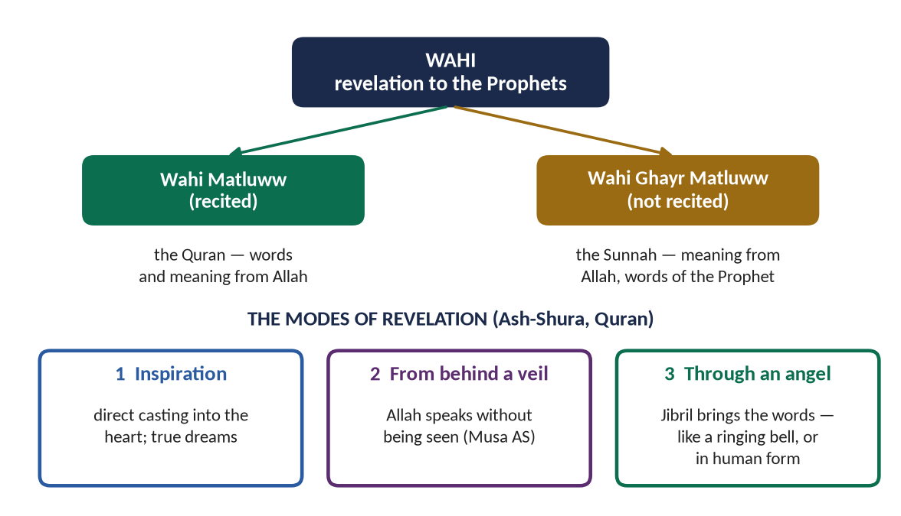
Figure 5 · The kinds and modes of Wahi.

(3) How revelation came to the Prophet ﷺ
✦ HADITH
أَحْيَانًا يَأْتِينِي مِثْلَ صَلْصَلَةِ الْجَرَسِ، وَهُوَ أَشَدُّهُ عَلَيَّ، فَيُفْصَمُ عَنِّي وَقَدْ وَعَيْتُ عَنْهُ مَا قَالَ، وَأَحْيَانًا يَتَمَثَّلُ لِيَ الْمَلَكُ رَجُلًا فَيُكَلِّمُنِي فَأَعِي مَا يَقُولُ
“Sometimes it comes to me like the ringing of a bell, and that is the hardest on me; then it leaves me and I have grasped what was said. And sometimes the angel appears to me as a man and speaks to me, and I grasp what he says.” (Al-Bukhari)
➜ Revelation was objective and external — not the Prophet's own thought — and it was received with full awareness.

(4) The first revelation
In 610 CE, in the Cave of Hira, Jibril (AS) brought the first verses. It is significant that the very first word of revelation was 'Read!' — Wahi begins by honouring knowledge.
✦ QURAN
﴿ٱقۡرَأۡ بِٱسۡمِ رَبِّكَ ٱلَّذِي خَلَقَ ۝ خَلَقَ ٱلۡإِنسَٰنَ مِنۡ عَلَقٍ ۝ ٱقۡرَأۡ وَرَبُّكَ ٱلۡأَكۡرَمُ ۝ ٱلَّذِي عَلَّمَ بِٱلۡقَلَمِ ۝ عَلَّمَ ٱلۡإِنسَٰنَ مَا لَمۡ يَعۡلَمۡ﴾
“Recite in the name of your Lord who created. Created man from a clinging substance. Recite, and your Lord is the most Generous. Who taught by the pen. Taught man that which he knew not.” (Al-Alaq, Quran)
➜ 'Read in the name of your Lord who created … who taught by the pen, taught man what he did not know' — revelation and learning begin together.

5.3 The sources of human knowledge — and their limits
Man has four ways of knowing. Islam accepts all four as gifts of Allah — the Quran says that hearing, sight and the heart will all be questioned (Al-Isra) — but it shows that only one of them is certain and complete.
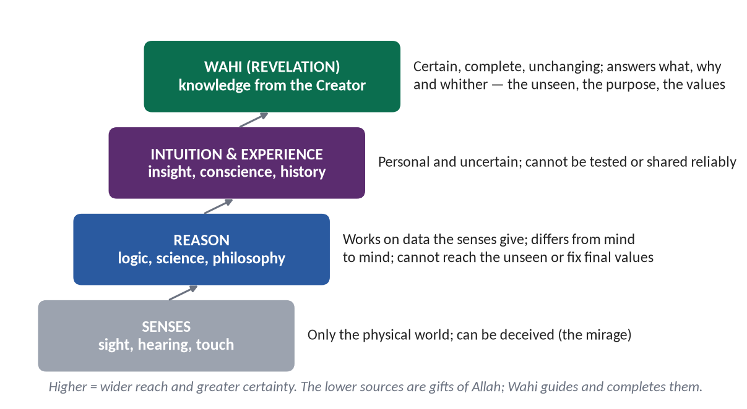
Figure 6 · The sources of human knowledge and their limits.

(1) The senses

(i) Their value
All science begins with observation. The Quran constantly directs man to look at the sky, the earth, the camel and the rain.

(ii) Their limits
The senses reach only the physical world, and they can be deceived — the mirage looks like water; the stick looks broken in water. They cannot tell us anything about the unseen, about purpose, or about right and wrong.

(2) Reason

(i) Its value
Reason is the faculty that makes man responsible. The Quran asks again and again, 'Do you not reason? Do you not reflect?'

(ii) Its limits
- Reason works only on the data the senses give it.
- Reason differs from person to person and age to age — what one philosopher proves, the next disproves.
- Reason is often led by desire and interest; it can justify almost anything.
- Reason cannot reach the unseen — the nature of God, the soul, the life after death.
- Reason cannot, by itself, fix final values: why justice is good, why the weak must be protected.
✦ QURAN
﴿وَيَسۡـَٔلُونَكَ عَنِ ٱلرُّوحِۖ قُلِ ٱلرُّوحُ مِنۡ أَمۡرِ رَبِّي وَمَآ أُوتِيتُم مِّنَ ٱلۡعِلۡمِ إِلَّا قَلِيلٗا﴾
“And they ask you, [O Muhammad], about the soul. Say, "The soul is of the affair of my Lord. And mankind have not been given of knowledge except a little.” (Al-Isra, Quran)
➜ 'You have been given of knowledge only a little' — human knowledge, however great, is limited.

(3) Intuition and experience
Intuition, conscience and the lessons of history are real, but they are personal and uncertain; one person's intuition cannot be tested or imposed on another.

(4) Wahi
Wahi comes from the One who created the senses, reason and the universe itself. It is the only source that is certain, complete, unchanging and free from desire.
✦ HADITH
تَرَكْتُ فِيكُمْ أَمْرَيْنِ لَنْ تَضِلُّوا مَا تَمَسَّكْتُمْ بِهِمَا: كِتَابَ اللَّهِ وَسُنَّةَ نَبِيِّهِ
“I have left among you two things; you will never go astray as long as you hold fast to them: the Book of Allah and the Sunnah of His Prophet.” (Muwatta Imam Malik)
➜ Wahi — the Quran and the Sunnah — is the guarantee against going astray.

5.4 The supremacy of Wahi as the solution of human problems (CSS 2015)
Argue the supremacy of Wahi point by point. Each point compares Wahi with the other sources.

(1) Certainty against conjecture
✦ QURAN
﴿وَمَا يَتَّبِعُ أَكۡثَرُهُمۡ إِلَّا ظَنًّاۚ إِنَّ ٱلظَّنَّ لَا يُغۡنِي مِنَ ٱلۡحَقِّ شَيۡـًٔاۚ إِنَّ ٱللَّهَ عَلِيمُۢ بِمَا يَفۡعَلُونَ﴾
“And most of them follow not except assumption. Indeed, assumption avails not against the truth at all. Indeed, Allah is Knowing of what they do.” (Yunus, Quran)
➜ Most of them follow nothing but assumption; and assumption is of no use against the truth — Wahi gives knowledge; the rest often give guesses.

(2) Freedom from contradiction
✦ QURAN
﴿أَفَلَا يَتَدَبَّرُونَ ٱلۡقُرۡءَانَۚ وَلَوۡ كَانَ مِنۡ عِندِ غَيۡرِ ٱللَّهِ لَوَجَدُواْ فِيهِ ٱخۡتِلَٰفٗا كَثِيرٗا﴾
“Then do they not reflect upon the Qur'an? If it had been from [any] other than Allah, they would have found within it much contradiction.” (An-Nisa, Quran)
➜ If it had been from other than Allah, they would have found in it much contradiction — human thought contradicts itself; revelation does not.

(3) Freedom from desire and interest
Human law-makers — kings, classes, parties, corporations — legislate in their own interest. Wahi comes from One who needs nothing from anyone and is equally the Lord of all.

(4) Permanence of values
Human morality has changed repeatedly: the same societies that once called something a crime later called it a right, and back again. Wahi gives values that do not bend with fashion.

(i) Examples of human reason's reversals
- Alcohol: the United States banned it by constitutional amendment in 1920 and repealed the ban in 1933 — reason could see the harm but could not hold the line. The Quran's prohibition, revealed in stages, remains.
- Interest (riba): the 2008 financial crisis showed the dangers of a debt-based economy that Islam had forbidden fourteen centuries earlier.
- Racial theories: in the early twentieth century many 'scientific' thinkers defended racial hierarchy; the Quran had declared all humans equal (Al-Hujurat).

(5) Answers to the ultimate questions
Science can say how the universe works; it cannot say why it exists, what man is for, or where he is going. Wahi answers all three (Part Zero).

(6) A complete and balanced system
Human ideologies solve one problem by creating another: capitalism gave freedom and produced inequality; communism promised equality and destroyed freedom. Wahi balances the individual and the society, the soul and the body, rights and duties.

(7) The proof of history
Within twenty-three years, Wahi turned the tribes of Arabia — without a state, a law or a book — into the most just society of their age and the teachers of the world.

(8) The inimitable challenge
✦ QURAN
﴿قُل لَّئِنِ ٱجۡتَمَعَتِ ٱلۡإِنسُ وَٱلۡجِنُّ عَلَىٰٓ أَن يَأۡتُواْ بِمِثۡلِ هَٰذَا ٱلۡقُرۡءَانِ لَا يَأۡتُونَ بِمِثۡلِهِۦ وَلَوۡ كَانَ بَعۡضُهُمۡ لِبَعۡضٖ ظَهِيرٗا﴾
“Say, "If mankind and the jinn gathered in order to produce the like of this Qur'an, they could not produce the like of it, even if they were to each other assistants.” (Al-Isra, Quran)
➜ If mankind and the jinn gathered to produce the like of this Quran, they could not — the Quran's own proof of its divine origin.

✦ SCHOLARLY VIEW
Imam Al-Ghazali · Al-Munqidh min al-Dalal (Deliverance from Error)
Ghazali, the greatest scholar of his age, describes how he doubted the senses and even reason, fell into a crisis in which he could neither teach nor speak, and was healed not by an argument but by 'a light which Allah cast into the heart'. He concludes that above reason there is a stage of knowledge — prophecy — whose truths reason cannot reach alone.
➜ A master of philosophy testifies to the limits of reason and the necessity of revelation.

5.5 Wahi and reason are partners, not enemies
Do not write that Islam rejects reason. The truth is the opposite: Wahi guides reason, and reason understands Wahi.

(1) Islam honours reason
The Quran appeals to reason, observation and reflection on almost every page, and makes the sane adult alone responsible for religious duties.

(2) The division of labour
✦ HADITH
أَنْتُمْ أَعْلَمُ بِأَمْرِ دُنْيَاكُمْ
“You know better the affairs of your world.” (Muslim)
➜ Said about the pollination of date palms: in technical worldly matters, experience and reason decide; in belief, worship and moral law, Wahi decides.

(3) The rule of priority
Where Wahi has spoken clearly and decisively, reason follows it; where Wahi is silent, reason works freely within its principles — this is Ijtihad (T9).
✦ QURAN
﴿يَـٰٓأَيُّهَا ٱلَّذِينَ ءَامَنُوٓاْ أَطِيعُواْ ٱللَّهَ وَأَطِيعُواْ ٱلرَّسُولَ وَأُوْلِي ٱلۡأَمۡرِ مِنكُمۡۖ فَإِن تَنَٰزَعۡتُمۡ فِي شَيۡءٖ فَرُدُّوهُ إِلَى ٱللَّهِ وَٱلرَّسُولِ إِن كُنتُمۡ تُؤۡمِنُونَ بِٱللَّهِ وَٱلۡيَوۡمِ ٱلۡأٓخِرِۚ ذَٰلِكَ خَيۡرٞ وَأَحۡسَنُ تَأۡوِيلًا﴾
“O you who have believed, obey Allah and obey the Messenger and those in authority among you. And if you disagree over anything, refer it to Allah and the Messenger, if you should believe in Allah and the Last Day. That is the best [way] and best in result.” (An-Nisa, Quran)
➜ In any dispute, refer it to Allah and the Messenger — Wahi is the final court of appeal.

5.6 Wahi and science

(1) Different questions
Science answers 'how?'; Wahi answers 'why?' and 'what ought to be?'. They do not compete; they complete each other.

(2) The Quran's invitation to science
✦ QURAN
﴿سَنُرِيهِمۡ ءَايَٰتِنَا فِي ٱلۡأٓفَاقِ وَفِيٓ أَنفُسِهِمۡ حَتَّىٰ يَتَبَيَّنَ لَهُمۡ أَنَّهُ ٱلۡحَقُّۗ أَوَلَمۡ يَكۡفِ بِرَبِّكَ أَنَّهُۥ عَلَىٰ كُلِّ شَيۡءٖ شَهِيدٌ﴾
“We will show them Our signs in the horizons and within themselves until it becomes clear to them that it is the truth. But is it not sufficient concerning your Lord that He is, over all things, a Witness.” (Fussilat, Quran)
➜ 'We will show them Our signs in the horizons and within themselves until it becomes clear to them that it is the truth.'

✦ QURAN
﴿أَفَلَا يَنظُرُونَ إِلَى ٱلۡإِبِلِ كَيۡفَ خُلِقَتۡ ۝ وَإِلَى ٱلسَّمَآءِ كَيۡفَ رُفِعَتۡ ۝ وَإِلَى ٱلۡجِبَالِ كَيۡفَ نُصِبَتۡ ۝ وَإِلَى ٱلۡأَرۡضِ كَيۡفَ سُطِحَتۡ﴾
“Then do they not look at the camels - how they are created. And at the sky - how it is raised. And at the mountains - how they are erected. And at the earth - how it is spread out.” (Al-Ghashiyah, Quran)
➜ 'Do they not look at the camel — how it is created? And at the sky — how it is raised? …' — the Quran commands observation.

(3) Muslim science was born of revelation
Muslim scientists — Ibn al-Haytham in optics, Al-Khwarizmi in algebra, Ibn Sina and Al-Razi in medicine, Al-Biruni in geography — saw research as worship: studying the signs of Allah (see T6).
✦ SCHOLARLY VIEW
Albert Einstein · physicist, 1941
“Science without religion is lame, religion without science is blind.”
➜ Even the greatest modern scientist saw science and religion as partners.

TRAP · FORCED 'SCIENTIFIC MIRACLES'
Do not claim that a verse 'proves' a particular scientific theory. Theories change; the Quran does not. Say instead that the Quran is consistent with established facts and invites scientific inquiry, and give examples of its invitation to observe.

PAKISTAN ANGLE · THE SUPREMACY OF WAHI IN LAW
Article 227 of the Constitution: all existing laws shall be brought into conformity with the Injunctions of Islam as laid down in the Holy Quran and Sunnah, and no law shall be enacted which is repugnant to them. The Constitution itself recognises Wahi as the supreme source of law.

Chapter 6 · Tawhid: Concept, Kinds, Rational Arguments and Impact

6.1 The meaning of Tawhid

(1) Literal meaning
Tawhid (تَوْحِيد) comes from wahhada — to make one, to declare one. It is the noun of the root w-h-d, from which also come wahid (one) and ahad (the One, the Unique).

(2) Technical meaning
Tawhid is the belief that Allah is One — in His essence, His attributes, His lordship and His right to be worshipped — without partner, equal, son or rival, and the living of life according to that belief.

(3) The Kalimah: the formula of Tawhid
The first pillar of Islam, 'La ilaha illallah', has two parts:
- La ilaha — a negation: there is no god, no one worthy of worship, no absolute authority;
- illallah — an affirmation: except Allah.
A Muslim first rejects every false god — idols, tyrants, wealth, ego — and then affirms Allah alone.

6.2 Tawhid in the Quran and Sunnah
✦ QURAN
﴿قُلۡ هُوَ ٱللَّهُ أَحَدٌ ۝ ٱللَّهُ ٱلصَّمَدُ ۝ لَمۡ يَلِدۡ وَلَمۡ يُولَدۡ ۝ وَلَمۡ يَكُن لَّهُۥ كُفُوًا أَحَدُۢ﴾
“Say, "He is Allah, [who is] One. Allah, the Eternal Refuge. He neither begets nor is born. Nor is there to Him any equivalent.” (Al-Ikhlas, Quran)
➜ Surah Al-Ikhlas — called by the Prophet ﷺ equal to one-third of the Quran — is Tawhid in four verses.

✦ QURAN
﴿وَإِلَٰهُكُمۡ إِلَٰهٞ وَٰحِدٞۖ لَّآ إِلَٰهَ إِلَّا هُوَ ٱلرَّحۡمَٰنُ ٱلرَّحِيمُ﴾
“And your god is one God. There is no deity [worthy of worship] except Him, the Entirely Merciful, the Especially Merciful.” (Al-Baqarah, Quran)
➜ 'Your God is one God; there is no god except Him, the Most Merciful, the Especially Merciful.'

✦ QURAN
﴿وَمَآ أَرۡسَلۡنَا مِن قَبۡلِكَ مِن رَّسُولٍ إِلَّا نُوحِيٓ إِلَيۡهِ أَنَّهُۥ لَآ إِلَٰهَ إِلَّآ أَنَا۠ فَٱعۡبُدُونِ﴾
“And We sent not before you any messenger except that We revealed to him that, "There is no deity except Me, so worship Me.” (Al-Anbiya, Quran)
➜ Every messenger before you was told: there is no god but Me, so worship Me — Tawhid is the common message of all the Prophets.

✦ HADITH
حَقُّ اللَّهِ عَلَى الْعِبَادِ أَنْ يَعْبُدُوهُ وَلَا يُشْرِكُوا بِهِ شَيْئًا، وَحَقُّ الْعِبَادِ عَلَى اللَّهِ أَنْ لَا يُعَذِّبَ مَنْ لَا يُشْرِكُ بِهِ شَيْئًا
“The right of Allah upon His servants is that they worship Him and associate nothing with Him; and the right of the servants upon Allah is that He does not punish whoever associates nothing with Him.” (Al-Bukhari and Muslim)
➜ Said to Hazrat Mu'adh (RA): Tawhid is the first right of Allah and the key to salvation.

6.3 The kinds of Tawhid
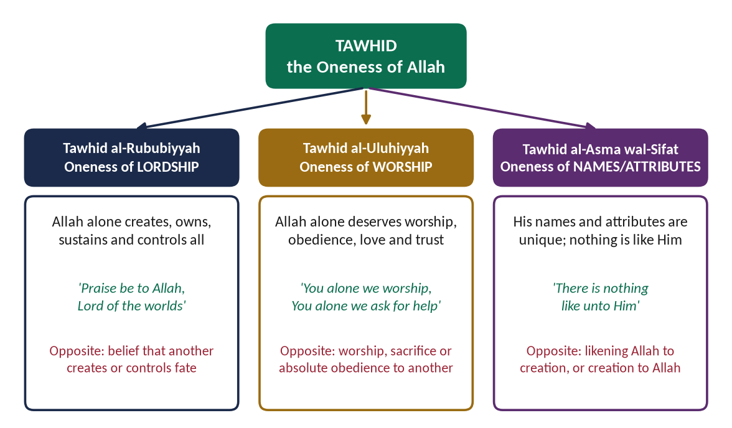
Figure 7 · The three kinds of Tawhid, with their Quranic key phrases and their opposites.

(1) Tawhid al-Rububiyyah — the Oneness of Lordship
Allah alone is the Creator, Owner, Sustainer and Controller of everything. Nothing happens in the universe except by His will.
✦ QURAN
﴿ٱللَّهُ خَٰلِقُ كُلِّ شَيۡءٖۖ وَهُوَ عَلَىٰ كُلِّ شَيۡءٖ وَكِيلٞ﴾
“Allah is the Creator of all things, and He is, over all things, Disposer of affairs.” (Az-Zumar, Quran)
➜ Allah is the Creator of all things, and He is the Disposer of all things.

(2) Tawhid al-Uluhiyyah — the Oneness of Worship
Allah alone deserves worship — prayer, sacrifice, vows, trust, love, fear and absolute obedience. This was the real point of dispute with the Makkans, who admitted Allah as Creator but worshipped others beside Him.
✦ QURAN
﴿إِيَّاكَ نَعۡبُدُ وَإِيَّاكَ نَسۡتَعِينُ﴾
“It is You we worship and You we ask for help.” (Al-Fatihah, Quran)
➜ 'You alone we worship, and You alone we ask for help' — said by every Muslim at least seventeen times a day.

(3) Tawhid al-Asma wal-Sifat — the Oneness of Names and Attributes
Allah's names and attributes are unique and perfect; nothing in creation resembles Him, and He resembles nothing.
✦ QURAN
﴿فَاطِرُ ٱلسَّمَٰوَٰتِ وَٱلۡأَرۡضِۚ جَعَلَ لَكُم مِّنۡ أَنفُسِكُمۡ أَزۡوَٰجٗا وَمِنَ ٱلۡأَنۡعَٰمِ أَزۡوَٰجٗا يَذۡرَؤُكُمۡ فِيهِۚ لَيۡسَ كَمِثۡلِهِۦ شَيۡءٞۖ وَهُوَ ٱلسَّمِيعُ ٱلۡبَصِيرُ﴾
“[He is] Creator of the heavens and the earth. He has made for you from yourselves, mates, and among the cattle, mates; He multiplies you thereby. There is nothing like unto Him, and He is the Hearing, the Seeing.” (Ash-Shura, Quran)
➜ 'There is nothing like unto Him, and He is the Hearing, the Seeing.'

✦ QURAN
﴿وَلِلَّهِ ٱلۡأَسۡمَآءُ ٱلۡحُسۡنَىٰ فَٱدۡعُوهُ بِهَاۖ وَذَرُواْ ٱلَّذِينَ يُلۡحِدُونَ فِيٓ أَسۡمَـٰٓئِهِۦۚ سَيُجۡزَوۡنَ مَا كَانُواْ يَعۡمَلُونَ﴾
“And to Allah belong the best names, so invoke Him by them. And leave [the company of] those who practice deviation concerning His names. They will be recompensed for what they have been doing.” (Al-A'raf, Quran)
➜ To Allah belong the most beautiful names, so call upon Him by them.

6.4 The rational arguments for the existence of Allah (CSS 2026)
The Quran does not only command belief; it argues for it, and invites man to use his reason. The classical scholars — Imam Abu Hanifa, Imam Ghazali, Ibn Rushd — developed these arguments further.
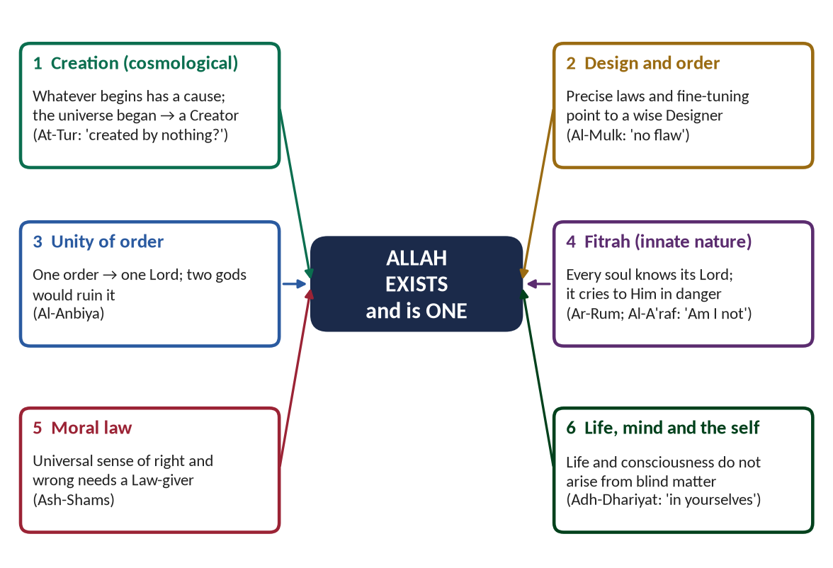
Figure 8 · Six rational arguments for the existence and oneness of Allah.

(1) The argument from creation (cosmological argument)

(i) The argument
Everything that begins to exist has a cause. The universe began to exist. Therefore the universe has a cause — a Creator who is not Himself created.

(ii) The Quran's form of the argument
✦ QURAN
﴿أَمۡ خُلِقُواْ مِنۡ غَيۡرِ شَيۡءٍ أَمۡ هُمُ ٱلۡخَٰلِقُونَ ۝ أَمۡ خَلَقُواْ ٱلسَّمَٰوَٰتِ وَٱلۡأَرۡضَۚ بَل لَّا يُوقِنُونَ﴾
“Or were they created by nothing, or were they the creators [of themselves]. Or did they create the heavens and the earth? Rather, they are not certain.” (At-Tur, Quran)
➜ Were they created by nothing, or were they the creators of themselves? Or did they create the heavens and the earth? — the three possibilities, and only one is reasonable.

(iii) Support from modern science
Modern cosmology holds that the universe had a beginning — the idea behind the 'Big Bang'. A universe with a beginning needs a cause outside itself.
✦ SCHOLARLY VIEW
Imam Al-Ghazali · Al-Iqtisad fi al-I'tiqad
Ghazali formulated the argument in its classic form: whatever comes into being must have a cause; the world came into being; therefore it has a cause. Modern philosophers still call it the 'Kalam cosmological argument', after the Muslim scholars (mutakallimun) who developed it.
➜ A Muslim argument that is still debated in Western universities.

(2) The argument from design and order (teleological argument)

(i) The argument
The universe shows precise order, law and fine-tuning: the constants of physics, the distance of the earth from the sun, the balance of the atmosphere. Precise design points to a wise Designer.
✦ QURAN
﴿ٱلَّذِي خَلَقَ سَبۡعَ سَمَٰوَٰتٖ طِبَاقٗاۖ مَّا تَرَىٰ فِي خَلۡقِ ٱلرَّحۡمَٰنِ مِن تَفَٰوُتٖۖ فَٱرۡجِعِ ٱلۡبَصَرَ هَلۡ تَرَىٰ مِن فُطُورٖ ۝ ثُمَّ ٱرۡجِعِ ٱلۡبَصَرَ كَرَّتَيۡنِ يَنقَلِبۡ إِلَيۡكَ ٱلۡبَصَرُ خَاسِئٗا وَهُوَ حَسِيرٞ﴾
“[And] who created seven heavens in layers. You do not see in the creation of the Most Merciful any inconsistency. So return [your] vision [to the sky]; do you see any breaks. Then return [your] vision twice again. [Your] vision will return to you humbled while it is fatigued.” (Al-Mulk, Quran)
➜ 'You do not see any flaw in the creation of the Most Merciful. Look again: do you see any rift?'

✦ QURAN
﴿ٱلَّذِي لَهُۥ مُلۡكُ ٱلسَّمَٰوَٰتِ وَٱلۡأَرۡضِ وَلَمۡ يَتَّخِذۡ وَلَدٗا وَلَمۡ يَكُن لَّهُۥ شَرِيكٞ فِي ٱلۡمُلۡكِ وَخَلَقَ كُلَّ شَيۡءٖ فَقَدَّرَهُۥ تَقۡدِيرٗا﴾
“He to whom belongs the dominion of the heavens and the earth and who has not taken a son and has not had a partner in dominion and has created each thing and determined it with [precise] determination.” (Al-Furqan, Quran)
➜ He created everything and determined it with precise measure.

(ii) The classical story
✦ SCHOLARLY VIEW
Imam Abu Hanifa · a well-known story told of the Imam
It is related that atheists came to debate Imam Abu Hanifa. He asked them what they would say of a ship that loaded its cargo, sailed through storms and reached its port with no captain or crew. They said no sane person could believe it. He replied: if a ship cannot run itself, how can this vast universe, with its perfect order, run itself without a Creator?
➜ The Hanafi Imam's famous use of the design argument — a story known in every madrasah of Pakistan.

✦ SCHOLARLY VIEW
A Bedouin's argument · a classical Arabic saying
Asked how he knew his Lord, a desert Arab is reported to have said: 'Camel dung points to a camel, and footprints point to a traveller; then a sky with its constellations, an earth with its paths and seas with their waves — do they not point to the All-Subtle, the All-Aware?'
➜ Simple reason reaches the Creator from His signs — the design argument in a nomad's words.

(iii) A modern example
The British philosopher Antony Flew, for fifty years one of the world's best-known atheists, announced in 2004 that the complexity of DNA and the fine-tuning of the universe had convinced him that there must be an intelligent Creator (There Is a God, 2007).

(3) The argument from the unity of order
One single, consistent law runs through the whole universe — the same physics in the farthest galaxy as on earth. One order points to one Lord. If there were two gods, there would be two wills, conflict and chaos.
✦ QURAN
﴿لَوۡ كَانَ فِيهِمَآ ءَالِهَةٌ إِلَّا ٱللَّهُ لَفَسَدَتَاۚ فَسُبۡحَٰنَ ٱللَّهِ رَبِّ ٱلۡعَرۡشِ عَمَّا يَصِفُونَ﴾
“Had there been within the heavens and earth gods besides Allah, they both would have been ruined. So exalted is Allah, Lord of the Throne, above what they describe.” (Al-Anbiya, Quran)
➜ 'Had there been within them gods besides Allah, they both would have been ruined' — the Quran's argument for the oneness, not only the existence, of God.

✦ QURAN
﴿مَا ٱتَّخَذَ ٱللَّهُ مِن وَلَدٖ وَمَا كَانَ مَعَهُۥ مِنۡ إِلَٰهٍۚ إِذٗا لَّذَهَبَ كُلُّ إِلَٰهِۭ بِمَا خَلَقَ وَلَعَلَا بَعۡضُهُمۡ عَلَىٰ بَعۡضٖۚ سُبۡحَٰنَ ٱللَّهِ عَمَّا يَصِفُونَ﴾
“Allah has not taken any son, nor has there ever been with Him any deity. [If there had been], then each deity would have taken what it created, and some of them would have sought to overcome others. Exalted is Allah above what they describe [concerning Him].” (Al-Mu'minun, Quran)
➜ Each god would have taken away what he created, and some would have overpowered others.

(4) The argument from the fitrah (innate nature)
Every human being carries an inner knowledge of the Creator. It appears in every culture, and it rises to the surface in moments of danger, when even a denier cries out to God.
✦ QURAN
﴿وَإِذۡ أَخَذَ رَبُّكَ مِنۢ بَنِيٓ ءَادَمَ مِن ظُهُورِهِمۡ ذُرِّيَّتَهُمۡ وَأَشۡهَدَهُمۡ عَلَىٰٓ أَنفُسِهِمۡ أَلَسۡتُ بِرَبِّكُمۡۖ قَالُواْ بَلَىٰ شَهِدۡنَآۚ أَن تَقُولُواْ يَوۡمَ ٱلۡقِيَٰمَةِ إِنَّا كُنَّا عَنۡ هَٰذَا غَٰفِلِينَ﴾
“And [mention] when your Lord took from the children of Adam - from their loins - their descendants and made them testify of themselves, [saying to them], "Am I not your Lord?" They said, "Yes, we have testified." [This] - lest you should say on the day of Resurrection, "Indeed, we were of this unaware.” (Al-A'raf, Quran)
➜ Before creation, Allah took the covenant of the souls: 'Am I not your Lord?' They said: 'Yes' — belief is written in the soul.

✦ QURAN
﴿فَإِذَا رَكِبُواْ فِي ٱلۡفُلۡكِ دَعَوُاْ ٱللَّهَ مُخۡلِصِينَ لَهُ ٱلدِّينَ فَلَمَّا نَجَّىٰهُمۡ إِلَى ٱلۡبَرِّ إِذَا هُمۡ يُشۡرِكُونَ﴾
“And when they board a ship, they supplicate Allah, sincere to Him in religion. But when He delivers them to the land, at once they associate others with Him.” (Al-Ankabut, Quran)
➜ When they board a ship in a storm, they call upon Allah sincerely — the fitrah speaks when the ego is silent.

(5) The moral argument
All human beings recognise that some things are truly right (justice, honesty, protecting the weak) and some truly wrong (cruelty to the innocent). If morality were only an evolutionary accident or a social custom, no act could be truly evil. An objective moral law points to a Moral Law-giver.
✦ QURAN
﴿وَنَفۡسٖ وَمَا سَوَّىٰهَا ۝ فَأَلۡهَمَهَا فُجُورَهَا وَتَقۡوَىٰهَا﴾
“And [by] the soul and He who proportioned it. And inspired it [with discernment of] its wickedness and its righteousness.” (Ash-Shams, Quran)
➜ By the soul and Him who proportioned it, and inspired it with its wickedness and its righteousness — the moral sense is placed in the soul by Allah.

(6) The argument from life, consciousness and the self
Life, reason and consciousness — the ability to think, to love, to know right from wrong — cannot be explained as the product of blind, unconscious matter.
✦ QURAN
﴿وَفِي ٱلۡأَرۡضِ ءَايَٰتٞ لِّلۡمُوقِنِينَ ۝ وَفِيٓ أَنفُسِكُمۡۚ أَفَلَا تُبۡصِرُونَ﴾
“And on the earth are signs for the certain [in faith]. And in yourselves. Then will you not see.” (Adh-Dhariyat, Quran)
➜ 'On the earth are signs for the certain in faith, and in yourselves — do you not see?'

METHOD · ANSWERING THE 2026 QUESTION
'What are the rational arguments for the existence of Allah? Explain the impacts of belief in monotheism on human life.' → (1) Introduction (Al-Ikhlas; reason in the Quran) (2) Why reason matters in belief (3)–(8) the six arguments, each with a Quranic verse and one scholar/example (9) Impact of monotheism on the individual (10) Impact on society (11) Conclusion. Use the figure of the six arguments.

6.5 Shirk: the opposite of Tawhid

(1) Meaning
Shirk (شِرْك) is to associate partners with Allah — in His essence, His attributes, His lordship or His worship.
✦ QURAN
﴿وَإِذۡ قَالَ لُقۡمَٰنُ لِٱبۡنِهِۦ وَهُوَ يَعِظُهُۥ يَٰبُنَيَّ لَا تُشۡرِكۡ بِٱللَّهِۖ إِنَّ ٱلشِّرۡكَ لَظُلۡمٌ عَظِيمٞ﴾
“And [mention, O Muhammad], when Luqman said to his son while he was instructing him, "O my son, do not associate [anything] with Allah. Indeed, association [with him] is great injustice.” (Luqman, Quran)
➜ Luqman said to his son: 'Do not associate anything with Allah; shirk is a great injustice' (zulmun azim) — injustice to Allah's right and to man's own dignity.

✦ QURAN
﴿إِنَّ ٱللَّهَ لَا يَغۡفِرُ أَن يُشۡرَكَ بِهِۦ وَيَغۡفِرُ مَا دُونَ ذَٰلِكَ لِمَن يَشَآءُۚ وَمَن يُشۡرِكۡ بِٱللَّهِ فَقَدِ ٱفۡتَرَىٰٓ إِثۡمًا عَظِيمًا﴾
“Indeed, Allah does not forgive association with Him, but He forgives what is less than that for whom He wills. And he who associates others with Allah has certainly fabricated a tremendous sin.” (An-Nisa, Quran)
➜ Allah does not forgive that partners be associated with Him, but forgives what is less than that for whom He wills.

✦ HADITH
أَيُّ الذَّنْبِ أَعْظَمُ عِنْدَ اللَّهِ؟ قَالَ: أَنْ تَجْعَلَ لِلَّهِ نِدًّا وَهُوَ خَلَقَكَ
“'Which sin is the greatest in the sight of Allah?' He said: 'That you set up a rival to Allah, while He created you.'” (Al-Bukhari and Muslim)
➜ Shirk is the greatest sin in Islam.

(2) The kinds of shirk

(i) Major shirk (shirk akbar)
Worshipping another besides Allah, or ascribing His unique attributes to a creature. It takes a person out of Islam.

(ii) Minor shirk (shirk asghar)
Chiefly riya — doing good deeds to be seen by people.
✦ HADITH
إِنَّ أَخْوَفَ مَا أَخَافُ عَلَيْكُمُ الشِّرْكُ الْأَصْغَرُ. قَالُوا: وَمَا الشِّرْكُ الْأَصْغَرُ يَا رَسُولَ اللَّهِ؟ قَالَ: الرِّيَاءُ
“'What I fear most for you is the minor shirk.' They asked: 'What is the minor shirk, O Messenger of Allah?' He said: 'Showing off (riya).'” (Musnad Ahmad)
➜ Even good deeds can carry shirk if done for people's praise.

(3) Modern forms of shirk
Shirk is not only bowing to idols of stone. The modern idols are wealth, power, the self and its desires, the nation or the party placed above Allah's law.
✦ QURAN
﴿أَرَءَيۡتَ مَنِ ٱتَّخَذَ إِلَٰهَهُۥ هَوَىٰهُ أَفَأَنتَ تَكُونُ عَلَيۡهِ وَكِيلًا﴾
“Have you seen the one who takes as his god his own desire? Then would you be responsible for him.” (Al-Furqan, Quran)
➜ 'Have you seen the one who takes his own desire as his god?' — the shirk of the modern age.

TRAP · STAY AWAY FROM SECTARIAN EXAMPLES
In explaining shirk, never point at the practices of any school or group in Pakistan. State the principle — worship belongs to Allah alone — and use the Quran's own examples and the modern idols above. The examiner may belong to any school.

6.6 The impact of Tawhid on the individual (CSS 2019, 2026)
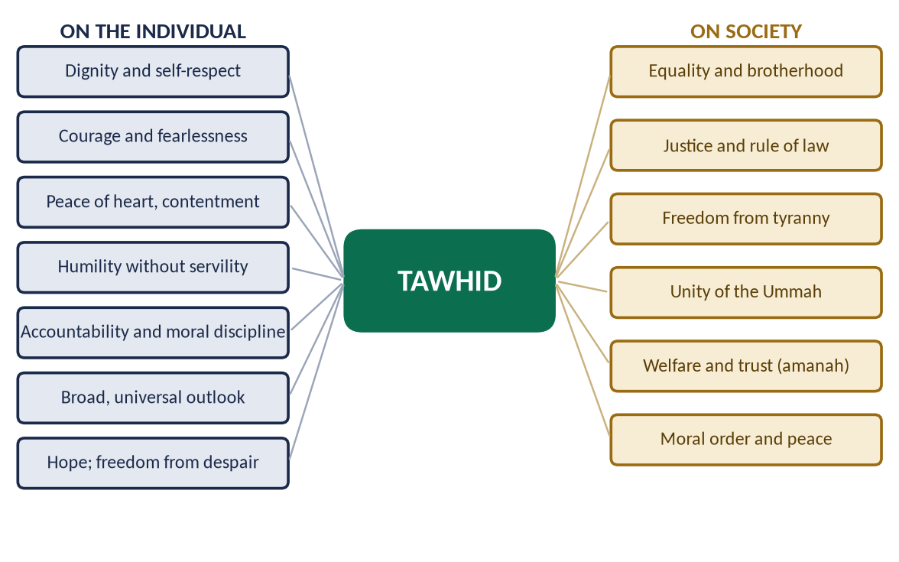
Figure 9 · The impact of Tawhid on the individual and on society.

(1) Dignity and self-respect
A believer in Tawhid bows before no one but Allah — not a king, a rich man, a tyrant or an idol. Tawhid frees the human head from every other yoke.
✦ SCHOLARLY VIEW
Allama Muhammad Iqbal · Zarb-e-Kalim
In his famous Urdu couplet — 'Yeh ek sajda jise tu giran samajhta hai, hazar sajdon se deta hai admi ko najat' — Iqbal says: this one prostration, which you think so heavy, frees man from a thousand prostrations.
➜ One prostration to Allah frees man from bowing to everything else — Tawhid is liberation.

(i) An example from history
Hazrat Bilal (RA), a slave, was laid on the burning sand of Makkah with a rock on his chest; he answered his torturers with one word: 'Ahad, Ahad' — 'One, One'. Tawhid made a slave freer than his master.

(2) Courage and fearlessness
If Allah alone gives benefit and harm, there is nothing else to fear.
✦ QURAN
﴿ٱلَّذِينَ قَالَ لَهُمُ ٱلنَّاسُ إِنَّ ٱلنَّاسَ قَدۡ جَمَعُواْ لَكُمۡ فَٱخۡشَوۡهُمۡ فَزَادَهُمۡ إِيمَٰنٗا وَقَالُواْ حَسۡبُنَا ٱللَّهُ وَنِعۡمَ ٱلۡوَكِيلُ﴾
“Those to whom hypocrites said, "Indeed, the people have gathered against you, so fear them." But it [merely] increased them in faith, and they said, "Sufficient for us is Allah, and [He is] the best Disposer of affairs.” (Aal-e-Imran, Quran)
➜ When they were told 'the people have gathered against you, so fear them', it increased their faith, and they said: 'Allah is sufficient for us, and He is the best Disposer of affairs' (hasbunallahu wa ni'mal wakil).

✦ HADITH
وَاعْلَمْ أَنَّ الْأُمَّةَ لَوِ اجْتَمَعَتْ عَلَى أَنْ يَنْفَعُوكَ بِشَيْءٍ لَمْ يَنْفَعُوكَ إِلَّا بِشَيْءٍ قَدْ كَتَبَهُ اللَّهُ لَكَ، وَلَوِ اجْتَمَعُوا عَلَى أَنْ يَضُرُّوكَ بِشَيْءٍ لَمْ يَضُرُّوكَ إِلَّا بِشَيْءٍ قَدْ كَتَبَهُ اللَّهُ عَلَيْكَ
“Know that if the whole world gathered to benefit you, they could benefit you only with what Allah has written for you; and if they gathered to harm you, they could harm you only with what Allah has written against you.” (Al-Tirmidhi)
➜ Taught to young Ibn Abbas (RA): Tawhid makes a believer fear no one but Allah.

(3) Peace of heart and contentment
✦ QURAN
﴿ٱلَّذِينَ ءَامَنُواْ وَلَمۡ يَلۡبِسُوٓاْ إِيمَٰنَهُم بِظُلۡمٍ أُوْلَـٰٓئِكَ لَهُمُ ٱلۡأَمۡنُ وَهُم مُّهۡتَدُونَ﴾
“They who believe and do not mix their belief with injustice - those will have security, and they are [rightly] guided.” (Al-An'am, Quran)
➜ Those who believe and do not mix their belief with injustice (shirk) — theirs is security, and they are rightly guided.

(4) Humility without servility
The believer knows that everything he has is from Allah; so he is humble before people, but not servile before any power.
✦ QURAN
﴿وَلَا تَمۡشِ فِي ٱلۡأَرۡضِ مَرَحًاۖ إِنَّكَ لَن تَخۡرِقَ ٱلۡأَرۡضَ وَلَن تَبۡلُغَ ٱلۡجِبَالَ طُولٗا﴾
“And do not walk upon the earth exultantly. Indeed, you will never tear the earth [apart], and you will never reach the mountains in height.” (Al-Isra, Quran)
➜ 'Do not walk upon the earth exultantly; you will never tear the earth apart, nor reach the mountains in height.'

(5) Accountability and moral discipline
✦ QURAN
﴿… وَهُوَ مَعَكُمۡ أَيۡنَ مَا كُنتُمۡۚ وَٱللَّهُ بِمَا تَعۡمَلُونَ بَصِيرٞ﴾
“And He is with you wherever you are; and Allah sees what you do.” (Al-Hadid, Quran)
➜ He is with you wherever you are, and Allah sees what you do — the belief that makes a person honest when no one else is watching.

(6) A broad and universal outlook
Allah is Rabb al-Alamin — the Lord of all the worlds, not of one race or nation. A believer's sympathy is therefore universal.

(7) Hope and freedom from despair
✦ QURAN
﴿قُلۡ يَٰعِبَادِيَ ٱلَّذِينَ أَسۡرَفُواْ عَلَىٰٓ أَنفُسِهِمۡ لَا تَقۡنَطُواْ مِن رَّحۡمَةِ ٱللَّهِۚ إِنَّ ٱللَّهَ يَغۡفِرُ ٱلذُّنُوبَ جَمِيعًاۚ إِنَّهُۥ هُوَ ٱلۡغَفُورُ ٱلرَّحِيمُ﴾
“Say, "O My servants who have transgressed against themselves [by sinning], do not despair of the mercy of Allah. Indeed, Allah forgives all sins. Indeed, it is He who is the Forgiving, the Merciful.” (Az-Zumar, Quran)
➜ 'O My servants who have transgressed against themselves, do not despair of the mercy of Allah' — Tawhid closes the door to hopelessness and suicide.

(8) Trust in Allah with hard work (tawakkul)
✦ HADITH
لَوْ أَنَّكُمْ تَوَكَّلُونَ عَلَى اللَّهِ حَقَّ تَوَكُّلِهِ لَرَزَقَكُمْ كَمَا يَرْزُقُ الطَّيْرَ، تَغْدُو خِمَاصًا وَتَرُوحُ بِطَانًا
“If you relied on Allah as He deserves to be relied upon, He would provide for you as He provides for the birds: they go out hungry in the morning and return full in the evening.” (Al-Tirmidhi)
➜ The birds go out — tawakkul is trust with effort, not instead of it.

✦ HADITH
اعْقِلْهَا وَتَوَكَّلْ
“Tie it, and then trust [in Allah].” (Al-Tirmidhi)
➜ Said to a man who asked whether to tie his camel or trust Allah: first the effort, then the trust.

6.7 The impact of Tawhid on society

(1) Equality and brotherhood
If all people are the servants of one Lord and the children of one father, no race, caste or class is superior.
✦ QURAN
﴿يَـٰٓأَيُّهَا ٱلنَّاسُ ٱتَّقُواْ رَبَّكُمُ ٱلَّذِي خَلَقَكُم مِّن نَّفۡسٖ وَٰحِدَةٖ وَخَلَقَ مِنۡهَا زَوۡجَهَا وَبَثَّ مِنۡهُمَا رِجَالٗا كَثِيرٗا وَنِسَآءٗۚ وَٱتَّقُواْ ٱللَّهَ ٱلَّذِي تَسَآءَلُونَ بِهِۦ وَٱلۡأَرۡحَامَۚ إِنَّ ٱللَّهَ كَانَ عَلَيۡكُمۡ رَقِيبٗا﴾
“O mankind, fear your Lord, who created you from one soul and created from it its mate and dispersed from both of them many men and women. And fear Allah, through whom you ask one another, and the wombs. Indeed Allah is ever, over you, an Observer.” (An-Nisa, Quran)
➜ 'O mankind, fear your Lord who created you from one soul' — one Lord, one origin, one human family.

✦ SCHOLARLY VIEW
Allama Muhammad Iqbal · The Reconstruction of Religious Thought in Islam
“The essence of Tawhid as a working idea is equality, solidarity, and freedom.”
➜ Iqbal's formula: Tawhid is not only a belief but a social principle.

(2) Justice and the rule of law
If the law is Allah's, it applies equally to the ruler and the ruled.
✦ QURAN
﴿يَـٰٓأَيُّهَا ٱلَّذِينَ ءَامَنُواْ كُونُواْ قَوَّـٰمِينَ بِٱلۡقِسۡطِ شُهَدَآءَ لِلَّهِ وَلَوۡ عَلَىٰٓ أَنفُسِكُمۡ أَوِ ٱلۡوَٰلِدَيۡنِ وَٱلۡأَقۡرَبِينَۚ …﴾
“O you who believe, stand firmly for justice, as witnesses for Allah, even if it be against yourselves, your parents or your relatives.” (An-Nisa, Quran)
➜ 'Stand firm for justice as witnesses for Allah, even against yourselves, your parents and your relatives.'

✦ HADITH
وَايْمُ اللَّهِ لَوْ أَنَّ فَاطِمَةَ بِنْتَ مُحَمَّدٍ سَرَقَتْ لَقَطَعْتُ يَدَهَا
“By Allah, if Fatimah the daughter of Muhammad were to steal, I would cut off her hand.” (Al-Bukhari and Muslim)
➜ Under Tawhid, no one is above the law — not even the Prophet's own daughter.

(3) Freedom from tyranny and exploitation
Tawhid denies any human being the right to be obeyed absolutely. It is the charter of freedom against kings, priests and exploiters.
✦ QURAN
﴿قُلۡ يَـٰٓأَهۡلَ ٱلۡكِتَٰبِ تَعَالَوۡاْ إِلَىٰ كَلِمَةٖ سَوَآءِۭ بَيۡنَنَا وَبَيۡنَكُمۡ أَلَّا نَعۡبُدَ إِلَّا ٱللَّهَ وَلَا نُشۡرِكَ بِهِۦ شَيۡـٔٗا وَلَا يَتَّخِذَ بَعۡضُنَا بَعۡضًا أَرۡبَابٗا مِّن دُونِ ٱللَّهِۚ …﴾
“Say: O People of the Scripture, come to a word common between us and you: that we worship none but Allah, associate nothing with Him, and that none of us take others as lords besides Allah.” (Aal-e-Imran, Quran)
➜ '… that we worship none but Allah, associate nothing with Him, and that none of us take others as lords besides Allah.'

✦ SCHOLARLY VIEW
Hazrat Rib'i ibn Amir (RA) · Companion; envoy to the Persian commander Rustam
Asked why the Muslims had come, he replied that Allah had sent them to bring people from the worship of servants to the worship of the Lord of servants, from the narrowness of this world to its breadth, and from the injustice of religions to the justice of Islam.
➜ Tawhid as liberation — in the words of a Companion before an empire.

(4) Unity of the Ummah
✦ QURAN
﴿إِنَّ هَٰذِهِۦٓ أُمَّتُكُمۡ أُمَّةٗ وَٰحِدَةٗ وَأَنَا۠ رَبُّكُمۡ فَٱعۡبُدُونِ﴾
“Indeed this, your religion, is one religion, and I am your Lord, so worship Me.” (Al-Anbiya, Quran)
➜ 'This, your Ummah, is one Ummah, and I am your Lord, so worship Me' — one Lord makes one community.

(5) Cooperation and welfare
✦ QURAN
﴿… وَتَعَاوَنُواْ عَلَى ٱلۡبِرِّ وَٱلتَّقۡوَىٰۖ وَلَا تَعَاوَنُواْ عَلَى ٱلۡإِثۡمِ وَٱلۡعُدۡوَٰنِۚ …﴾
“Cooperate in righteousness and piety, and do not cooperate in sin and aggression.” (Al-Ma'idah, Quran)
➜ 'Cooperate in righteousness and piety, and do not cooperate in sin and aggression.'

(6) Moral order and social peace
A society whose members believe that Allah sees every act needs fewer police, courts and prisons. Honesty, trust and mercy become social habits.
PAKISTAN ANGLE · TAWHID IN THE CONSTITUTION
The Objectives Resolution (1949) opens: 'Sovereignty over the entire Universe belongs to Allah Almighty alone, and the authority to be exercised by the people of Pakistan within the limits prescribed by Him is a sacred trust.' It is the Tawhid of sovereignty turned into constitutional law (now Article 2A).

Chapter 7 · Risalat: The Doctrine of Prophethood and Its Importance
This chapter answers the question set word for word in 2022 and 2024: 'Explain the doctrine of Prophethood and its importance in human life.'

7.1 The meaning of Nubuwwah and Risalah

(1) Nabi — the Prophet
Nabi (نَبِيّ) comes from naba', 'great news': a Prophet is one who receives and gives news from Allah. Some scholars derive it from nubuwwah, 'elevation': the Prophet is raised above others in rank.

(2) Rasul — the Messenger
Rasul (رَسُول) comes from irsal, 'sending': a Messenger is one sent with a message.

(3) The difference between Nabi and Rasul
Point | Nabi | Rasul
Mission | Receives revelation and guides people | Receives revelation with a new Shariah or Book, and is sent to a people
Scope | Often follows the Shariah of an earlier Rasul | Often brings a new law
Relation | Not every Nabi is a Rasul | Every Rasul is a Nabi
Examples | Harun, Yahya (AS) | Nuh, Ibrahim, Musa, Isa, Muhammad (peace be upon them)

(4) How many Prophets?
The Quran names twenty-five Prophets. A narration in the Musnad of Imam Ahmad gives the number of Prophets as 124,000 and of Messengers as 313 (or 315); scholars discuss its chain, so say 'about'. What is certain is the principle:
✦ QURAN
﴿إِنَّآ أَرۡسَلۡنَٰكَ بِٱلۡحَقِّ بَشِيرٗا وَنَذِيرٗاۚ وَإِن مِّنۡ أُمَّةٍ إِلَّا خَلَا فِيهَا نَذِيرٞ﴾
“Indeed, We have sent you with the truth as a bringer of good tidings and a warner. And there was no nation but that there had passed within it a warner.” (Fatir, Quran)
➜ There was no nation but that a warner had passed among them — guidance was sent to every people.

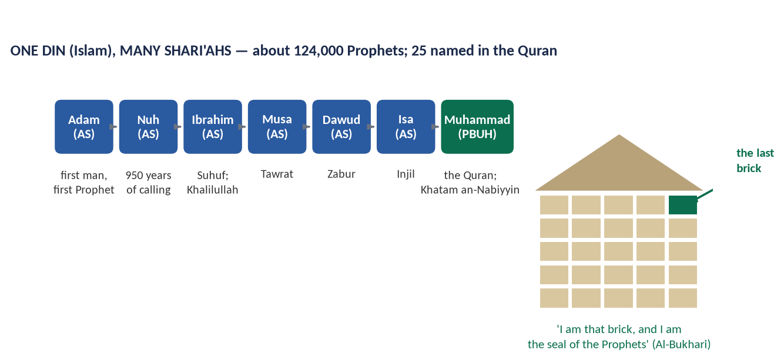
Figure 10 · One Din through the chain of Prophets, sealed by the Prophet Muhammad ﷺ.

7.2 The doctrine of Prophethood — what a Muslim believes

(1) Prophethood is a gift of Allah, not an achievement
No one can become a Prophet by effort, worship or genius. Allah chooses whom He wills.
✦ QURAN
﴿… ٱللَّهُ أَعۡلَمُ حَيۡثُ يَجۡعَلُ رِسَالَتَهُۥۗ …﴾
“Allah knows best where to place His message.” (Al-An'am, Quran)
➜ 'Allah knows best where to place His message' — prophethood is chosen by Allah, not earned by man.

(2) The Prophets are human beings
They eat, sleep, marry, trade and die. Their humanity is what makes them a model: a model must be imitable.
✦ QURAN
﴿قُلۡ إِنَّمَآ أَنَا۠ بَشَرٞ مِّثۡلُكُمۡ يُوحَىٰٓ إِلَيَّ أَنَّمَآ إِلَٰهُكُمۡ إِلَٰهٞ وَٰحِدٞۖ فَمَن كَانَ يَرۡجُواْ لِقَآءَ رَبِّهِۦ فَلۡيَعۡمَلۡ عَمَلٗا صَٰلِحٗا وَلَا يُشۡرِكۡ بِعِبَادَةِ رَبِّهِۦٓ أَحَدَۢا﴾
“Say, "I am only a man like you, to whom has been revealed that your god is one God. So whoever would hope for the meeting with his Lord - let him do righteous work and not associate in the worship of his Lord anyone.” (Al-Kahf, Quran)
➜ 'Say: I am only a man like you, to whom it has been revealed that your God is one God.'

(3) The Prophets are protected from sin (ismah)
Allah protects His Prophets from sin and from error in conveying the message, so that their example can be followed safely.

(4) The Prophets convey the message completely
✦ QURAN
﴿يَـٰٓأَيُّهَا ٱلرَّسُولُ بَلِّغۡ مَآ أُنزِلَ إِلَيۡكَ مِن رَّبِّكَۖ وَإِن لَّمۡ تَفۡعَلۡ فَمَا بَلَّغۡتَ رِسَالَتَهُۥۚ وَٱللَّهُ يَعۡصِمُكَ مِنَ ٱلنَّاسِۗ إِنَّ ٱللَّهَ لَا يَهۡدِي ٱلۡقَوۡمَ ٱلۡكَٰفِرِينَ﴾
“O Messenger, announce that which has been revealed to you from your Lord, and if you do not, then you have not conveyed His message. And Allah will protect you from the people. Indeed, Allah does not guide the disbelieving people.” (Al-Ma'idah, Quran)
➜ 'O Messenger, convey what has been revealed to you from your Lord; if you do not, you have not conveyed His message.'

(5) Belief in all the Prophets is required
A Muslim believes in every Prophet — Musa and Isa (AS) as much as Muhammad ﷺ — and does not separate between them in belief.
✦ QURAN
﴿ءَامَنَ ٱلرَّسُولُ بِمَآ أُنزِلَ إِلَيۡهِ مِن رَّبِّهِۦ وَٱلۡمُؤۡمِنُونَۚ كُلٌّ ءَامَنَ بِٱللَّهِ وَمَلَـٰٓئِكَتِهِۦ وَكُتُبِهِۦ وَرُسُلِهِۦ لَا نُفَرِّقُ بَيۡنَ أَحَدٖ مِّن رُّسُلِهِۦۚ وَقَالُواْ سَمِعۡنَا وَأَطَعۡنَاۖ غُفۡرَانَكَ رَبَّنَا وَإِلَيۡكَ ٱلۡمَصِيرُ﴾
“The Messenger has believed in what was revealed to him from his Lord, and [so have] the believers. All of them have believed in Allah and His angels and His books and His messengers, [saying], "We make no distinction between any of His messengers." And they say, "We hear and we obey. [We seek] Your forgiveness, our Lord, and to You is the [final] destination.” (Al-Baqarah, Quran)
➜ The believers say: 'We make no distinction between any of His messengers.'

(6) The Prophets are supported by miracles
Each Prophet was given signs suited to his people: the staff of Musa (AS) for a people of magic, the healing of Isa (AS) for a people of medicine, and the Quran — a miracle of language, law and knowledge — for the Prophet ﷺ and for all time.

7.3 Why man needs Prophets
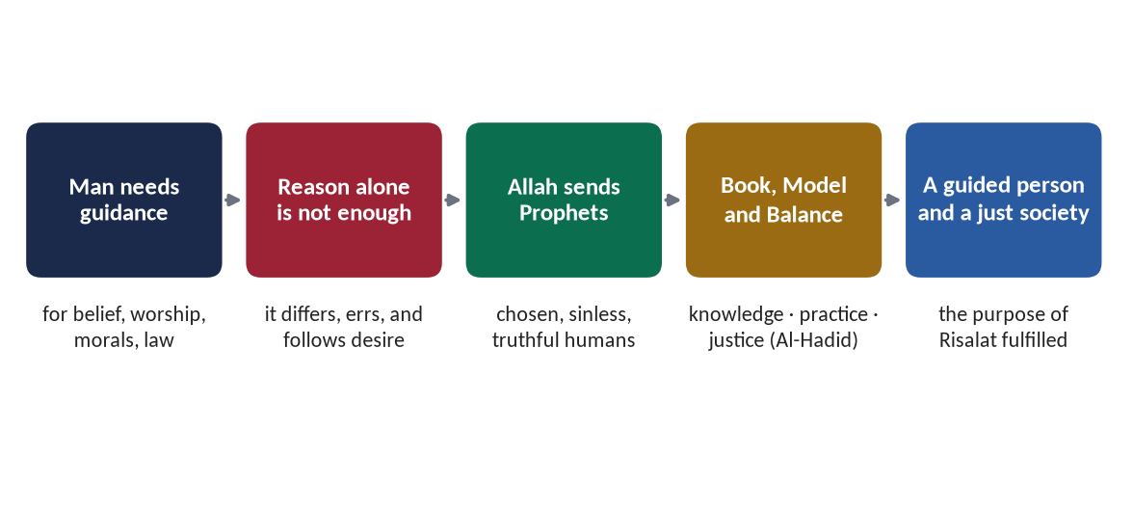
Figure 11 · The need for Prophethood, from man's need for guidance to a just society.

(1) Reason alone cannot find the full truth
Reason can reach the existence of God, but not His will: how He wants to be worshipped, what is lawful and unlawful, what happens after death. Philosophers have disagreed on all of these for three thousand years.

(2) Man needs a practical model, not only a theory
Books alone are not enough; people learn from living examples. Every Prophet showed in his own life how the guidance is lived.
✦ SCHOLARLY VIEW
Syed Sulaiman Nadvi · Khutbat-e-Madras (1925)
In his celebrated lectures at Madras, Nadvi argues that a life fit to be a universal model must meet four conditions: it must be historical (reliably recorded), comprehensive (covering every role of life), complete (every detail known) and practical (possible to follow). Only the life of the Prophet Muhammad ﷺ meets all four.
➜ Why the final model had to be a Prophet whose life is fully recorded.

(3) Justice needs a revealed standard
✦ QURAN
﴿لَقَدۡ أَرۡسَلۡنَا رُسُلَنَا بِٱلۡبَيِّنَٰتِ وَأَنزَلۡنَا مَعَهُمُ ٱلۡكِتَٰبَ وَٱلۡمِيزَانَ لِيَقُومَ ٱلنَّاسُ بِٱلۡقِسۡطِۖ وَأَنزَلۡنَا ٱلۡحَدِيدَ فِيهِ بَأۡسٞ شَدِيدٞ وَمَنَٰفِعُ لِلنَّاسِ وَلِيَعۡلَمَ ٱللَّهُ مَن يَنصُرُهُۥ وَرُسُلَهُۥ بِٱلۡغَيۡبِۚ إِنَّ ٱللَّهَ قَوِيٌّ عَزِيزٞ﴾
“We have already sent Our messengers with clear evidences and sent down with them the Scripture and the balance that the people may maintain [their affairs] in justice. And We sent down iron, wherein is great military might and benefits for the people, and so that Allah may make evident those who support Him and His messengers unseen. Indeed, Allah is Powerful and Exalted in Might.” (Al-Hadid, Quran)
➜ Allah sent His messengers with clear proofs, and sent down with them the Book and the Balance, so that people may uphold justice.

(4) The argument of man is removed
✦ QURAN
﴿رُّسُلٗا مُّبَشِّرِينَ وَمُنذِرِينَ لِئَلَّا يَكُونَ لِلنَّاسِ عَلَى ٱللَّهِ حُجَّةُۢ بَعۡدَ ٱلرُّسُلِۚ وَكَانَ ٱللَّهُ عَزِيزًا حَكِيمٗا﴾
“[We sent] messengers as bringers of good tidings and warners so that mankind will have no argument against Allah after the messengers. And ever is Allah Exalted in Might and Wise.” (An-Nisa, Quran)
➜ Messengers were sent as bringers of good news and warners so that mankind will have no argument against Allah after the messengers.

7.4 The functions of the Prophets
✦ QURAN
﴿هُوَ ٱلَّذِي بَعَثَ فِي ٱلۡأُمِّيِّـۧنَ رَسُولٗا مِّنۡهُمۡ يَتۡلُواْ عَلَيۡهِمۡ ءَايَٰتِهِۦ وَيُزَكِّيهِمۡ وَيُعَلِّمُهُمُ ٱلۡكِتَٰبَ وَٱلۡحِكۡمَةَ وَإِن كَانُواْ مِن قَبۡلُ لَفِي ضَلَٰلٖ مُّبِينٖ﴾
“It is He who has sent among the unlettered a Messenger from themselves reciting to them His verses and purifying them and teaching them the Book and wisdom - although they were before in clear error.” (Al-Jumu'ah, Quran)
➜ The four functions: reciting His verses, purifying the people, teaching the Book, and teaching wisdom.

Function | What it means
Tilawah — conveying the verses | Delivering the words of revelation exactly
Tazkiyah — purification | Cleansing hearts of shirk, vices and bad habits
Ta'lim al-Kitab — teaching the Book | Explaining its meaning and law
Hikmah — teaching wisdom | Showing how to apply it — the Sunnah
Bashir and Nadhir — good news and warning | Giving hope of reward and warning of punishment (Al-Ahzab)
Iqamat al-Adl — establishing justice | Building a just society (Al-Hadid)
Uswah — being the model | Living the message (Al-Ahzab)

7.5 The qualities of the Prophets

(1) The four essential qualities
- Sidq — truthfulness: the Prophet ﷺ was called al-Sadiq by his enemies.
- Amanah — trustworthiness: he was al-Amin; the Makkans kept their valuables with him even while opposing him, and he returned them at the Hijrah.
- Tabligh — conveying the message fully, without hiding anything.
- Fatanah — wisdom and intelligence.

(2) Other qualities
Noble lineage, excellent character, courage, patience, mercy, and complete sincerity.
✦ QURAN
﴿وَإِنَّكَ لَعَلَىٰ خُلُقٍ عَظِيمٖ﴾
“And indeed, you are of a great moral character.” (Al-Qalam, Quran)
➜ 'You are truly of an exalted character.'

7.6 The importance of Prophethood in human life

(1) In belief: the only door to the knowledge of Allah
Everything we know of Allah's names, His will, the angels and the Hereafter reaches us only through the Prophets. Without Risalat, Tawhid would remain a guess.

(2) In worship: the method of obedience
✦ HADITH
صَلُّوا كَمَا رَأَيْتُمُونِي أُصَلِّي
“Pray as you have seen me praying.” (Al-Bukhari)
➜ Worship is taught by the Prophet; without him no one would know how to pray.

(3) In morality: the perfect example
The Prophets are the living standard of good character; the believer measures himself against them.
✦ HADITH
لَا يُؤْمِنُ أَحَدُكُمْ حَتَّى أَكُونَ أَحَبَّ إِلَيْهِ مِنْ وَالِدِهِ وَوَلَدِهِ وَالنَّاسِ أَجْمَعِينَ
“None of you truly believes until I am more beloved to him than his father, his child and all the people.” (Al-Bukhari and Muslim)
➜ Love of the Prophet ﷺ makes his example the driving force of a Muslim's character.

(4) In law and society: the final authority
✦ QURAN
﴿مَّن يُطِعِ ٱلرَّسُولَ فَقَدۡ أَطَاعَ ٱللَّهَۖ وَمَن تَوَلَّىٰ فَمَآ أَرۡسَلۡنَٰكَ عَلَيۡهِمۡ حَفِيظٗا﴾
“He who obeys the Messenger has obeyed Allah; but those who turn away - We have not sent you over them as a guardian.” (An-Nisa, Quran)
➜ 'Whoever obeys the Messenger has obeyed Allah.'

✦ QURAN
﴿فَلَا وَرَبِّكَ لَا يُؤۡمِنُونَ حَتَّىٰ يُحَكِّمُوكَ فِيمَا شَجَرَ بَيۡنَهُمۡ ثُمَّ لَا يَجِدُواْ فِيٓ أَنفُسِهِمۡ حَرَجٗا مِّمَّا قَضَيۡتَ وَيُسَلِّمُواْ تَسۡلِيمٗا﴾
“But no, by your Lord, they will not [truly] believe until they make you, [O Muhammad], judge concerning that over which they dispute among themselves and then find within themselves no discomfort from what you have judged and submit in [full, willing] submission.” (An-Nisa, Quran)
➜ They will not truly believe until they make you judge in their disputes and find no discomfort in your decision.

(5) In civilization: the founders of just societies
Every great moral civilization began with a Prophet. The Prophet Muhammad ﷺ founded, in ten years, a state with a written charter, a system of justice, a welfare treasury and a brotherhood of races (see T3).
✦ SCHOLARLY VIEW
Alphonse de Lamartine · French poet and historian, Histoire de la Turquie (1854)
“If greatness of purpose, smallness of means, and astonishing results are the three criteria of human genius, who could dare to compare any great man in modern history with Muhammad?”
➜ A European testimony to the civilizational impact of Prophethood.

(6) In the unity of mankind
All the Prophets taught one Din; belief in all of them unites Muslims with the whole history of guidance and builds respect for other faith-communities.

(7) In salvation
✦ QURAN
﴿وَمَن يُطِعِ ٱللَّهَ وَٱلرَّسُولَ فَأُوْلَـٰٓئِكَ مَعَ ٱلَّذِينَ أَنۡعَمَ ٱللَّهُ عَلَيۡهِم مِّنَ ٱلنَّبِيِّـۧنَ وَٱلصِّدِّيقِينَ وَٱلشُّهَدَآءِ وَٱلصَّـٰلِحِينَۚ وَحَسُنَ أُوْلَـٰٓئِكَ رَفِيقٗا﴾
“And whoever obeys Allah and the Messenger - those will be with the ones upon whom Allah has bestowed favor of the prophets, the steadfast affirmers of truth, the martyrs and the righteous. And excellent are those as companions.” (An-Nisa, Quran)
➜ Whoever obeys Allah and the Messenger will be with the Prophets, the truthful, the martyrs and the righteous — Prophethood is the road to success in the Hereafter.

METHOD · THE 2022/2024 QUESTION IN HEADINGS
(1) Introduction — Al-Ahzab (uswah) · (2) Meaning of Nubuwwah and Risalah · (3) The doctrine: what a Muslim believes (six points) · (4) The need for Prophethood (figure) · (5) Functions of the Prophets (Al-Jumu'ah) · (6) Qualities of the Prophets · (7) Importance in human life: belief, worship, morality, law and society, civilization, unity, salvation · (8) Finality — the completion of the doctrine · (9) Relevance today · (10) Conclusion.

Chapter 8 · Khatm-e-Nubuwwat: The Finality of Prophethood
This chapter answers CSS 2015: 'The entire faith in Prophethood is unacceptable without faith in the finality of the Prophethood. Discuss in the light of Quran and Sunnah.'

8.1 The meaning of Khatm-e-Nubuwwat

(1) Literal meaning
Khatam (خَاتَم) means a seal — the last thing placed on a document to close it — and khatim (خَاتِم) means the one who ends or completes. Both readings of Al-Ahzab lead to the same meaning: the last.

(2) Technical meaning
Khatm-e-Nubuwwat is the belief that the Prophet Muhammad ﷺ is the last Prophet and Messenger of Allah; no new Prophet, of any kind, will come after him until the Day of Judgement, and whoever claims prophethood after him is a false claimant.

8.2 The evidence from the Quran

(1) The explicit text
✦ QURAN
﴿مَّا كَانَ مُحَمَّدٌ أَبَآ أَحَدٖ مِّن رِّجَالِكُمۡ وَلَٰكِن رَّسُولَ ٱللَّهِ وَخَاتَمَ ٱلنَّبِيِّـۧنَۗ وَكَانَ ٱللَّهُ بِكُلِّ شَيۡءٍ عَلِيمٗا﴾
“Muhammad is not the father of [any] one of your men, but [he is] the Messenger of Allah and last of the prophets. And ever is Allah, of all things, Knowing.” (Al-Ahzab, Quran)
➜ Muhammad ﷺ is the Messenger of Allah and the seal of the Prophets (Khatam an-Nabiyyin) — the clear and final text.

(2) The completion of the Din
✦ QURAN
﴿… ٱلۡيَوۡمَ أَكۡمَلۡتُ لَكُمۡ دِينَكُمۡ وَأَتۡمَمۡتُ عَلَيۡكُمۡ نِعۡمَتِي وَرَضِيتُ لَكُمُ ٱلۡإِسۡلَٰمَ دِينٗاۚ …﴾
“This day I have perfected for you your religion, completed My favour upon you, and approved for you Islam as your way of life.” (Al-Ma'idah, Quran)
➜ A completed Din needs no new Prophet.

(3) A universal Prophet for all people and all time
✦ QURAN
﴿قُلۡ يَـٰٓأَيُّهَا ٱلنَّاسُ إِنِّي رَسُولُ ٱللَّهِ إِلَيۡكُمۡ جَمِيعًا …﴾
“Say: O mankind, I am the Messenger of Allah to you all.” (Al-A'raf, Quran)
➜ 'Say: O mankind, I am the Messenger of Allah to you all' — a Prophet for all humanity leaves no people needing another.

(4) The Quran speaks of revelation 'before you', never 'after you'
✦ QURAN
﴿وَٱلَّذِينَ يُؤۡمِنُونَ بِمَآ أُنزِلَ إِلَيۡكَ وَمَآ أُنزِلَ مِن قَبۡلِكَ وَبِٱلۡأٓخِرَةِ هُمۡ يُوقِنُونَ﴾
“And who believe in what has been revealed to you, [O Muhammad], and what was revealed before you, and of the Hereafter they are certain [in faith].” (Al-Baqarah, Quran)
➜ The believers believe in what was revealed to you and what was revealed before you — the Quran never asks belief in any revelation after him.

(5) The preservation of the message
✦ QURAN
﴿إِنَّا نَحۡنُ نَزَّلۡنَا ٱلذِّكۡرَ وَإِنَّا لَهُۥ لَحَٰفِظُونَ﴾
“Indeed, it is We who sent down the Qur'an and indeed, We will be its guardian.” (Al-Hijr, Quran)
➜ Allah Himself guards the Quran — earlier Prophets were followed by new ones partly because earlier messages were lost or changed; the final message cannot be lost.

8.3 The evidence from the Sunnah

(1) The parable of the house and the last brick
✦ HADITH
إِنَّ مَثَلِي وَمَثَلَ الْأَنْبِيَاءِ مِنْ قَبْلِي كَمَثَلِ رَجُلٍ بَنَى بَيْتًا فَأَحْسَنَهُ وَأَجْمَلَهُ إِلَّا مَوْضِعَ لَبِنَةٍ مِنْ زَاوِيَةٍ، فَجَعَلَ النَّاسُ يَطُوفُونَ بِهِ وَيَعْجَبُونَ لَهُ وَيَقُولُونَ: هَلَّا وُضِعَتْ هَذِهِ اللَّبِنَةُ؟ قَالَ: فَأَنَا اللَّبِنَةُ، وَأَنَا خَاتِمُ النَّبِيِّينَ
“My example and the example of the Prophets before me is that of a man who built a house, made it fine and beautiful, except for the place of one brick in a corner. People walked around it, admired it and said: 'If only this brick were put in place!' I am that brick, and I am the seal of the Prophets.” (Al-Bukhari)
➜ The building of prophethood is complete; there is no place for another brick.

(2) 'There is no Prophet after me'
✦ HADITH
أَمَا تَرْضَى أَنْ تَكُونَ مِنِّي بِمَنْزِلَةِ هَارُونَ مِنْ مُوسَى، إِلَّا أَنَّهُ لَا نَبِيَّ بَعْدِي
“Are you not pleased to be to me as Harun was to Musa — except that there is no Prophet after me?” (Al-Bukhari and Muslim)
➜ Even the closest companion, Hazrat Ali (RA), could not be a Prophet.

(3) The warning against false claimants
✦ HADITH
وَإِنَّهُ سَيَكُونُ فِي أُمَّتِي كَذَّابُونَ ثَلَاثُونَ، كُلُّهُمْ يَزْعُمُ أَنَّهُ نَبِيٌّ، وَأَنَا خَاتَمُ النَّبِيِّينَ لَا نَبِيَّ بَعْدِي
“There will be in my Ummah thirty liars, each of them claiming to be a Prophet; and I am the seal of the Prophets — there is no Prophet after me.” (Abu Dawud and Al-Tirmidhi)
➜ The Prophet ﷺ foretold false claimants and closed the door in advance.

(4) Prophethood and messengership have ended
✦ HADITH
إِنَّ الرِّسَالَةَ وَالنُّبُوَّةَ قَدِ انْقَطَعَتْ، فَلَا رَسُولَ بَعْدِي وَلَا نَبِيَّ
“Messengership and prophethood have come to an end: there is no Messenger after me and no Prophet.” (Al-Tirmidhi)
➜ Both Risalah and Nubuwwah — of every kind — have ended.

(5) Sent to all creation, and the Prophets sealed with him
✦ HADITH
وَأُرْسِلْتُ إِلَى الْخَلْقِ كَافَّةً، وَخُتِمَ بِيَ النَّبِيُّونَ
“I have been sent to all of creation, and the Prophets have been sealed with me.” (Muslim)
➜ Universality and finality go together.

(6) Even the greatest would not have been a Prophet
✦ HADITH
لَوْ كَانَ بَعْدِي نَبِيٌّ لَكَانَ عُمَرَ بْنَ الْخَطَّابِ
“If there were to be a Prophet after me, it would have been Umar ibn al-Khattab.” (Al-Tirmidhi)
➜ The sentence is conditional because there is none: not even Umar (RA), whose opinions the Quran often confirmed.

8.4 The consensus (Ijma) of the Ummah

(1) The Companions' consensus in action
After the Prophet's death, several false claimants appeared — Musaylimah, Aswad al-Ansi and Tulayhah. Under Hazrat Abu Bakr (RA), the Companions unanimously treated the claim to prophethood as apostasy; Musaylimah's forces were defeated at the Battle of Yamamah (11–12 AH), where many memorisers of the Quran were martyred — which in turn led to the compilation of the Quran in one volume.

(2) The consensus of all schools
The four Sunni schools, and indeed every recognised school of Muslim thought across fourteen centuries, agree that belief in the finality of the Prophet ﷺ is an essential of faith, and its denial places a person outside Islam.

8.5 The wisdom of Finality — the rational argument

(1) The Din is complete
Earlier Prophets came because guidance was still being completed. After Al-Ma'idah ('This day I have perfected your Din'), nothing remains to be added.

(2) The message is preserved
Earlier scriptures were lost or altered; the Quran is preserved word for word, and the Sunnah by the science of Hadith. A new Prophet is needed only when the old message is lost.

(3) The message is universal
Earlier Prophets were sent to particular peoples; the last Prophet was sent to all mankind, for all time, in a world that his message could reach.

(4) Humanity reached maturity
✦ SCHOLARLY VIEW
Allama Muhammad Iqbal · The Reconstruction of Religious Thought in Islam, Lecture V
“In Islam prophecy reaches its perfection in discovering the need of its own abolition. This involves the keen perception that life cannot for ever be kept in leading strings; that, in order to achieve full self-consciousness, man must finally be thrown back on his own resources.”
➜ Finality means humanity now has complete guidance and must use reason (Ijtihad) under it — the rational wisdom of finality.

(5) Guidance continues — through the scholars and renewal
The end of prophethood is not the end of guidance: the Quran and Sunnah remain, the scholars inherit the knowledge of the Prophets, and renewers revive the Din in every age.
✦ HADITH
إِنَّ الْعُلَمَاءَ وَرَثَةُ الْأَنْبِيَاءِ
“The scholars are the heirs of the Prophets.” (Abu Dawud and Al-Tirmidhi)
➜ Prophethood has ended; its knowledge and its work continue.

✦ HADITH
إِنَّ اللَّهَ يَبْعَثُ لِهَذِهِ الْأُمَّةِ عَلَى رَأْسِ كُلِّ مِائَةِ سَنَةٍ مَنْ يُجَدِّدُ لَهَا دِينَهَا
“Allah will send to this Ummah, at the head of every hundred years, one who will renew its Din for it.” (Abu Dawud)
➜ Tajdid (renewal), not new prophethood, is Allah's way after the Seal.

(6) Finality protects the unity of the Ummah
If the door of prophethood were open, every claimant would split the Ummah into believers and deniers of his claim. Finality gives the whole Ummah one Prophet, one Book, one Qiblah.

8.6 Why faith in Prophethood is unacceptable without faith in its Finality
This is the thesis of the 2015 question. Prove it in five steps:
1. It denies the Quran. Al-Ahzab explicitly calls him the Seal; to reject finality is to reject a clear verse — and to reject one verse is to reject the Book.
2. It denies the Sunnah. The Prophet ﷺ himself said 'there is no Prophet after me' in many authentic narrations.
3. It breaks the consensus of the Companions and of the whole Ummah for fourteen centuries.
4. It makes the Din incomplete. Belief in a later prophet implies that the Din perfected at the Farewell Hajj was not perfect — a denial of Al-Ma'idah.
5. It destroys the meaning of prophethood itself. Faith in Muhammad ﷺ as a Prophet means accepting everything he said about himself; accepting him while rejecting his statement that he is the last is a contradiction.
PAKISTAN ANGLE · FINALITY IN THE CONSTITUTION
Article 260(3)(a) defines a Muslim as a person who believes in the unity and oneness of Almighty Allah and in the absolute and unqualified finality of the Prophethood of Muhammad (peace be upon him), and who does not believe in or recognise as a prophet or religious reformer any person who claimed or claims to be a prophet after him. The oaths of the President and the Prime Minister (Third Schedule) also include belief in the finality of Prophethood. These provisions go back to the Second Amendment (1974) and were given their present wording later.

EXAMINER'S EYE · TONE
State the belief firmly and prove it from the Quran, the Sunnah and consensus. Do not use abusive language about any group; the strength of the answer lies in its evidence, not its anger.

Chapter 9 · Akhirah: The Quranic Argument and Its Impact
This chapter answers CSS 2021 ('belief in the Day of Judgment … its effects on individual and collective lives') and CSS 2023 ('the Qur'anic argument on the Life Hereafter … its impacts on the individual and collective life').

9.1 The meaning of Akhirah

(1) Literal meaning
Akhirah (آخِرَة) means 'the last' or 'the end' — the life that comes after this one and has no end.

(2) Technical meaning
Belief in the Akhirah is the belief that this world will end; all human beings will be raised again; every person will be judged for his beliefs and deeds; and each will receive eternal reward in Paradise or punishment in Hell, by the perfect justice and mercy of Allah.

(3) The names of the Day in the Quran
Yawm al-Qiyamah (the Day of Rising), Yawm al-Din (the Day of Recompense), Yawm al-Hisab (the Day of Reckoning), Yawm al-Fasl (the Day of Decision), Al-Sa'ah (the Hour), Al-Haqqah (the Inevitable Reality). Each name shows one aspect of the Day.

9.2 The place of Akhirah in the faith
The Quran joins belief in the Last Day with belief in Allah more than any other article; it is the belief that turns faith into responsibility.
✦ QURAN
﴿لَّيۡسَ ٱلۡبِرَّ أَن تُوَلُّواْ وُجُوهَكُمۡ قِبَلَ ٱلۡمَشۡرِقِ وَٱلۡمَغۡرِبِ وَلَٰكِنَّ ٱلۡبِرَّ مَنۡ ءَامَنَ بِٱللَّهِ وَٱلۡيَوۡمِ ٱلۡأٓخِرِ وَٱلۡمَلَـٰٓئِكَةِ وَٱلۡكِتَٰبِ وَٱلنَّبِيِّـۧنَ وَءَاتَى ٱلۡمَالَ عَلَىٰ حُبِّهِۦ ذَوِي ٱلۡقُرۡبَىٰ وَٱلۡيَتَٰمَىٰ وَٱلۡمَسَٰكِينَ وَٱبۡنَ ٱلسَّبِيلِ …﴾
“Righteousness is not that you turn your faces toward the east or the west; but true righteousness is [in] one who believes in Allah, the Last Day, the angels, the Book and the Prophets, and gives wealth, in spite of love for it, to relatives, orphans, the needy and the traveller …” (Al-Baqarah, Quran)
➜ Righteousness is to believe in Allah and the Last Day … and to give wealth to relatives, orphans and the needy — belief in the Hereafter leads straight to social duty.

✦ QURAN
﴿يَـٰٓأَيُّهَا ٱلَّذِينَ ءَامَنُوٓاْ ءَامِنُواْ بِٱللَّهِ وَرَسُولِهِۦ وَٱلۡكِتَٰبِ ٱلَّذِي نَزَّلَ عَلَىٰ رَسُولِهِۦ وَٱلۡكِتَٰبِ ٱلَّذِيٓ أَنزَلَ مِن قَبۡلُۚ وَمَن يَكۡفُرۡ بِٱللَّهِ وَمَلَـٰٓئِكَتِهِۦ وَكُتُبِهِۦ وَرُسُلِهِۦ وَٱلۡيَوۡمِ ٱلۡأٓخِرِ فَقَدۡ ضَلَّ ضَلَٰلَۢا بَعِيدًا﴾
“O you who have believed, believe in Allah and His Messenger and the Book that He sent down upon His Messenger and the Scripture which He sent down before. And whoever disbelieves in Allah, His angels, His books, His messengers, and the Last Day has certainly gone far astray.” (An-Nisa, Quran)
➜ Whoever disbelieves in Allah, His angels, His books, His messengers and the Last Day has gone far astray.

9.3 The stages of the Hereafter
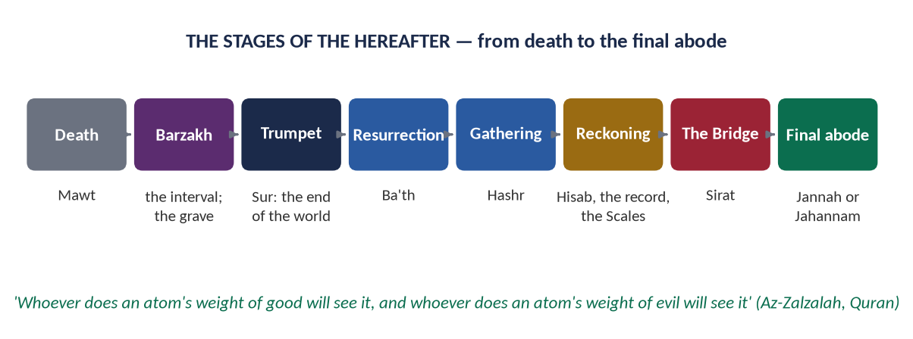
Figure 12 · The stages of the Hereafter, from death to the final abode.

(1) Death
✦ QURAN
﴿كُلُّ نَفۡسٖ ذَآئِقَةُ ٱلۡمَوۡتِۗ وَإِنَّمَا تُوَفَّوۡنَ أُجُورَكُمۡ يَوۡمَ ٱلۡقِيَٰمَةِۖ فَمَن زُحۡزِحَ عَنِ ٱلنَّارِ وَأُدۡخِلَ ٱلۡجَنَّةَ فَقَدۡ فَازَۗ وَمَا ٱلۡحَيَوٰةُ ٱلدُّنۡيَآ إِلَّا مَتَٰعُ ٱلۡغُرُورِ﴾
“Every soul will taste death, and you will only be given your [full] compensation on the Day of Resurrection. So he who is drawn away from the Fire and admitted to Paradise has attained [his desire]. And what is the life of this world except the enjoyment of delusion.” (Aal-e-Imran, Quran)
➜ Every soul will taste death, and you will be paid your full reward only on the Day of Resurrection.

(2) Barzakh — the interval
✦ QURAN
﴿لَعَلِّيٓ أَعۡمَلُ صَٰلِحٗا فِيمَا تَرَكۡتُۚ كَلَّآۚ إِنَّهَا كَلِمَةٌ هُوَ قَآئِلُهَاۖ وَمِن وَرَآئِهِم بَرۡزَخٌ إِلَىٰ يَوۡمِ يُبۡعَثُونَ﴾
“That I might do righteousness in that which I left behind." No! It is only a word he is saying; and behind them is a barrier until the Day they are resurrected.” (Al-Mu'minun, Quran)
➜ Behind them is a barrier (barzakh) until the Day they are resurrected — the life of the grave between death and resurrection.

(3) The Trumpet and the Resurrection
✦ QURAN
﴿وَنُفِخَ فِي ٱلصُّورِ فَإِذَا هُم مِّنَ ٱلۡأَجۡدَاثِ إِلَىٰ رَبِّهِمۡ يَنسِلُونَ﴾
“And the Horn will be blown; and at once from the graves to their Lord they will hasten.” (Ya-Sin, Quran)
➜ The Trumpet will be blown, and from their graves they will hasten to their Lord.

(4) The Reckoning and the Record
✦ QURAN
﴿وَكُلَّ إِنسَٰنٍ أَلۡزَمۡنَٰهُ طَـٰٓئِرَهُۥ فِي عُنُقِهِۦۖ وَنُخۡرِجُ لَهُۥ يَوۡمَ ٱلۡقِيَٰمَةِ كِتَٰبٗا يَلۡقَىٰهُ مَنشُورًا ۝ ٱقۡرَأۡ كِتَٰبَكَ كَفَىٰ بِنَفۡسِكَ ٱلۡيَوۡمَ عَلَيۡكَ حَسِيبٗا﴾
“And [for] every person We have imposed his fate upon his neck, and We will produce for him on the Day of Resurrection a record which he will encounter spread open. [It will be said], "Read your record. Sufficient is yourself against you this Day as accountant.” (Al-Isra, Quran)
➜ Every person's deeds are fastened to his neck; on the Day a record is brought out: 'Read your record; sufficient is yourself against you this Day as an accountant.'

(5) The witnesses
✦ QURAN
﴿ٱلۡيَوۡمَ نَخۡتِمُ عَلَىٰٓ أَفۡوَٰهِهِمۡ وَتُكَلِّمُنَآ أَيۡدِيهِمۡ وَتَشۡهَدُ أَرۡجُلُهُم بِمَا كَانُواْ يَكۡسِبُونَ﴾
“That Day, We will seal over their mouths, and their hands will speak to Us, and their feet will testify about what they used to earn.” (Ya-Sin, Quran)
➜ That Day We will seal their mouths, and their hands will speak to Us and their feet will testify about what they used to earn.

(6) The Scales
✦ QURAN
﴿وَنَضَعُ ٱلۡمَوَٰزِينَ ٱلۡقِسۡطَ لِيَوۡمِ ٱلۡقِيَٰمَةِ فَلَا تُظۡلَمُ نَفۡسٞ شَيۡـٔٗاۖ وَإِن كَانَ مِثۡقَالَ حَبَّةٖ مِّنۡ خَرۡدَلٍ أَتَيۡنَا بِهَاۗ وَكَفَىٰ بِنَا حَٰسِبِينَ﴾
“And We place the scales of justice for the Day of Resurrection, so no soul will be treated unjustly at all. And if there is [even] the weight of a mustard seed, We will bring it forth. And sufficient are We as accountant.” (Al-Anbiya, Quran)
➜ We will set up the scales of justice for the Day of Resurrection, so no soul will be wronged at all.

(7) Paradise and Hell
The final abode: Paradise for those who believed and did good, Hell for those who rejected and did evil — by the justice and mercy of Allah.

9.4 The Quranic arguments for the Hereafter (CSS 2023)
The Quran does not ask for blind belief in the Hereafter; it argues for it with reason. These are its five main arguments.
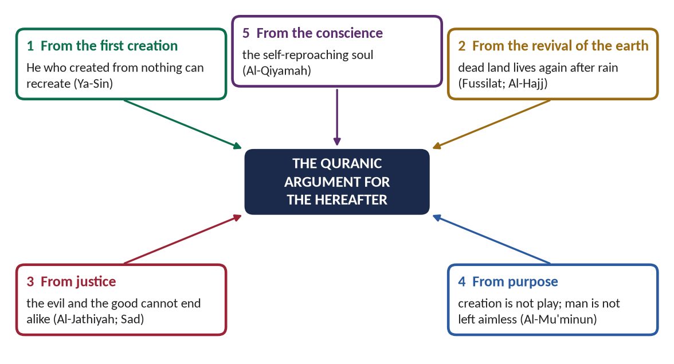
Figure 13 · The five Quranic arguments for the Hereafter.

(1) The argument from the first creation

(i) The argument
He who created man the first time from nothing can surely create him again. To recreate is easier than to create.

(ii) The occasion
A Makkan came to the Prophet ﷺ with a decayed bone, crumbled it in his hand, and asked: 'Who will give life to this?' The answer came in Ya-Sin:
✦ QURAN
﴿وَضَرَبَ لَنَا مَثَلٗا وَنَسِيَ خَلۡقَهُۥۖ قَالَ مَن يُحۡيِ ٱلۡعِظَٰمَ وَهِيَ رَمِيمٞ ۝ قُلۡ يُحۡيِيهَا ٱلَّذِيٓ أَنشَأَهَآ أَوَّلَ مَرَّةٖۖ وَهُوَ بِكُلِّ خَلۡقٍ عَلِيمٌ﴾
“And he presents for Us an example and forgets his [own] creation. He says, "Who will give life to bones while they are disintegrated. Say, "He will give them life who produced them the first time; and He is, of all creation, Knowing.” (Ya-Sin, Quran)
➜ 'Who will give life to bones while they are decayed?' Say: 'He will give them life who produced them the first time; and He is, of all creation, Knowing.'

✦ QURAN
﴿وَهُوَ ٱلَّذِي يَبۡدَؤُاْ ٱلۡخَلۡقَ ثُمَّ يُعِيدُهُۥ وَهُوَ أَهۡوَنُ عَلَيۡهِۚ وَلَهُ ٱلۡمَثَلُ ٱلۡأَعۡلَىٰ فِي ٱلسَّمَٰوَٰتِ وَٱلۡأَرۡضِۚ وَهُوَ ٱلۡعَزِيزُ ٱلۡحَكِيمُ﴾
“And it is He who begins creation; then He repeats it, and that is [even] easier for Him. To Him belongs the highest attribute in the heavens and earth. And He is the Exalted in Might, the Wise.” (Ar-Rum, Quran)
➜ It is He who begins creation and then repeats it, and that is easier for Him.

(iii) Even the fingertips
✦ QURAN
﴿أَيَحۡسَبُ ٱلۡإِنسَٰنُ أَلَّن نَّجۡمَعَ عِظَامَهُۥ ۝ بَلَىٰ قَٰدِرِينَ عَلَىٰٓ أَن نُّسَوِّيَ بَنَانَهُۥ﴾
“Does man think that We will not assemble his bones. Yes. [We are] Able [even] to proportion his fingertips.” (Al-Qiyamah, Quran)
➜ Does man think We will not assemble his bones? Yes — We are able even to proportion his fingertips — the fingertip, unique to every person, will be restored exactly.

(2) The argument from the revival of the earth
Every year the dead, dry earth comes back to life after rain. The same power will bring the dead back to life.
✦ QURAN
﴿وَمِنۡ ءَايَٰتِهِۦٓ أَنَّكَ تَرَى ٱلۡأَرۡضَ خَٰشِعَةٗ فَإِذَآ أَنزَلۡنَا عَلَيۡهَا ٱلۡمَآءَ ٱهۡتَزَّتۡ وَرَبَتۡۚ إِنَّ ٱلَّذِيٓ أَحۡيَاهَا لَمُحۡيِ ٱلۡمَوۡتَىٰٓۚ إِنَّهُۥ عَلَىٰ كُلِّ شَيۡءٖ قَدِيرٌ﴾
“And of His signs is that you see the earth stilled, but when We send down upon it rain, it quivers and grows. Indeed, He who has given it life is the Giver of Life to the dead. Indeed, He is over all things competent.” (Fussilat, Quran)
➜ You see the earth barren; when We send down rain, it stirs and swells. He who gave it life will give life to the dead.

✦ QURAN
﴿… وَتَرَى ٱلۡأَرۡضَ هَامِدَةٗ فَإِذَآ أَنزَلۡنَا عَلَيۡهَا ٱلۡمَآءَ ٱهۡتَزَّتۡ وَرَبَتۡ وَأَنۢبَتَتۡ مِن كُلِّ زَوۡجِۭ بَهِيجٖ﴾
“And you see the earth barren; but when We send down rain upon it, it quivers and swells and brings forth every kind of beautiful growth.” (Al-Hajj, Quran)
➜ The stages of man's creation, and the dead earth that quivers with life after rain — so will the resurrection be.

(3) The argument from justice
In this world, the oppressor often dies in comfort and the oppressed in pain; the honest man is poor and the cheat is rich. If there is no Hereafter, the universe is unjust. A just God must have a Day of Justice.
✦ QURAN
﴿أَمۡ حَسِبَ ٱلَّذِينَ ٱجۡتَرَحُواْ ٱلسَّيِّـَٔاتِ أَن نَّجۡعَلَهُمۡ كَٱلَّذِينَ ءَامَنُواْ وَعَمِلُواْ ٱلصَّـٰلِحَٰتِ سَوَآءٗ مَّحۡيَاهُمۡ وَمَمَاتُهُمۡۚ سَآءَ مَا يَحۡكُمُونَ﴾
“Or do those who commit evils think We will make them like those who have believed and done righteous deeds - [make them] equal in their life and their death? Evil is that which they judge.” (Al-Jathiyah, Quran)
➜ Do those who commit evil think We will make them like those who believe and do good, equal in their life and death? Evil is what they judge.

✦ QURAN
﴿أَمۡ نَجۡعَلُ ٱلَّذِينَ ءَامَنُواْ وَعَمِلُواْ ٱلصَّـٰلِحَٰتِ كَٱلۡمُفۡسِدِينَ فِي ٱلۡأَرۡضِ أَمۡ نَجۡعَلُ ٱلۡمُتَّقِينَ كَٱلۡفُجَّارِ﴾
“Or should we treat those who believe and do righteous deeds like corrupters in the land? Or should We treat those who fear Allah like the wicked.” (Sad, Quran)
➜ Should We treat those who believe and do good like those who cause corruption on earth? Or the righteous like the wicked?

(4) The argument from purpose
A wise Creator does not make a world as a game. If life ended in dust, it would have no final meaning.
✦ QURAN
﴿أَفَحَسِبۡتُمۡ أَنَّمَا خَلَقۡنَٰكُمۡ عَبَثٗا وَأَنَّكُمۡ إِلَيۡنَا لَا تُرۡجَعُونَ﴾
“Then did you think that We created you uselessly and that to Us you would not be returned.” (Al-Mu'minun, Quran)
➜ Did you think that We created you uselessly, and that to Us you would not be returned?

✦ QURAN
﴿وَمَا خَلَقۡنَا ٱلسَّمَٰوَٰتِ وَٱلۡأَرۡضَ وَمَا بَيۡنَهُمَا لَٰعِبِينَ ۝ مَا خَلَقۡنَٰهُمَآ إِلَّا بِٱلۡحَقِّ وَلَٰكِنَّ أَكۡثَرَهُمۡ لَا يَعۡلَمُونَ﴾
“And We did not create the heavens and earth and that between them in play. We did not create them except in truth, but most of them do not know.” (Ad-Dukhan, Quran)
➜ We did not create the heavens and the earth and what is between them in play; We created them only in truth.

(5) The argument from the conscience
The human soul itself bears witness to accountability: it blames itself after wrongdoing. This inner court is a sign of the outer Court to come.
✦ QURAN
﴿لَآ أُقۡسِمُ بِيَوۡمِ ٱلۡقِيَٰمَةِ ۝ وَلَآ أُقۡسِمُ بِٱلنَّفۡسِ ٱللَّوَّامَةِ﴾
“I swear by the Day of Resurrection. And I swear by the reproaching soul [to the certainty of resurrection].” (Al-Qiyamah, Quran)
➜ 'I swear by the Day of Resurrection, and I swear by the self-reproaching soul (al-nafs al-lawwamah).'

(6) The rational and moral support
Philosophers have reached the same conclusion from reason: the German philosopher Immanuel Kant argued that morality requires us to 'postulate' the immortality of the soul and a God who unites virtue with happiness — because in this life they are not united. The Quran gave the argument, with certainty, twelve centuries earlier.

9.5 The impact of belief in the Hereafter on the individual

(1) A sense of accountability — the inner judge
✦ HADITH
لَا تَزُولُ قَدَمَا عَبْدٍ يَوْمَ الْقِيَامَةِ حَتَّى يُسْأَلَ عَنْ عُمُرِهِ فِيمَا أَفْنَاهُ، وَعَنْ عِلْمِهِ فِيمَ فَعَلَ، وَعَنْ مَالِهِ مِنْ أَيْنَ اكْتَسَبَهُ وَفِيمَ أَنْفَقَهُ، وَعَنْ جِسْمِهِ فِيمَ أَبْلَاهُ
“The feet of a servant will not move on the Day of Resurrection until he is asked about his life and how he spent it, his knowledge and what he did with it, his wealth — where he earned it and how he spent it — and his body and how he used it.” (Al-Tirmidhi)
➜ The four questions of the Hereafter shape how a believer uses time, knowledge, money and health.

(2) Moral conduct and self-control
✦ HADITH
مَنْ كَانَ يُؤْمِنُ بِاللَّهِ وَالْيَوْمِ الْآخِرِ فَلْيَقُلْ خَيْرًا أَوْ لِيَصْمُتْ، وَمَنْ كَانَ يُؤْمِنُ بِاللَّهِ وَالْيَوْمِ الْآخِرِ فَلْيُكْرِمْ جَارَهُ، وَمَنْ كَانَ يُؤْمِنُ بِاللَّهِ وَالْيَوْمِ الْآخِرِ فَلْيُكْرِمْ ضَيْفَهُ
“Whoever believes in Allah and the Last Day should speak good or keep silent; whoever believes in Allah and the Last Day should honour his neighbour; whoever believes in Allah and the Last Day should honour his guest.” (Al-Bukhari and Muslim)
➜ Belief in the Last Day is tied directly to speech, neighbours and guests — belief becomes conduct.

(3) Purpose, seriousness and good use of time
✦ HADITH
الْكَيِّسُ مَنْ دَانَ نَفْسَهُ وَعَمِلَ لِمَا بَعْدَ الْمَوْتِ، وَالْعَاجِزُ مَنْ أَتْبَعَ نَفْسَهُ هَوَاهَا وَتَمَنَّى عَلَى اللَّهِ
“The wise person is the one who holds himself to account and works for what comes after death; and the foolish one is he who follows his desires and then hopes for things from Allah.” (Al-Tirmidhi)
➜ Self-accounting (muhasabah) is the daily practice of a believer in the Hereafter.

(4) Patience and hope in suffering
✦ QURAN
﴿وَلَنَبۡلُوَنَّكُم بِشَيۡءٖ مِّنَ ٱلۡخَوۡفِ وَٱلۡجُوعِ وَنَقۡصٖ مِّنَ ٱلۡأَمۡوَٰلِ وَٱلۡأَنفُسِ وَٱلثَّمَرَٰتِۗ وَبَشِّرِ ٱلصَّـٰبِرِينَ ۝ ٱلَّذِينَ إِذَآ أَصَٰبَتۡهُم مُّصِيبَةٞ قَالُوٓاْ إِنَّا لِلَّهِ وَإِنَّآ إِلَيۡهِ رَٰجِعُونَ ۝ أُوْلَـٰٓئِكَ عَلَيۡهِمۡ صَلَوَٰتٞ مِّن رَّبِّهِمۡ وَرَحۡمَةٞۖ وَأُوْلَـٰٓئِكَ هُمُ ٱلۡمُهۡتَدُونَ﴾
“And We will surely test you with something of fear and hunger and a loss of wealth and lives and fruits, but give good tidings to the patient. Who, when disaster strikes them, say, "Indeed we belong to Allah, and indeed to Him we will return. Those are the ones upon whom are blessings from their Lord and mercy. And it is those who are the [rightly] guided.” (Al-Baqarah, Quran)
➜ We will test you with fear, hunger and loss … and give good news to the patient, who say: 'To Allah we belong and to Him we will return.'

(5) Freedom from greed and materialism
✦ QURAN
﴿بَلۡ تُؤۡثِرُونَ ٱلۡحَيَوٰةَ ٱلدُّنۡيَا ۝ وَٱلۡأٓخِرَةُ خَيۡرٞ وَأَبۡقَىٰٓ﴾
“But you prefer the worldly life. While the Hereafter is better and more enduring.” (Al-A'la, Quran)
➜ You prefer the worldly life, while the Hereafter is better and more lasting.

✦ HADITH
كُنْ فِي الدُّنْيَا كَأَنَّكَ غَرِيبٌ أَوْ عَابِرُ سَبِيلٍ
“Be in this world as though you were a stranger or a traveller passing through.” (Al-Bukhari)
➜ The traveller uses the world without being owned by it.

(6) Courage and sacrifice
The believer does not fear death more than dishonour; the martyr is promised life with his Lord (Aal-e-Imran).

(7) Remembrance of death
✦ HADITH
أَكْثِرُوا ذِكْرَ هَاذِمِ اللَّذَّاتِ، يَعْنِي الْمَوْتَ
“Remember often the destroyer of pleasures — meaning death.” (Al-Tirmidhi)
➜ Remembering death corrects priorities and cures arrogance.

TRAP · 'AL-DUNYA MAZRA'AT AL-AKHIRAH' IS NOT A HADITH
The popular saying 'The world is the farm of the Hereafter' is a wise saying of the scholars, but it is not an authentic hadith. Use it as a proverb ('as the saying goes'), never as 'the Prophet ﷺ said'.

9.6 The impact of belief in the Hereafter on collective life

(1) Justice and the rule of law
Rulers who believe they will answer before Allah govern with fear of Him.
✦ SCHOLARLY VIEW
Hazrat Umar Farooq (RA) · the second Rightly-Guided Caliph
Hazrat Umar is reported to have said that if a dog were to die of hunger on the banks of the Euphrates, he feared Allah would question Umar about it.
➜ Belief in the Hereafter made the ruler of an empire answerable for every creature in it.

(2) Honest trade and economy
✦ QURAN
﴿وَيۡلٞ لِّلۡمُطَفِّفِينَ ۝ ٱلَّذِينَ إِذَا ٱكۡتَالُواْ عَلَى ٱلنَّاسِ يَسۡتَوۡفُونَ ۝ وَإِذَا كَالُوهُمۡ أَو وَّزَنُوهُمۡ يُخۡسِرُونَ ۝ أَلَا يَظُنُّ أُوْلَـٰٓئِكَ أَنَّهُم مَّبۡعُوثُونَ ۝ لِيَوۡمٍ عَظِيمٖ ۝ يَوۡمَ يَقُومُ ٱلنَّاسُ لِرَبِّ ٱلۡعَٰلَمِينَ﴾
“Woe to those who give less [than due]. Who, when they take a measure from people, take in full. But if they give by measure or by weight to them, they cause loss. Do they not think that they will be resurrected. For a tremendous Day. The Day when mankind will stand before the Lord of the worlds.” (Al-Mutaffifin, Quran)
➜ Woe to those who give less in measure … Do they not think they will be resurrected for a tremendous Day? — cheating in trade is the fruit of forgetting the Hereafter.

(3) The rights of people (Huquq al-Ibad)
✦ HADITH
إِنَّ الْمُفْلِسَ مِنْ أُمَّتِي يَأْتِي يَوْمَ الْقِيَامَةِ بِصَلَاةٍ وَصِيَامٍ وَزَكَاةٍ، وَيَأْتِي قَدْ شَتَمَ هَذَا، وَقَذَفَ هَذَا، وَأَكَلَ مَالَ هَذَا، وَسَفَكَ دَمَ هَذَا، وَضَرَبَ هَذَا، فَيُعْطَى هَذَا مِنْ حَسَنَاتِهِ وَهَذَا مِنْ حَسَنَاتِهِ
“The truly bankrupt of my Ummah is the one who comes on the Day of Resurrection with prayer, fasting and Zakat, but he had abused this one, slandered that one, consumed the wealth of this one, shed the blood of that one and beaten this one; so they will be given from his good deeds.” (Muslim)
➜ On the Day, the rights of people are paid from one's good deeds — the strongest guarantee of social rights.

(4) Care for the weak
✦ QURAN
﴿أَرَءَيۡتَ ٱلَّذِي يُكَذِّبُ بِٱلدِّينِ ۝ فَذَٰلِكَ ٱلَّذِي يَدُعُّ ٱلۡيَتِيمَ ۝ وَلَا يَحُضُّ عَلَىٰ طَعَامِ ٱلۡمِسۡكِينِ﴾
“Have you seen the one who denies the Recompense. For that is the one who drives away the orphan. And does not encourage the feeding of the poor.” (Al-Ma'un, Quran)
➜ Have you seen the one who denies the Recompense (al-Din)? That is the one who drives away the orphan and does not encourage feeding the poor — denial of the Hereafter shows itself as cruelty to the weak.

(5) Less crime and corruption
A society in which most people believe every hidden act will be exposed needs less policing. Corruption, bribery and fraud grow where the fear of accountability dies.

(6) Peace instead of revenge
Because final justice is certain, the wronged person can forgive, or seek lawful justice, without taking the law into his own hands.
PAKISTAN ANGLE · THE GAP BETWEEN BELIEF AND BEHAVIOUR
Almost all Pakistanis believe in the Day of Judgement, yet corruption, adulteration of food and medicine, and tax evasion remain widespread. The examiner likes an honest admission: the problem is not the belief but its reduction to a ritual. The cure — muhasabah, education of character, and accountability institutions — is part of a strong conclusion.

Chapter 10 · Angels, Books and Qadr
These three articles are rarely asked alone, but they complete the six articles of faith and support every belief answer.

10.1 Belief in the Angels (Mala'ikah)

(1) Who the angels are
Angels are a creation of Allah, made of light, who obey Him perfectly and have no free will to disobey.
✦ HADITH
خُلِقَتِ الْمَلَائِكَةُ مِنْ نُورٍ، وَخُلِقَ الْجَانُّ مِنْ مَارِجٍ مِنْ نَارٍ، وَخُلِقَ آدَمُ مِمَّا وُصِفَ لَكُمْ
“The angels were created from light, the jinn from a smokeless flame of fire, and Adam from what has been described to you.” (Muslim)
➜ The three creations and their origins.

✦ QURAN
﴿يَـٰٓأَيُّهَا ٱلَّذِينَ ءَامَنُواْ قُوٓاْ أَنفُسَكُمۡ وَأَهۡلِيكُمۡ نَارٗا وَقُودُهَا ٱلنَّاسُ وَٱلۡحِجَارَةُ عَلَيۡهَا مَلَـٰٓئِكَةٌ غِلَاظٞ شِدَادٞ لَّا يَعۡصُونَ ٱللَّهَ مَآ أَمَرَهُمۡ وَيَفۡعَلُونَ مَا يُؤۡمَرُونَ﴾
“O you who have believed, protect yourselves and your families from a Fire whose fuel is people and stones, over which are [appointed] angels, harsh and severe; they do not disobey Allah in what He commands them but do what they are commanded.” (At-Tahrim, Quran)
➜ Angels do not disobey Allah in what He commands them, and do what they are commanded.

(2) The great angels and their duties
- Jibril (AS) — brings revelation to the Prophets (named in Al-Baqarah).
- Mika'il (AS) — entrusted with rain and provision (named in Al-Baqarah).
- Israfil (AS) — will blow the Trumpet (named in the Hadith).
- The Angel of Death (Malak al-Mawt; popularly called Izra'il) — takes the souls (As-Sajdah).
- Kiraman Katibin — the honourable recorders of deeds.
✦ QURAN
﴿إِذۡ يَتَلَقَّى ٱلۡمُتَلَقِّيَانِ عَنِ ٱلۡيَمِينِ وَعَنِ ٱلشِّمَالِ قَعِيدٞ ۝ مَّا يَلۡفِظُ مِن قَوۡلٍ إِلَّا لَدَيۡهِ رَقِيبٌ عَتِيدٞ﴾
“When the two receivers receive, seated on the right and on the left. Man does not utter any word except that with him is an observer prepared [to record].” (Qaf, Quran)
➜ Two receivers record, one on the right and one on the left; not a word does he utter but there is an observer ready.

(3) The impact of belief in angels
- A constant awareness of being recorded — a check on speech and action.
- Companionship in goodness: angels pray for the believers and descend on gatherings of remembrance.
- Humility: even these perfect, obedient beings bowed to Adam (AS) by Allah's command — an honour to man.

10.2 Belief in the revealed Books

(1) The Books named in the Quran
- Suhuf (scrolls) of Ibrahim and Musa (AS) — Al-A'la
- Tawrat (Torah) to Musa (AS)
- Zabur (Psalms) to Dawud (AS) — An-Nisa
- Injil (Gospel) to Isa (AS)
- The Quran to Muhammad ﷺ

(2) What a Muslim believes about them
A Muslim believes that all these Books were revealed by Allah in their original form; that the earlier ones were partly lost or altered over time; and that the Quran is the final, preserved Book that confirms the truth in them and judges over them.
✦ QURAN
﴿وَأَنزَلۡنَآ إِلَيۡكَ ٱلۡكِتَٰبَ بِٱلۡحَقِّ مُصَدِّقٗا لِّمَا بَيۡنَ يَدَيۡهِ مِنَ ٱلۡكِتَٰبِ وَمُهَيۡمِنًا عَلَيۡهِۖ …﴾
“And We have revealed to you the Book in truth, confirming the Scripture that came before it and as a criterion (muhaymin) over it.” (Al-Ma'idah, Quran)
➜ We revealed to you the Book in truth, confirming the Scripture before it and a criterion (muhaymin) over it.

(3) The impact
Respect for the scriptures of others; a sense of one continuous history of guidance; and confidence that the final guidance is available, preserved and complete.

10.3 Belief in Qadr — divine decree

(1) Meaning
Qadr (قَدَر) means measure and decree: Allah knows, has recorded, wills and creates everything that happens, in its exact measure.
✦ QURAN
﴿إِنَّا كُلَّ شَيۡءٍ خَلَقۡنَٰهُ بِقَدَرٖ﴾
“Indeed, all things We created with predestination.” (Al-Qamar, Quran)
➜ 'Indeed, all things We created with predestination (bi-qadar).'

(2) The four levels of Qadr (as taught in the books of creed)
1. Ilm — Allah knows everything before it happens.
2. Kitabah — He has recorded it.
3. Mashi'ah — nothing happens without His will.
4. Khalq — He is the Creator of all things, including human actions.

(3) Qadr and human free will
Qadr does not mean that man is a puppet. Allah knows what man will choose, but man chooses — and is responsible for his choice.
✦ QURAN
﴿وَقُلِ ٱلۡحَقُّ مِن رَّبِّكُمۡۖ فَمَن شَآءَ فَلۡيُؤۡمِن وَمَن شَآءَ فَلۡيَكۡفُرۡۚ إِنَّآ أَعۡتَدۡنَا لِلظَّـٰلِمِينَ نَارًا أَحَاطَ بِهِمۡ سُرَادِقُهَاۚ وَإِن يَسۡتَغِيثُواْ يُغَاثُواْ بِمَآءٖ كَٱلۡمُهۡلِ يَشۡوِي ٱلۡوُجُوهَۚ بِئۡسَ ٱلشَّرَابُ وَسَآءَتۡ مُرۡتَفَقًا﴾
“And say, "The truth is from your Lord, so whoever wills - let him believe; and whoever wills - let him disbelieve." Indeed, We have prepared for the wrongdoers a fire whose walls will surround them. And if they call for relief, they will be relieved with water like murky oil, which scalds [their] faces. Wretched is the drink, and evil is the resting place.” (Al-Kahf, Quran)
➜ The truth is from your Lord: whoever wills, let him believe; and whoever wills, let him disbelieve.

✦ QURAN
﴿… إِنَّ ٱللَّهَ لَا يُغَيِّرُ مَا بِقَوۡمٍ حَتَّىٰ يُغَيِّرُواْ مَا بِأَنفُسِهِمۡۗ …﴾
“Indeed, Allah will not change the condition of a people until they change what is in themselves.” (Ar-Ra'd, Quran)
➜ Allah does not change the condition of a people until they change what is in themselves.

✦ QURAN
﴿وَأَن لَّيۡسَ لِلۡإِنسَٰنِ إِلَّا مَا سَعَىٰ﴾
“And that there is not for man except that [good] for which he strives.” (An-Najm, Quran)
➜ Man shall have only what he strives for.

✦ SCHOLARLY VIEW
Hazrat Umar Farooq (RA) · at the time of the plague of Amwas, reported in Al-Bukhari and Muslim
When Hazrat Umar decided not to enter Syria during a plague, Abu Ubaidah (RA) asked: 'Are you fleeing from the decree of Allah?' Umar replied: 'Yes, we flee from the decree of Allah to the decree of Allah.'
➜ Taking precautions is itself part of Qadr — the model for pandemics and public-health policy.

(4) The impact of belief in Qadr
✦ QURAN
﴿مَآ أَصَابَ مِن مُّصِيبَةٖ فِي ٱلۡأَرۡضِ وَلَا فِيٓ أَنفُسِكُمۡ إِلَّا فِي كِتَٰبٖ مِّن قَبۡلِ أَن نَّبۡرَأَهَآۚ إِنَّ ذَٰلِكَ عَلَى ٱللَّهِ يَسِيرٞ ۝ لِّكَيۡلَا تَأۡسَوۡاْ عَلَىٰ مَا فَاتَكُمۡ وَلَا تَفۡرَحُواْ بِمَآ ءَاتَىٰكُمۡۗ وَٱللَّهُ لَا يُحِبُّ كُلَّ مُخۡتَالٖ فَخُورٍ﴾
“No disaster strikes upon the earth or among yourselves except that it is in a register before We bring it into being - indeed that, for Allah, is easy. In order that you not despair over what has eluded you and not exult [in pride] over what He has given you. And Allah does not like everyone self-deluded and boastful.” (Al-Hadid, Quran)
➜ No disaster strikes except that it is recorded … so that you do not despair over what has escaped you, nor exult over what has come to you.

✦ HADITH
عَجَبًا لِأَمْرِ الْمُؤْمِنِ، إِنَّ أَمْرَهُ كُلَّهُ خَيْرٌ، وَلَيْسَ ذَاكَ لِأَحَدٍ إِلَّا لِلْمُؤْمِنِ، إِنْ أَصَابَتْهُ سَرَّاءُ شَكَرَ فَكَانَ خَيْرًا لَهُ، وَإِنْ أَصَابَتْهُ ضَرَّاءُ صَبَرَ فَكَانَ خَيْرًا لَهُ
“How wonderful is the affair of the believer — all of it is good, and this is for no one except the believer: if good comes to him he is grateful, and that is good for him; if harm comes to him he is patient, and that is good for him.” (Muslim)
➜ Qadr gives emotional balance: gratitude in success, patience in loss.

TRAP · QADR IS NOT FATALISM
Never present Qadr as 'whatever will be, will be'. Iqbal repeatedly blamed the decline of Muslims partly on a fatalistic misreading of Qadr. Islam's teaching is effort + trust: 'tie your camel and trust in Allah' (Al-Tirmidhi).

Chapter 11 · The Islamic Beliefs Together: Impact on the Individual and Society
The syllabus line reads: 'Islamic beliefs and their impact on individual and society, and the fundamentals of Islam'. This chapter joins all the beliefs into one answer.

11.1 Belief and deeds are inseparable
✦ QURAN
﴿وَٱلۡعَصۡرِ ۝ إِنَّ ٱلۡإِنسَٰنَ لَفِي خُسۡرٍ ۝ إِلَّا ٱلَّذِينَ ءَامَنُواْ وَعَمِلُواْ ٱلصَّـٰلِحَٰتِ وَتَوَاصَوۡاْ بِٱلۡحَقِّ وَتَوَاصَوۡاْ بِٱلصَّبۡرِ﴾
“By time. Indeed, mankind is in loss. Except for those who have believed and done righteous deeds and advised each other to truth and advised each other to patience.” (Al-Asr, Quran)
➜ By time, mankind is in loss — except those who believe, do righteous deeds, advise one another to truth and advise one another to patience — faith, action, and social responsibility in one surah.

✦ HADITH
وَاللَّهِ لَا يُؤْمِنُ، وَاللَّهِ لَا يُؤْمِنُ، وَاللَّهِ لَا يُؤْمِنُ. قِيلَ: وَمَنْ يَا رَسُولَ اللَّهِ؟ قَالَ: الَّذِي لَا يَأْمَنُ جَارُهُ بَوَائِقَهُ
“'By Allah, he does not believe! By Allah, he does not believe! By Allah, he does not believe!' It was asked: 'Who, O Messenger of Allah?' He said: 'The one whose neighbour is not safe from his harm.'” (Al-Bukhari)
➜ Faith is denied to one whose neighbour is not safe from him — belief is proved by social conduct.

11.2 The impact matrix
Belief | Impact on the individual | Impact on society
Tawhid | Dignity, courage, peace, humility, hope | Equality, justice, freedom from tyranny, unity
Angels | Awareness of being recorded; restraint | Honesty in private and public dealings
Books | Certain guidance; love of knowledge | A fixed law above rulers; respect for other scriptures
Risalat | A perfect model; love of the Prophet ﷺ | A common standard of conduct; a Sunnah-based culture
Khatm-e-Nubuwwat | Certainty and stability of faith | Unity of the Ummah; one Prophet, one Book
Akhirah | Accountability, purpose, patience, freedom from greed | Rule of law, honest trade, rights of people, care for the weak
Qadr | Balance in joy and grief; courage; effort with trust | Stability, resilience, low despair in crises

11.3 The impact on the individual — in one list

(1) A clear identity and purpose

(2) Moral discipline from within

(3) Peace of mind and emotional balance

(4) Courage, dignity and freedom from fear of creatures

(5) Responsibility for time, wealth, knowledge and body

(6) Good character — the proof of faith
✦ HADITH
أَكْمَلُ الْمُؤْمِنِينَ إِيمَانًا أَحْسَنُهُمْ خُلُقًا
“The most complete of the believers in faith is the one with the best character.” (Abu Dawud and Al-Tirmidhi)
➜ Character is the measure of faith.

11.4 The impact on society — in one list

(1) Brotherhood and equality
✦ HADITH
لَا يُؤْمِنُ أَحَدُكُمْ حَتَّى يُحِبَّ لِأَخِيهِ مَا يُحِبُّ لِنَفْسِهِ
“None of you truly believes until he loves for his brother what he loves for himself.” (Al-Bukhari and Muslim)
➜ Faith produces mutual care — the social bond of the Ummah.

(2) Justice and the rule of law

(3) Honesty in trade, office and public life

(4) Care for the poor, the orphan and the weak

(5) Stability, trust and social peace

(6) The historical proof: the society of Madinah
In ten years, the beliefs of Islam produced in Madinah a society in which a ruler could be questioned in the mosque, a slave could lead the prayer, a Jew could win a case against a Muslim, and the treasury fed the poor. That society is the proof that belief has impact.
✦ QURAN
﴿لَّيۡسَ ٱلۡبِرَّ أَن تُوَلُّواْ وُجُوهَكُمۡ قِبَلَ ٱلۡمَشۡرِقِ وَٱلۡمَغۡرِبِ وَلَٰكِنَّ ٱلۡبِرَّ مَنۡ ءَامَنَ بِٱللَّهِ وَٱلۡيَوۡمِ ٱلۡأٓخِرِ وَٱلۡمَلَـٰٓئِكَةِ وَٱلۡكِتَٰبِ وَٱلنَّبِيِّـۧنَ وَءَاتَى ٱلۡمَالَ عَلَىٰ حُبِّهِۦ ذَوِي ٱلۡقُرۡبَىٰ وَٱلۡيَتَٰمَىٰ وَٱلۡمَسَٰكِينَ وَٱبۡنَ ٱلسَّبِيلِ …﴾
“Righteousness is not that you turn your faces toward the east or the west; but true righteousness is [in] one who believes in Allah, the Last Day, the angels, the Book and the Prophets, and gives wealth, in spite of love for it, to relatives, orphans, the needy and the traveller …” (Al-Baqarah, Quran)
➜ True righteousness (birr) joins belief (in Allah, the Last Day, angels, Book, Prophets) with giving wealth to relatives, orphans, the needy and travellers, freeing slaves, prayer, Zakat, keeping promises and patience — the whole of this chapter in one verse.

Part Two — Contemporary Challenges, Narratives and Hot Debates

12.1 Atheism and scepticism among the educated youth

(1) The challenge
Surveys around the world show a growing number of young people who call themselves non-religious. In Pakistan, open atheism is rare but quiet doubt is spreading through the internet, social media and foreign education.

(2) The causes
- Intellectual: arguments from popular science writers; the 'problem of evil' (why does a good God allow suffering?).
- Social: the bad behaviour of some religious people; sectarian quarrels; hypocrisy.
- Educational: religion taught as memorisation, without reasoning.
- Cultural: a consumer culture that makes God seem irrelevant.

(3) The Islamic response

(i) Reason: the six rational arguments (Chapter 6.4)

(ii) The problem of evil answered
- This life is a test, not the final stage (Al-Mulk: 'to test which of you is best in deeds').
- Much suffering is caused by human free will — war, injustice, greed (Ar-Rum: 'corruption has appeared on land and sea because of what men's hands have earned').
- The Hereafter completes justice; no suffering is wasted.
✦ QURAN
﴿ظَهَرَ ٱلۡفَسَادُ فِي ٱلۡبَرِّ وَٱلۡبَحۡرِ بِمَا كَسَبَتۡ أَيۡدِي ٱلنَّاسِ لِيُذِيقَهُم بَعۡضَ ٱلَّذِي عَمِلُواْ لَعَلَّهُمۡ يَرۡجِعُونَ﴾
“Corruption has appeared throughout the land and sea by [reason of] what the hands of people have earned so He may let them taste part of [the consequence of] what they have done that perhaps they will return [to righteousness].” (Ar-Rum, Quran)
➜ Corruption has appeared on land and sea because of what the hands of people have earned — much of the world's suffering is man-made.

(iii) The method: wisdom and good argument
✦ QURAN
﴿ٱدۡعُ إِلَىٰ سَبِيلِ رَبِّكَ بِٱلۡحِكۡمَةِ وَٱلۡمَوۡعِظَةِ ٱلۡحَسَنَةِۖ وَجَٰدِلۡهُم بِٱلَّتِي هِيَ أَحۡسَنُۚ إِنَّ رَبَّكَ هُوَ أَعۡلَمُ بِمَن ضَلَّ عَن سَبِيلِهِۦ وَهُوَ أَعۡلَمُ بِٱلۡمُهۡتَدِينَ﴾
“Invite to the way of your Lord with wisdom and good instruction, and argue with them in a way that is best. Indeed, your Lord is most knowing of who has strayed from His way, and He is most knowing of who is [rightly] guided.” (An-Nahl, Quran)
➜ Invite to the way of your Lord with wisdom and good instruction, and argue with them in the best way — the Islamic method with doubters is dialogue, not anger.

12.2 'Science has replaced religion'

(1) The narrative
Some claim that science explains everything and leaves no room for God.

(2) The answer
- Science explains how nature works; it cannot explain why there is a nature at all, or what is right and wrong.
- The laws of nature need a Law-giver; the fine-tuning of the universe points to a Designer (Chapter 6.4).
- Many of the founders of modern science believed in God; Muslim science itself grew from the Quran's command to observe (T6).
- Islam has no history of a war between religion and science like Europe's.

12.3 Secularism and 'religion is a private matter'
See Chapter 3.4. The Islamic answer is Din: Allah's guidance covers public as well as private life, while non-Muslims keep full freedom of belief (Al-Baqarah: 'no compulsion in religion').

12.4 The meaning crisis: anxiety, depression and loneliness

(1) The challenge
The World Health Organization estimates that more than 700,000 people die by suicide every year, and depression is one of the leading causes of ill-health worldwide. Material prosperity has not brought inner peace.

(2) The answer of the Islamic beliefs
✦ QURAN
﴿فَإِنَّ مَعَ ٱلۡعُسۡرِ يُسۡرًا ۝ إِنَّ مَعَ ٱلۡعُسۡرِ يُسۡرٗا﴾
“For indeed, with hardship [will be] ease. Indeed, with hardship [will be] ease.” (Ash-Sharh, Quran)
➜ 'With hardship comes ease; indeed, with hardship comes ease' — repeated twice as a promise.

- Tawhid gives a relationship with a loving, present Lord (Qaf: 'We are nearer to him than his jugular vein').
- Akhirah gives meaning to suffering and hope beyond death.
- Qadr gives balance: no despair in loss, no arrogance in success.
- The Ummah gives belonging: the mosque, the family and the neighbour.
- Islam also values medical treatment: 'Allah has not sent down a disease without sending down its cure' (Al-Bukhari) — faith and therapy work together.

12.5 Relativism: 'all truths are equal'

(1) The narrative
Post-modern thought says there is no absolute truth — every belief is equally valid.

(2) The answer
Islam distinguishes tolerance of people from relativism of truth. It respects the right of others to believe differently ('for you your religion, and for me mine') while holding that truth is one and knowable through revelation.

12.6 Materialism and consumerism — the modern idols
Wealth, brands, status and the self have become objects of devotion. The Quran calls this taking one's desire as one's god (Al-Furqan) and warns against the 'rivalry in worldly increase' (At-Takathur).
✦ QURAN
﴿أَلۡهَىٰكُمُ ٱلتَّكَاثُرُ ۝ حَتَّىٰ زُرۡتُمُ ٱلۡمَقَابِرَ﴾
“Competition in [worldly] increase diverts you. Until you visit the graveyards.” (At-Takathur, Quran)
➜ 'Competition in worldly increase diverts you until you visit the graveyards' — the diagnosis of consumer culture.

12.7 Finality of Prophethood today
The belief remains a point of complete consensus among Muslims and is protected by the Constitution (Chapter 8.6). In an answer, state the belief, its evidence and its constitutional position calmly; avoid personal attacks on anyone.
HOT DEBATE · AI, THE SOUL AND HUMAN UNIQUENESS
Artificial intelligence raises the question: is man only a thinking machine? Islam answers that man has a ruh (soul) — 'the soul is of the affair of my Lord' (Al-Isra) — moral responsibility and a relationship with his Creator, which no machine can have. Use this in a modern conclusion on Tawhid or Akhirah.

Part Three — The Examiner's Record and Five Likely Questions

13.1 Every question on this topic, 2015–2026
Year | Question | Chapter
2015 Q4 | The entire faith in Prophethood is unacceptable without faith in finality of the Prophethood. Discuss in the light of Quran & Sunnah. | 8
2015 Q7 | Argue for supremacy of 'Wahi' as the solution of human problems against other sources of knowledge. | 5
2016 Q3 | What is the difference between Deen and Religion? Describe the importance of Deen in human life with arguments. | 2, 3
2019 Q2 | Define Tauheed. What is its impact on individual life and the society? Elaborate. | 6
2021 Q2 | What is belief in the Day of Judgment? Explore its effects on individual and collective lives of human beings. | 9
2022 Q5 | Explain the doctrine of Prophethood and its importance in human life. | 7
2022 Q8 | Describe the importance of Deen (Doctrine of life) in human life. Differentiate between Deen and Religions. | 2, 3
2023 Q2 | What is the Qur'anic argument on the Life Hereafter? What are its impacts on the individual and collective life of a human being? | 9
2024 Q4 | Explain the doctrine of Prophethood and its importance in human life. | 7
2026 Q5 | What are the rational arguments for the existence of Allah? Explain the impacts of the belief in monotheism on human life. | 6

All ten are answered as full model answers in T1QA.

13.2 What the record teaches
- Prophethood is the favourite (three times); Din (twice), Tawhid (twice), Akhirah (twice).
- The second limb is almost always 'impact on individual and society' or 'importance in human life'.
- The examiner wants arguments — 'with arguments' (2016), 'argue' (2015), 'Qur'anic argument' (2023), 'rational arguments' (2026).
- Never asked: distinctive aspects of Islam, the concept of Islam as such, angels, books and Qadr.

13.3 Five likely questions
1. What are the distinctive features of Islam that make it a complete code of life? Discuss.
2. Explain the concept of Islam and prove that it is the Din of all the Prophets.
3. Belief in the Hereafter is the basis of moral life. Discuss with Quranic arguments.
4. How does belief in Tawhid remove the crises of modern man? Explain.
5. Revelation (Wahi) is the only certain source of guidance. Argue against the claims of pure reason and science.

Part Four — The One-Liner Bank

One-liners · Islam and Din
- Islam comes from the root s-l-m: submission, peace, safety.
- The only Din accepted by Allah is Islam — Aal-e-Imran.
- 'This day I have perfected your religion' was revealed at the Farewell Hajj, 10 AH — Al-Ma'idah.
- 'Enter Islam completely' — Al-Baqarah.
- Four meanings of Din: sovereignty, obedience, law, recompense.
- 'Master of the Day of Din' — Al-Fatihah; Din = recompense.
- 'The din of the king' — Surah Yusuf; Din = law.
- Every child is born on the fitrah — Al-Bukhari and Muslim.
- 'Islam is built on five' — Al-Bukhari and Muslim.
- The Hadith of Jibril teaches Islam, Iman, Ihsan — Muslim.
- 'Hold fast to the rope of Allah' — Aal-e-Imran.
- 'The Prophets are brothers; their Din is one' — Al-Bukhari.
- 'No compulsion in religion' — Al-Baqarah.
- 'A middle nation' (ummatan wasata) — Al-Baqarah.
- 'We will guard it' (the Quran) — Al-Hijr.

One-liners · Wahi
- Wahi literally: a quick, hidden communication.
- The three modes of Wahi are in Surah Ash-Shura.
- Wahi Matluww = the Quran; Wahi Ghayr Matluww = the Sunnah.
- First revelation: Iqra, Cave of Hira, 610 CE — Al-Alaq.
- 'He does not speak from desire; it is a revelation revealed' — An-Najm.
- 'Like the ringing of a bell' — the hardest form of revelation (Al-Bukhari).
- 'You have been given of knowledge only a little' — Al-Isra.
- 'You know better the affairs of your world' — Muslim (date-palm pollination).
- The Quran's challenge to produce its like — Al-Isra, Al-Baqarah, Yunus, Hud.

One-liners · Tawhid
- Surah Al-Ikhlas equals one-third of the Quran (Al-Bukhari).
- Three kinds of Tawhid: Rububiyyah, Uluhiyyah, Asma wa Sifat.
- 'There is nothing like unto Him' — Ash-Shura.
- 'Had there been gods besides Allah, both would be ruined' — Al-Anbiya.
- 'Were they created by nothing?' — At-Tur (cosmological argument).
- The covenant 'Am I not your Lord?' — Al-A'raf (Alast).
- Shirk is 'a great injustice' — Luqman's advice (Surah Luqman).
- Allah does not forgive shirk — An-Nisa.
- Minor shirk = riya (Musnad Ahmad).
- Kalam cosmological argument — Imam Ghazali.
- 'Tawhid as a working idea is equality, solidarity and freedom' — Iqbal.
- Hazrat Bilal (RA): 'Ahad, Ahad'.

One-liners · Risalat and Finality
- Nabi from naba' (news); Rasul from irsal (sending). Every Rasul is a Nabi.
- 25 Prophets named in the Quran; about 124,000 in a narration of Musnad Ahmad.
- 'I am only a man like you' — Al-Kahf.
- Four functions of the Prophet — Al-Jumu'ah (and Al-Baqarah, Aal-e-Imran).
- 'Khatam an-Nabiyyin' — Al-Ahzab.
- The last-brick parable — Al-Bukhari.
- 'Thirty liars' will claim prophethood — Abu Dawud, Al-Tirmidhi.
- 'If there were a Prophet after me, it would have been Umar' — Al-Tirmidhi.
- Musaylimah defeated at Yamamah under Hazrat Abu Bakr (RA).
- Constitution of Pakistan: finality in Article 260(3); the Second Amendment, 1974.
- Khutbat-e-Madras — Syed Sulaiman Nadvi (MCQ 2026).
- 'Prophecy reaches its perfection in discovering the need of its own abolition' — Iqbal.

One-liners · Akhirah, Angels, Books, Qadr
- Barzakh — Al-Mu'minun; 'Read your record' — Al-Isra; the Scales — Al-Anbiya.
- The decayed bone argument — Ya-Sin; the fingertips — Al-Qiyamah.
- The self-reproaching soul (nafs lawwamah) — Al-Qiyamah.
- 'Did you think We created you in vain?' — Al-Mu'minun.
- The four questions of the Day — Al-Tirmidhi.
- The Muflis (bankrupt) hadith — Muslim.
- Denier of the Din drives away the orphan — Al-Ma'un.
- Angels created from light, jinn from fire, Adam from clay — Muslim.
- Kiraman Katibin: 'not a word but there is an observer' — Qaf.
- Zabur — Dawud (AS); Tawrat — Musa (AS); Injil — Isa (AS).
- The Quran is muhaymin over earlier Books — Al-Ma'idah.
- 'All things We created with qadar' — Al-Qamar.
- 'We flee from the decree of Allah to the decree of Allah' — Hazrat Umar, plague of Amwas.
- 'Tie your camel and trust' — Al-Tirmidhi.

Part Five — Revision Sheet · Topic 1

R1.1 The topic in ten lines
1. Islam = peace through submission; the Din of all Prophets; completed at the Farewell Hajj.
2. Din = sovereignty + obedience + law + recompense: a complete way of life, not a private 'religion'.
3. Din is needed by the fitrah, the individual, society and humanity.
4. Islam's distinctive aspects: pure Tawhid, universality, completeness, preserved sources, balance, ease, reason, equality, freedom of belief, direct access to God, finality.
5. Wahi is the only certain, complete, desire-free source of knowledge; reason is its partner, not its rival.
6. Tawhid: Rububiyyah, Uluhiyyah, Asma wa Sifat; proved by six rational arguments; its opposite is shirk.
7. Risalat: chosen, human, sinless Prophets with Book, model and balance; the door to all knowledge of Allah.
8. Finality: Quran (Al-Ahzab), Sunnah (last brick, thirty liars), Ijma (Yamamah), wisdom (complete, preserved, universal Din).
9. Akhirah: proved from first creation, revival of the earth, justice, purpose and conscience; it creates accountability.
10. Beliefs → awareness → character → conduct → society: faith is proved by deeds (Al-Asr).

R1.2 The definitions to write word for word
Term | Definition
Islam | Complete submission to Allah in belief, worship and the whole conduct of life, according to the guidance revealed to the Prophet Muhammad ﷺ.
Din | The complete system of life revealed by Allah: His sovereignty, man's obedience, His law, and recompense on the Day of Judgement.
Wahi | The message of Allah conveyed to His Prophets — by inspiration, from behind a veil, or through an angel — to guide mankind.
Tawhid | The belief that Allah is One in His essence, attributes, lordship and right to worship, without partner or equal.
Risalat | The belief that Allah sends chosen human beings with His guidance, as messengers and models for mankind.
Khatm-e-Nubuwwat | The belief that Muhammad ﷺ is the last Prophet; no Prophet of any kind will come after him.
Akhirah | The belief that all will be raised, judged by Allah for their deeds, and rewarded or punished eternally.
Qadr | The belief that Allah knows, has recorded, wills and creates all things in their measure, while man chooses and is responsible.

R1.3 The evidence to carry into the hall
Point | Evidence (short reference)
Islam is the only Din | Aal-e-Imran ('the Din with Allah is Islam'); Aal-e-Imran ('whoever seeks other than Islam')
Din complete | Al-Ma'idah ('This day I have perfected'); Al-Baqarah ('enter completely')
Fitrah | Ar-Rum; 'every child is born on the fitrah' (Al-Bukhari and Muslim)
Purpose | Adh-Dhariyat ('only to worship Me'); Al-Mulk ('to test')
Peace | Ar-Ra'd ('in the remembrance of Allah hearts find rest')
Wahi | An-Najm ('not from desire'); Ash-Shura (modes); An-Nisa ('no contradiction')
Tawhid | Al-Ikhlas; Al-Anbiya ('two gods would ruin'); At-Tur ('created by nothing?')
Shirk | Luqman ('great injustice'); An-Nisa ('not forgiven')
Risalat | Al-Jumu'ah (four functions); Al-Hadid (Book and Balance); An-Nisa ('no argument')
Finality | Al-Ahzab; last brick (Al-Bukhari); 'no Prophet after me' (Al-Bukhari and Muslim)
Akhirah | Ya-Sin (bones); Fussilat (earth revived); Al-Jathiyah (justice); Al-Mu'minun (purpose); Al-Qiyamah (conscience)
Impact | Al-Asr; the four questions (Al-Tirmidhi); the Muflis (Muslim); Al-Ma'un; Al-Mutaffifin

R1.4 The two impact lists (learn them as a pair)
On the individual | On society
Dignity and self-respect | Equality and brotherhood
Courage and fearlessness | Justice and rule of law
Peace of heart and balance | Freedom from tyranny
Accountability and moral discipline | Honest trade and public life
Purpose and good use of time | Care for the weak and the poor
Hope; freedom from despair | Unity of the Ummah and social peace

R1.5 The figures to practise
- The four meanings of Din (Chapter 2).
- Din vs religion: the two circles, and the comparison table (Chapter 3).
- The ladder of knowledge (Chapter 5).
- The three kinds of Tawhid (Chapter 6).
- The six rational arguments (Chapter 6).
- The Tawhid impact diagram (Chapter 6).
- The chain of Prophets and the last brick (Chapter 7–8).
- The stages of the Hereafter and the five Quranic arguments (Chapter 9).
- Belief → awareness → character → conduct → society (Part Zero).

